
School of Engineering
Honours Computer Science Project

Fair and Explainable AI for Credit Risk Classification
A Machine Learning Approach

Victor Constantin Pavel
Student ID: 4320446

Project Supervisor
Dr. Ali Salimian

July, 2025

Declaration


Abstract

This dissertation addresses the critical challenge of developing a fair and explainable artificial intelligence (AI) model for multiclass credit risk classification. The primary objective is to enhance traditional credit risk categories systems by employing advanced machine learning algorithms, ensuring not only high predictive accuracy but also fairness and interpretability in decisions affecting diverse demographic groups. Multiple classifiers, including Logistic Regression, Random Forest, Gradient Boosting, XGBoost, LightGBM, and CatBoost were rigorously trained and evaluated using comprehensive performance metrics such as F1 macro score, AUC-ROC, and Average Precision, particularly under severe class imbalance. To address data imbalance, synthetic oversampling (SMOTE), cost-sensitive learning, and threshold tuning strategies were employed. Fairness evaluations were performed using IBM AI Fairness 360 toolkit, assessing bias across gender, age, and education level, while model interpretability was ensured through SHAP analysis. The final Random Forest model achieved balanced performance, optimal recall for the critical high-risk segment, and minimal bias across protected attributes. The results underline the practical value of integrating fairness and explainability in AI-driven credit risk assessments, providing a replicable framework for responsible AI deployment in financial services.

Acknowledgements

I would like to express my profound gratitude to my supervisor, Dr. Ali Salimian, for his invaluable guidance, continuous support, and insightful feedback throughout this research journey. I am also deeply appreciative of my professors, Dr. Daqing Chen and Dr. Bugra Alkan, as well as my peers within the School of Engineering, for fostering an environment conducive to rigorous inquiry and intellectual growth. Special thanks go to my family and friends, whose unwavering support and encouragement have been instrumental in my academic and personal achievements. Finally, I acknowledge the contributions of open-source communities, particularly GitHub repositories, IBM AI Fairness 360, Streamlit, and resources such as Hands-On Machine Learning with Scikit-Learn, Keras & TensorFlow by Aurélien Géron, whose tools and materials significantly facilitated the development and deployment of this project.

Table of Contents

Declaration 1
Abstract 2
Acknowledgements 3
Lists of Figures, Tables & Code Screenshots 7
Chapter 1: Introduction 11
1.1 Background and Rationale 11
1.2 Objectives of the Project 11
1.3 Significance of the Project 12
1.4 Commercial and Economic Relevance 13
1.5 Constraints and Challenges 13
1.6 Dissertation Outline 14
Chapter 2: Literature and Technical Review 15
2.1 Credit Risk Classification with Machine Learning 15
2.2 Fairness in AI and Machine Learning 16
2.3 Explainability in AI and ML (XAI) 17
2.4 Imbalanced Data Handling Techniques 18
2.5 Comparative Review of Machine Learning Algorithms 19
2.6 Evaluation Metrics and Benchmarking 21
2.7 Technical Review: Tools, Architectures, and Mathematical Foundations 22
Chapter 3: Methodology 26
3.1 Overview 26
3.2 Research Design: CRISP-DM Framework 28
3.3 Data Overview and Characteristics 30
3.4 Data Preprocessing 35
3.5 Feature Engineering 37
3.6 Model Development and Training 38
3.7 Model Evaluation and Interpretation 40
Chapter 4 – Implementation 48
4.1 Data Preprocessing 48
4.1.1 Handling Special Cases and Creating Employment Features 49
4.1.2 Exploratory Data Analysis (EDA) 51
4.1.3 Improving Data Quality: Outlier Removal, Statistical Tests, and Correlation Insights 62
4.2 Feature Engineering 72
4.3 Model Implementation 75
4.3.1 Data Splitting and Feature Transformation 75
4.3.2 Encoding and Scaling 76
4.3.3 Model Training and Evaluation 78
4.4 Hyperparameter Tuning 80
Chapter 5 – Results and Analysis: Model Evaluation and Comparison 82
5.1 Overview 82
5.2 Train, Validation and Test Performance 83
5.2.1 Model Evaluation Results – ADASYN (Validation Set) 84
5.2.2 Model Evaluation Results – SMOTE (Validation Set) 89
5.2.3 Validation Results after Hyperparameter Tuning 95
5.2.4 Threshold Tuning on Selected Models 99
5.2.5 Final Model Evaluation Results (Test Set) 105
5.2.6 Final Model Selection and Justification 109
5.2.7 Feature Importance 111
5.3 SHAPE Explainability 112
5.4 AIF360 and Fairness Evaluation 118
Chapter 6 – Deployment 128
6.1 Deployment Methodology 128
5.2 UI Design and Usability 130
Chapter 7 - Discussion and Critical Evaluation 132
Chapter 8 - Conclusion and Reflection 134
References 135
Chapter 9 – Appendix 146
9.1 Credit Risk SQL EDA: 10 Key Business Questions 146
9.2 Case Study: Client 3333 – Streamlit Dashboard Explanation 159

Lists of Figures, Tables & Code Screenshots

Figure 1 Credit Risk Classification Model Workflow/Pipeline Diagram 27
Figure 2 F1-Macro Score Calculation and Classification Report for Random Forest Model 41
Figure 3 Average Precision Score Calculation and PR-AUC Performance by Class for Random Forest Model 42
Figure 4 AUC-ROC Analysis - Multiclass One-vs-Rest Performance for RF 43
Figure 5 Precision-Recall Analysis for High Risk Class Detection for RF 44
Figure 6 Comprehensive Classification Report with Performance Metrics for RF 45
Figure 7 Output of Handling Creating Employment 50
Figure 8 Missing Values Figure 9 Data types 52
Figure 10 Age Boxplot and Distribution 52
Figure 11 Income Boxplot and Distribution 53
Figure 12 Employment Duration Boxplot and Distribution 53
Figure 13 Family Size Boxplot and Distribution 54
Figure 14 Account Age Boxplot and Distribution 54
Figure 15 Children Count Boxplot and distribution 55
Figure 16 Gender Plot and Pie Chart 55
Figure 17 Own Car Plot and Pie Chart 56
Figure 18 Own Property Plot and Pie Chart 56
Figure 19 Income Type Distribution by proportion 57
Figure 20 Education Level Distribution by proportion 57
Figure 21 Marital status Distribution by proportion 58
Figure 22 Housing Type Distribution by proportion 58
Figure 23 Occupation by proportion 59
Figure 24 Risk level distribution by class 60
Figure 25 Statistical Summary for all features 60
Figure 26 New Dataframe confirmation after missing and drop colums 61
Code Screenshot 5 IQR-based cleaning logic Figure 27 IQR Output 62
Figure 28 Chi-Squared results 64
Figure 29 Anova test results 66
Figure 30 Correlation Matrix with target and sorted values 68
Figure 31 Correlation Matrix without target 70
Figure 32 ADASYN Classification Report and results (Validation Set) 85
Figure 33 ADASYN Confusion Matrix 86
Figure 34 ADASYN Precision-Recall Curves 87
Figure 35 SMOTE Classification Report and results (Validation Set) 90
Figure 36 SMOTE Confusion Matrix 91
Figure 37 SMOTE Precision-Recall Curve 92
Figure 38 After Hyperparameter Tuning results and Classification Report 98
Figure 39 Threshold Tuning Curve for Class 2 – LightGBM (Validation Set) 100
Figure 40 Classification Report for LightGBM (Threshold=0.45, Validation Set) 100
Figure 41 Threshold Tuning Curve for Class 2 – Random Forest (Validation Set) 101
Figure 42 Classification Report for Random Forest (Threshold=0.28, Validation Set) 102
Figure 43 Threshold Tuning Curve for Class 2 – XGBoost (Validation Set) 103
Figure 44 Classification Report for XGBoost (Threshold=0.57, Validation Set) 103
Figure 45 Minority Class Threshold Optimization 105
Figure 46 Final evaluation Test Set 107
Figure 47 Confusion Matrix Test Set 108
Figure 48 Classification Report Test Set 109
Figure 49 Final Model Classification Matrix, results and PR Curves by class 110
Figure 50 Random Forest Feature Importances 111
Figure 51 SHAPE Feature Importance Boxplot 113
Figure 52 SHAPE Feature Importance Swarm Plot 114
Figure 53 Force plot for client idx=0 116
Figure 54 Gender output predictions 121
Figure 55 Age output predictions 121
Figure 56 Education output predictions 122
Figure 57 Fairness Metrics Barplot and Heatmap 123
Figure 58 Protected Distribution by Gender 123
Figure 59 Protected Distribution by Age 124
Figure 60 Protected Distribution by Education 124
Figure 61 Risk Level Distribution by Protected Attribute Gender 125
Figure 62 Risk Level Distribution by Protected Attribute Age 126
Figure 63 Risk Level Distribution by Protected Attribute Education 127
Figure 64 Streamlit Dashboard 131
Figure 65 Import, dataset load and create SQLite table Clients 147
Figure 66 Query, Output and Barplot for Distribution of Clients by Credit Risk Class 148
Figure 67 Query and Output for Average & Median Income per Risk Class 149
Figure 68 Query, Output and Barplot for Property Ownership vs Credit Risk 150
Figure 69 Query, Output and Barplot for Car Ownership Distribution Across Risk 151
Figure 70 Query and Ouput of Average Employment Duration by Risk Class 152
Figure 71 Query and output of Average Number of Children by Risk 153
Figure 72 Code and output of Percentage of High-Risk Clients Above Median Income 154
Figure 73 Query and output Income Type Distribution Across Risk Levels 155
Figure 74 Query and output Feature Means for High-Risk Clients 156
Figure 75 Query and output Distribution by Family Size and Risk 157
Figure 76 Client idx 3333 SHAP Force Plot 160
Figure 77 Streamlit Real-time Dashboard SHAP and fairness prediction for client 3333 163
Figure 78 Fairness Overview page 164
Figure 79 Global Feature Importance page 165
Figure 80 Feature Distribution page 166
Figure 81 Download Reports & Plots page 167
Figure 82 All features in test_final 168
Figure 83 Streamlit share apps 169
Figure 84 GitHub Repository all files 169

Table 1 Machine Learning Algorithms (Classifiers Models) 19
Table 2 Evaluation Metrics and Benchmarking 21
Table 3 Renamed Colums and details 32
Table 4 IQR-method Interpretation and Results 63
Table 5 Variables explanation 77
Table 6 Final Dataset before modeling 77
Table 7 ADASYN Results 87
Table 8 SMOTE Results 89
Table 9 Validation Results Before/After Hypermarameter Tunning 95
Table 10 LightGBM Threshold results 99
Table 11 Random Forest Threshold results 101
Table 12 XGBoost Threshold results 102
Table 13 Threshold optimization all models 104
Table 14 Summary Test Set Model Performance 106
Table 15 Summary Best Model Performance 110
Table 16 Selected Client Details 116
Table 17 Fairness Metrics (Gender as protected attribute) 119
Table 18 Summary of All Fairness Metrics Results 122
Table 19 Client idx 3333 Row Features 159
Table 20 Protected Attributes for client idx 3333 159
Table 21 Top Features for this Prediction for client idx 3333 160
Table 22 Client 3333 SHAPE Force plot details 161

Code Screenshot 1 Renamed Columns 34
Code Screenshot 2 Handling Special Cases and Creating Employment Features 50
Code Screenshot 3 Check dataframe for missing values by percentage (%) 51
Code Screenshot 4 Impute Missing and Drop irrelevant columns 61
Code Screenshot 5 IQR-based cleaning logic Figure 27 IQR Output 62
Code Screenshot 6 Chi-Squared snippet 64
Code Screenshot 7 Anova testing 65
Code Screenshot 8 Correlation with target 68
Code Screenshot 9 Correlation without target 69
Code Screenshot 10 Feature Categories and Transformations 72
Code Screenshot 11 Model Data splitting 75
Code Screenshot 12 Encoding and Scaling 76
Code Screenshot 13 Model Training and evaluation 79
Code Screenshot 14 Baseline models fitted 80
Code Screenshot 15 Hyperparameters tunning 81
Code Screenshot 16 Age predictions assigned to AIF360 120

Chapter 1: Introduction

Background and Rationale

Credit risk assessment is a fundamental and critical process for financial institutions, traditionally executed using credit scorecards, expert judgment, and conventional statistical methods. Accurate credit risk assessment enables lenders to make informed decisions, minimizing financial losses by identifying high-risk applicants and expanding access to credit for qualified applicants (Gramegna & Giudici, 2021). Recent advancements in artificial intelligence (AI) and machine learning (ML) offer promising opportunities to improve the precision and efficiency of these risk classification processes.
However, the increasing complexity of machine learning models introduces challenges related to transparency, interpretability, and fairness (Misheva, et al., 2021). This project addresses these concerns directly by developing a fair and explainable AI model specifically tailored to multiclass credit risk classification.

Objectives of the Project

This dissertation investigates the application of advanced machine learning methods to classify credit card and personal loan applicants into three distinct risk categories:
- Good Client (Class 0)
- Low Risk (Class 1)
- High Risk (Class 2)

Unlike traditional binary loan approval models, this project emphasizes nuanced segmentation of creditworthiness to provide granular risk insights. The primary objectives include:
- Developing and evaluating multiple ML classifiers (Logistic Regression, Random Forest, Gradient Boosting, XGBoost, LightGBM, CatBoost, Balanced Random Forest, AdaBoost) to accurately predict credit risk categories.
- Addressing significant data imbalance, particularly for the High Risk category, through synthetic oversampling techniques (SMOTE), cost-sensitive learning methods, and threshold tuning strategies.
- Ensuring the fairness and transparency of the final ML model by integrating explainability methods (SHAP) and fairness assessments (IBM AIF360).
- Deploying a user-friendly prototype using Streamlit Cloud to demonstrate practical applicability and facilitate stakeholder understanding of model predictions.

Significance of the Project

The significance of this project extends beyond technical enhancements. From a commercial perspective, an accurate and fair credit risk model allows financial institutions to effectively manage default risks while minimizing biases that might inadvertently discriminate against certain demographic groups (Wang, 2025). It aligns closely with contemporary ethical and regulatory standards outlined by financial oversight bodies such as the UK's Financial Conduct Authority (FCA) and the Centre for Data Ethics and Innovation (Gov.uk, 2023).
From a societal standpoint, transparent AI systems enhance consumer trust and confidence in automated decision-making processes, fostering greater acceptance and ethical utilization of technology in finance. This project contributes to the broader goal of responsible AI by demonstrating how sophisticated ML algorithms can coexist with regulatory compliance and ethical principles.

Commercial and Economic Relevance

This project has direct commercial relevance as it aims to optimise a core business process in financial services: credit risk assessment. By improving risk classification accuracy and fairness, lenders can reduce default rates and financial losses while expanding access to underserved but creditworthy populations (Brown & Mues, 2012). Such improvements have the potential to lower operational costs, enhance customer retention, and support responsible lending practices.
Economically, the model could be scaled and deployed within credit decision systems used by banks, fintech platforms, and credit bureaus, contributing to more efficient capital allocation in the financial ecosystem. At a national level, fairer credit risk can support financial inclusion and reduce systemic risk from biased or inaccurate lending decisions (Hand & Henley, 1997). While the initial cost of implementation involves model development, fairness validation, and deployment, the long-term benefits include improved trust, compliance, and reduced regulatory risk exposure.
This work can thus be seen as both a prototype for a future commercial tool and as a contribution to the public good by demonstrating how fair and explainable AI can be responsibly applied in high-impact domains such as credit risk.

Constraints and Challenges
Several constraints underpin this research, most notably the inherent imbalance within the dataset. The High Risk class constitutes less than 1% of the total dataset, presenting challenges in training robust predictive models (Chawla, et al., 2002). Furthermore, ensuring fairness is complicated by historical biases inherent in credit data, which can lead to discriminatory outcomes if not actively mitigated (Wang, 2025). Achieving transparency and interpretability with inherently complex "black-box" ML models also poses a critical challenge, requiring specialized tools and careful methodological considerations.

Dissertation Outline
This dissertation is structured to systematically address the outlined objectives:

- Chapter 2 (Literature and Technical Review) provides a comprehensive analysis of existing research on credit risk classification, fairness, explainability, handling data imbalance, and technical methodologies relevant to the study.
- Chapter 3 (Methodology) details the approach adopted for data preprocessing, feature engineering, model selection, training procedures, fairness evaluation, and explainability integration.
- Chapter 4 (Implementation) presents the actual implementation steps, including detailed explanations of code and development processes.
- Chapter 5 (Results and Analysis) analyzes performance metrics, hyperparameter tuning outcomes, fairness assessments, and SHAP-based explainability insights.
- Chapter 6 (Deployment) discusses the prototype deployment using Streamlit Cloud, highlighting user interface considerations and system usability.
- Chapter 7 (Discussion and Critical Evaluation) critically evaluates project outcomes, assesses the strengths and limitations of methodologies used, and contextualizes findings within the broader field.
- Chapter 8 (Conclusion and Reflection) summarizes the project's contributions, identifies avenues for future research, and reflects on the personal learning and professional growth experienced throughout this research.

The Introduction effectively establishes the project's context, clearly stating objectives and highlighting the significance of fairness and explainability in AI-based credit risk assessment. It adeptly addresses core challenges such as data imbalance and model transparency. However, briefly discussing alternative approaches considered and explicitly acknowledging potential limitations related to generalizability would further enhance critical depth. Overall, this chapter provides a strong foundation, clearly justifying the research direction and framework.

Chapter 2: Literature and Technical Review

2.1 Credit Risk Classification with Machine Learning

Credit risk classification is a fundamental process in financial services, enabling institutions to assess the creditworthiness of credit card and personal loan applicants and make informed lending decisions. While traditional approaches have relied on expert-driven scoring rules and logistic regression due to their interpretability, recent research has demonstrated the superiority of advanced machine learning (ML) techniques in capturing complex, non-linear patterns in borrower data (Baesens, 2017).
Recent literature emphasizes the growing adoption of ensemble learning algorithms, particularly Random Forest, Gradient Boosting Machines (GBM), XGBoost, and LightGBM which consistently outperform single-model approaches in benchmark studies (Shi, et al., 2022) (Louzada, et al., 2021). These methods have been shown to increase predictive accuracy and robustness, especially in real-world datasets characterized by high dimensionality and substantial noise. Furthermore, current research has shifted focus from binary approval decisions to multiclass risk stratification, allowing financial institutions to differentiate between Good Clients, Low Risk, and High Risk applicants, thereby supporting more granular portfolio management and tailored credit offerings (Yeh & Lien, 2023), (Louzada, et al., 2021) (Lemhadri, et al., 2021).
Addressing class imbalance remains a critical concern, as public credit datasets, including the one used in this study typically show over 85% of applicants as low risk, with high-risk clients representing less than 1% of the population. Recent advances have introduced sophisticated resampling techniques such as SMOTE, ADASYN, and ensemble methods specifically designed for imbalanced data (e.g., RUSBoost, EasyEnsemble), which have demonstrated improved recall for minority classes without substantially increasing false positives (Shi, et al., 2022), (Lemhadri, et al., 2021). Moreover, interpretability and fairness have emerged as major research themes, with tools like SHAP and IBM AI Fairness 360 now commonly used to audit and mitigate potential bias in automated lending systems (Arya, et al., n.d.) ( Bellamy, et al., 2018) .
In summary, the contemporary landscape of credit risk modeling is defined by the integration of advanced ML methods, robust handling of imbalanced data, and a strong emphasis on explainability and fairness elements that this project adopts to ensure practical relevance and responsible AI deployment in consumer finance.

2.2 Fairness in AI and Machine Learning

Ensuring fairness in machine learning models for credit risk is both a technical and regulatory necessity, as models must not unfairly disadvantage protected groups such as gender, age, or education level. Recent studies have demonstrated that without proper auditing, credit risk and scoring models can inadvertently perpetuate or amplify social biases, leading to unjust outcomes (Mehrabi, et al., 2021).
To address this, a variety of fairness auditing and mitigation strategies have been developed and are now standard in both academic and industrial practice. Tools like IBM’s AI Fairness 360 (AIF360) have enabled practitioners to measure and mitigate bias using well-established metrics, including statistical parity difference, disparate impact, equal opportunity difference, and average odds difference. These metrics are typically computed on protected attributes, and mitigation can be performed through reweighting, adversarial debiasing, or post-processing model predictions to improve group fairness.
Although many fairness metrics were initially designed for binary classification, current research has extended these methods to multiclass problems such as segmenting clients into Good, Low Risk, and High Risk making them more relevant for real-world banking scenarios. Several studies have demonstrated the successful application of AIF360 and similar frameworks in financial settings, confirming their value in both regulatory compliance and ethical AI deployment.
From a legal perspective, frameworks such as the UK Equality Act (2010), EU General Data Protection Regulation (GDPR), and the forthcoming EU AI Act set clear guidelines requiring transparency, accountability, and regular fairness audits of algorithmic systems. In the United States, the Equal Credit Opportunity Act (ECOA) and guidance from the Consumer Financial Protection Bureau (CFPB) mandate non-discriminatory lending and model explainability.
Consequently, the integration of fairness toolkits and systematic auditing of bias are now essential components of responsible AI development in credit risk assessment, ensuring that machine learning models remain compliant, ethical, and equitable across all demographic groups.

2.3 Explainability in AI and ML (XAI)

Explainability in machine learning has become essential for fostering trust, transparency, and accountability in automated decision systems, particularly within high-stakes domains such as credit risk assessment (Rudin, 2019) (Arrieta, et al., 2020). Recent research emphasizes the integration of explainability frameworks into the model development lifecycle, aligning with regulatory demands and industry standards.
SHAP (SHapley Additive exPlanations), introduced by Lundberg and Lee (2017), has emerged as a leading tool for interpreting complex models by attributing individual prediction outcomes to feature contributions based on Shapley values from cooperative game theory. SHAP’s theoretical guarantees of local accuracy and consistency have led to its widespread adoption in financial services, where both global (feature importance) and local (instance-level) interpretability are required (Anang, et al., 2024).
In this project, SHAP was applied to both Random Forest and XGBoost classifiers, generating summary and force plots that reveal the impact of variables such as income, account age, education, and household composition on risk categorization. Recent studies have highlighted the effectiveness of SHAP in identifying discriminatory patterns, communicating model rationale to stakeholders, and facilitating compliance with regulatory frameworks like GDPR and the EU AI Act (Anang, et al., 2024).
Alternative techniques, including LIME and Anchors, were explored but ultimately found less stable and less scalable for large tabular datasets compared to SHAP, which remains the preferred method in industry and academic research (Molnar, 2023). Moreover, emerging work explores hybrid approaches combining SHAP with counterfactual explanations or adversarial analysis to further improve transparency and actionable insights in credit risk modeling.
By embedding explainability methods directly into the deployed dashboard, this project ensures that both technical and non-technical users can audit and interpret credit decisions, meeting modern standards for responsible and interpretable AI in finance.

2.4 Imbalanced Data Handling Techniques

Imbalanced classification is a critical issue in credit risk. Minority classes, such as high-risk applicants, are underrepresented in the dataset, leading to poor recall and precision for these groups if standard learning algorithms are applied. The model may achieve high overall accuracy by simply ignoring the minority class, a phenomenon known as the accuracy paradox (Fernández, et al., 2018).
To address this challenge, this project followed a multi-pronged strategy that is widely recognized in the literature (Louzada, et al., 2021) (Lemhadri, et al., 2021):
- Synthetic Oversampling: The Synthetic Minority Oversampling Technique (SMOTE), proposed by Chawla et al. (2002), was used to generate additional synthetic samples for minority classes (Class 1 and Class 2). Different sampling strategies were explored, such as sampling_strategy={1: 4000, 2: 600}, in line with established best practices.
- Cost-sensitive Learning: Class weights were assigned to the Random Forest model ({0:1, 1:10, 2:100}) and the scale_pos_weight parameter was set in XGBoost, penalizing the misclassification of minority classes. This aligns with recommendations in recent ensemble-based credit scoring research.
- Threshold Tuning: Custom probability thresholds were calibrated to optimize recall and F1-score for the rare High Risk (Class 2), without degrading performance for the majority class. This approach is supported by the findings of (Lenka, et al., 2022), who highlight the importance of threshold adjustment in highly imbalanced financial datasets.
While these methods help mitigate the effects of class imbalance, recent studies confirm that no single technique fully resolves the challenge of minority class detection in credit risk, particularly in real-world, large-scale datasets. Achieving high recall and precision for rare classes remains an open area of research requiring ongoing refinement and evaluation (Lemhadri, et al., 2021), (Louzada, et al., 2021).

2.5 Comparative Review of Machine Learning Algorithms

A diverse set of eight classification algorithms was rigorously evaluated in this project, reflecting the breadth of approaches currently used in credit risk modeling. These included both traditional and advanced ensemble methods: Logistic Regression, Random Forest, Gradient Boosting, XGBoost, LightGBM, CatBoost, Balanced Random Forest, and AdaBoost (see Table 1).
Table 1 Machine Learning Algorithms (Classifiers Models)
Model | Key Strengths | Limitations
Logistic Regression | Interpretable, fast | Poor with non-linear relationships
Random Forest | Robust, handles imbalance, explainable | Can overfit if not tuned
Gradient Boosting | Accurate, flexible | Slower to train
XGBoost | State-of-the-art performance | Complex, sensitive to hyperparameters
LightGBM | Fast, efficient with large datasets | Requires careful categorical encoding
CatBoost | Handles categorical vars natively | More memory-intensive
Balanced RF | Built-in resampling | Slightly slower than standard RF
AdaBoost | Simple ensemble with boosting | Less stable for noisy datasets

Recent literature consistently reports that tree-based ensemble algorithms such as Random Forest, Gradient Boosting, XGBoost, and LightGBM, deliver superior performance in credit risk applications, especially on datasets with non-linear interactions and severe class imbalance (Lessmann, et al., 2015) (Louzada, et al., 2021), (Shi, et al., 2022). XGBoost and LightGBM, in particular, have set new benchmarks in predictive accuracy for financial risk assessment, largely due to their efficient handling of high-dimensional data and support for advanced sampling or weighting schemes (Lemhadri, et al., 2021). CatBoost, with its native support for categorical features, has also demonstrated competitive results, reducing the need for extensive preprocessing (Prokhorenkova, et al., 2018).
In this project, ensemble methods consistently outperformed linear models such as Logistic Regression, which, despite their transparency, are limited in capturing complex feature interactions. The integration of advanced resampling techniques (e.g., SMOTE) and threshold tuning further improved minority class detection, as recommended by recent comparative studies (Lenka, et al., 2022). Among all candidates, Random Forest emerged as the preferred model due to its strong recall for the high-risk class, overall balanced performance, and compatibility with explainability (SHAP) and fairness (AIF360) toolkits.
While XGBoost and LightGBM demonstrated marginally higher precision in some metrics, Random Forest was ultimately chosen for deployment based on its interpretability, robustness to hyperparameter selection, and ease of integration in real-world applications qualities recognized as essential in recent risk analytics literature (Shi, et al., 2022).

2.6 Evaluation Metrics and Benchmarking

Evaluating credit risk models, particularly under multiclass imbalance, requires metrics that go beyond overall accuracy. The table below summarises key metrics and recommended interpretation thresholds (Chicco & Jurman , 2020), (Richardson, et al., 2024), (He & Garcia, 2009), (Sharma, 2023), (Brown & Mues, 2012), (Namvar, et al., 2025):

Table 2 Evaluation Metrics and Benchmarking
Metric | Description | Poor | Acceptable | Good | Excellent
F1 Macro Score | Harmonic mean of precision and recall across for each label | < 0.40 | 0.40–0.60 | 0.60–0.75 | > 0.75
Average Precision (AP) | AUC for precision-recall curves, critical for imbalanced classes | < 0.30 | 0.30–0.60 | 0.60–0.75 | > 0.75
AUC-ROC (One-vs-Rest) | Area under ROC curve per class | < 0.60 | 0.60–0.75 | 0.75–0.85 | > 0.85
Recall (High Risk Class) | Sensitivity for detecting Class 2 (High Risk) | < 0.20 | 0.20–0.40 | 0.40–0.60 | > 0.60
Precision (High Risk Class) | Accuracy of High Risk predictions | < 0.30 | 0.30–0.60 | 0.60–0.75 | > 0.75

Benchmarks vary by dataset and use case, but thresholds provide guidance for model tuning and comparison under imbalance challenges in credit risk classification. These thresholds reflect the realities of financial datasets, where perfect recall or precision is often unattainable due to noise, imbalance, and uncertainty in ground truth. These benchmarks help standardise evaluation under class imbalance and provide practical cut-offs for model tuning.

2.7 Technical Review: Tools, Architectures, and Mathematical Foundations

The software and architectural stack for this project was selected with careful consideration of the current standards and best practices in machine learning for credit risk classification. Each component was chosen for its established use in the research and industry community, its mathematical rigor, and its support for integration and reproducibility.
Programming Environment and Development Workflow
Python (3.x) remains the dominant language for data science, largely due to its rich ecosystem and clear syntax (Van Rossum & Drake, 2009). Jupyter Notebooks, widely used for experimental research and instructional purposes (Kluyver, et al., 2016), facilitated interactive exploration, rapid prototyping, and visualization. Visual Studio Code, with integrated Git support, streamlined modular development and enabled collaborative version control, a workflow mirrored in recent credit risk studies (Lessmann, et al., 2015).
Data Processing and Visualization
Pandas and NumPy served as the primary libraries for data wrangling, efficient matrix operations, and descriptive statistics underpinned by foundational concepts in vectorized computation. Visualization was performed with Matplotlib and Seaborn, supporting exploratory data analysis and model diagnostics. These tools have become standard in financial ML projects due to their flexibility and extensive documentation (McKinney, 2010).
Machine Learning Frameworks and Mathematical Techniques
Scikit-learn provided the foundational modeling toolkit, offering robust implementations of classical algorithms, pipeline abstractions, and cross-validation strategies grounded in statistical learning theory (Pedregosa, et al., 2012). Tree-based ensemble models, Random Forest, XGBoost, LightGBM, and CatBoost were included for their state-of-the-art performance on tabular data, as extensively benchmarked by (Lessmann, et al., 2015) and (Shi, et al., 2022). These models are based on principles such as bagging, boosting, and gradient descent optimization, and are mathematically justified in their ability to capture complex, non-linear relationships.
Imbalanced-learn, built atop scikit-learn, was used for applying synthetic oversampling (SMOTE) and integrating cost-sensitive learning via the ImbPipeline. These techniques are mathematically founded on sampling theory and cost-sensitive risk minimization (Chawla, et al., 2002), (He & Garcia, 2009).
Evaluation, Explainability, and Model Monitoring
Model performance was quantified using metrics such as F1 Macro, Average Precision, and AUC-ROC all rooted in information retrieval theory and signal detection (Saito & Rehmsmeier, 2015). Hyperparameter tuning was achieved through grid and randomized search with stratified cross-validation, ensuring fair evaluation on imbalanced data.
For explainability, SHAP (Lundberg & Lee, 2017) was preferred due to its rigorous game-theoretic foundation (Shapley values), which guarantees local accuracy and consistency in feature attributions. While other studies have used LIME or permutation importance, SHAP is now recognized as the standard for interpretable ML in regulated domains. SHAP’s integration with tree-based models was particularly useful for visualizing both global and local decision logic.
Fairness and Ethical Considerations
IBM AI Fairness 360 (AIF360), a toolkit designed to audit and mitigate algorithmic bias, was employed for post-hoc fairness analysis. This framework implements a range of statistical tests (e.g., disparate impact, statistical parity) and correction methods (reweighting, equalized odds), many of which are referenced in regulatory guidelines (Barocas, et al., 2019), (Mehrabi, et al., 2021).
Deployment and Collaboration
Streamlit Cloud enabled rapid deployment of the interactive dashboard, reflecting a growing trend towards cloud-native, Python-based solutions for model interpretability and stakeholder engagement (Streamlit, 2025) . GitHub facilitated reproducibility and transparent sharing of code, datasets, and documentation, aligning with open science practices advocated in the field.
Extending the State-of-the-Art
While this project leveraged widely adopted tools, several adaptations and custom integrations were introduced. These included advanced threshold tuning for minority class recall, automated pipeline synchronization for fairness analysis, and a unified dashboard for real-time interpretability and auditing approaches inspired by, but extending, current academic and industry practice.

Critical Evaluation
While this project reflects the current state-of-the-art in credit risk modeling incorporating robust ensemble algorithms, advanced resampling for imbalanced data, and industry-standard tools for explainability and fairness it also highlights several limitations and opportunities for future improvement. The technology stack, although well-suited for research-driven experimentation and transparent deployment, presents constraints that must be addressed for real-world scalability. Streamlit, for example, is ideal for demonstration purposes but lacks features essential for production environments, such as model versioning, user authentication, and real-time monitoring adopting frameworks like FastAPI, Flask with Docker, or MLflow could bridge this gap. The AIF360 toolkit, while powerful, requires significant preprocessing and offers limited multiclass support compared to newer libraries like Fairlearn or Responsibly, which provide easier integration with scikit-learn pipelines. Similarly, SHAP though the gold standard for interpretability is computationally expensive for large or highly correlated datasets future research might explore interpretable alternatives such as Generalized Additive Models (GAMs) or counterfactual explanations. Additionally, workflow automation and experiment tracking were not fully implemented; tools such as MLflow, Airflow, or DVC could greatly improve reproducibility and collaboration. Overall, the technical decisions made in this project strike a balance between practicality, interpretability, and fairness, but future iterations should focus on enhancing scalability, user accessibility, and regulatory compliance by adopting more robust ML engineering practices. Such improvements would ensure that advances in research are effectively translated into reliable, deployable solutions for the financial industry.

Chapter 3: Methodology

3.1 Overview

This chapter outlines the research methodology employed to design, develop, and evaluate a credit risk classification system integrating fairness and explainability techniques. The approach follows a systematic pipeline involving data acquisition, preprocessing, feature engineering, model development, evaluation, and post-hoc analysis using fairness-aware and interpretable machine learning tools. Each methodological choice is grounded in best practices for handling imbalanced, high-stakes financial datasets and guided by the specific goals of the project.
In high-stakes domains such as financial lending, it is critical that predictive systems not only perform well but also operate transparently and equitably. Therefore, a modular machine learning pipeline was adopted instead of black-box end-to-end solutions, allowing fine-grained control over each stage of the modeling process. This structure supports post-hoc interpretability and bias mitigation, both of which are essential in credit decisioning tasks (Barocas, et al., 2019).
The methodology also integrates post-processing tools for fairness (IBM AIF360) and model explainability (SHAP), in line with recent recommendations in the literature (Holstein, et al., 2019), (Raji, et al., 2020). These tools enable transparency and stakeholder trust while ensuring the model’s decisions can be audited and understood. Due to the extreme class imbalance in the dataset and the ethical consequences of false negatives in Class 2 (High Risk), the methodology prioritizes tailored evaluation metrics and cost-sensitive strategies over general performance measures such as accuracy.
The rest of this chapter elaborates on each stage of the pipeline, providing justification for every methodological choice based on academic literature and domain-specific requirements.

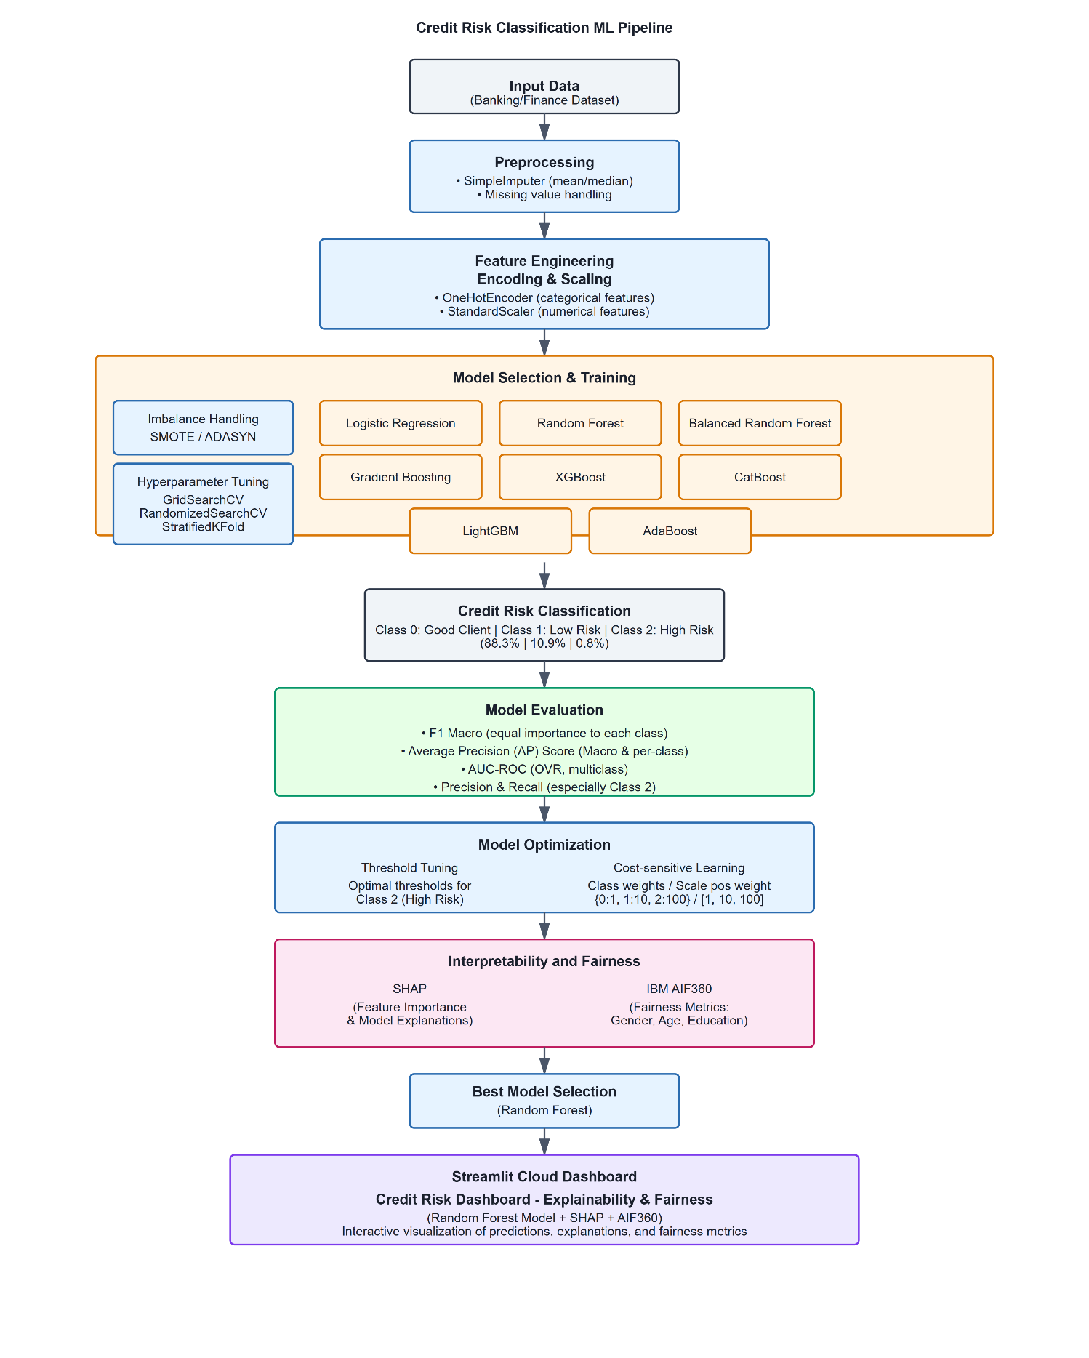
Figure 1 Credit Risk Classification Model Workflow/Pipeline Diagram

3.2 Research Design: CRISP-DM Framework

This study adopts the Cross Industry Standard Process for Data Mining (CRISP-DM) as the overarching methodology for structuring the project workflow. CRISP-DM is a widely recognized and industry-standard framework that provides a robust and iterative process for developing data science projects (Schröer, et al., 2021). Its flexibility, cyclical nature, and focus on real-world deployment make it well suited for complex and high-risk domains such as credit risk.

The framework consists of six phases:
1. Business Understanding:
The initial phase involved defining the business goal of developing a machine learning system capable of classifying credit applicants into three risk categories (Good Client, Low Risk, High Risk). In this context, fairness and explainability were identified as core non-functional requirements due to regulatory expectations and stakeholder needs in the financial services industry (Hurley & Adebayo, 2016).
2. Data Understanding:
Two datasets from (Kaggle, 2020) were used: application_record.csv, containing demographic and financial attributes for each client, and credit_record.csv, which provides longitudinal records of credit payment behavior. Both datasets include a unique client identifier (ID), which enabled a one-to-one merge, ensuring that each client’s application data could be directly linked to their full credit repayment history.
The merging process involved an inner join on the ID column, retaining only those clients present in both datasets and thus supporting comprehensive risk analysis. After merging, extensive feature engineering was performed:
- Account_Age was calculated for each client by measuring the timespan of their credit activity using the MONTHS_BALANCE field, which represents months relative to the data extraction point (1 to 60 months or 5 years).
- Credit history distribution features were derived by aggregating each client’s monthly payment statuses (STATUS values), enabling the identification of late payments and patterns of delinquency.
- The target variable, credit risk class was constructed by examining each client’s worst payment status across their history, grouping them into three mutually exclusive categories: Good Client (no late payments), Low Risk (minor delays), and High Risk (serious defaults).
Exploratory Data Analysis (EDA) revealed severe class imbalance (with most clients being classified as Good), as well as potential demographic and behavioral bias patterns. These findings guided subsequent modeling and fairness analysis.
This systematic data integration and feature derivation provided a robust foundation for multiclass credit risk classification and subsequent fairness and explainability assessments.
3. Data Preparation:
Data preprocessing involved handling missing values using SimpleImputer, encoding categorical variables with OneHotEncoder, and scaling numerical features with StandardScaler. Feature engineering included domain-specific transformations such as income-to-age ratios and polynomial features. Class imbalance was addressed using oversampling techniques (SMOTE, ADASYN) and selective resampling strategies (Blagus & Lusa, 2013).
4. Modeling:
Multiple machine learning classifiers were developed and compared, including Logistic Regression, Random Forest, Balanced Random Forest, Gradient Boosting, XGBoost, LightGBM, CatBoost, and AdaBoost. Each model was implemented in a pipeline using ImbPipeline with preprocessing, resampling, and hyperparameter optimization using GridSearchCV or RandomizedSearchCV. Class imbalance was further addressed via cost-sensitive learning (e.g., class weights) and threshold tuning for the most promising models.
5. Evaluation:
Models were evaluated using metrics suited for multiclass imbalanced classification: F1 Macro, Average Precision (AP), AUC-ROC (OvR), Precision and Recall per class. Special attention was given to Class 2 (High Risk) due to its operational significance. Stratified K-Fold Cross Validation ensured reliable performance estimates and generalization.
6. Deployment:
The final Random Forest model, selected for its generalization and interpretability, was deployed via a Streamlit Cloud dashboard. The dashboard incorporates SHAP for visualizing feature contributions and IBM AIF360 to assess group fairness across sensitive attributes. This step ensures the model is both transparent and accountable to end users.
The CRISP-DM framework was instrumental in aligning technical activities with business goals, iteratively refining decisions, and promoting transparency throughout the credit risk classification pipeline.

3.3 Data Overview and Characteristics

This project utilizes two publicly available datasets from (Kaggle, 2020) 'Credit Card Approval Prediction' repository

- application_record.csv, containing demographic and financial information for 438,557 clients. Shape: (438,557 rows × 18 columns)
- credit_record.csv, which provides 1,048,575 records of monthly credit payment status for these clients. The datasets were merged using the unique client identifier (ID) to form a unified dataset that combines static application features with dynamic repayment histories. Shape: (1,048,575 rows × 3 columns)
The key variable for credit risk modeling the target variable was derived from the STATUS column in credit_record.csv, which records each client’s payment behavior on a monthly basis. The STATUS values include:
- C: Closed account
- X: No loan for that month
- 0: Paid on time
- 1–5: Delays in payment, indicating the number of months overdue

To generate a multiclass risk label (Risk_Level) suitable for credit risk classification, clients were grouped into three categories based on the worst payment status observed in their credit history:
- Class 0 (“Good Client”): Clients with no late payments or only non-delinquent statuses (STATUS values ‘C’, ‘X’, or ‘0’), indicating consistently timely payments or no active credit in some months.
- Class 1 (“Low Risk”): Clients whose worst status indicates minor delays (at least one occurrence of STATUS equal to 1 or 2), corresponding to a payment delay of one or two months.
- Class 2 (“High Risk”): Clients with at least one serious delinquency (STATUS equal to 3, 4, or 5), reflecting payments overdue by three or more months an established indicator of high credit risk.

This categorization method assigns each client to a single risk class based on their most adverse repayment event, ensuring that the risk labels are mutually exclusive and capture the spectrum from good standing to severe default.
To enrich the feature set and account for temporal patterns, an additional variable Account_Age was engineered by computing the span (in months) of each client’s credit history from the MONTHS_BALANCE column. This variable provides a measure of credit ‘vintage’ without introducing temporal leakage, as it summarizes behavior across the entire historical record rather than modeling time series dynamics directly.
All data integration, feature engineering, and target construction steps were performed prior to modeling, and the resulting dataset supports robust multiclass credit risk analysis consistent with modern financial risk management practices.

Column names were also renamed for clarity and usability using the following mapping:

Table 3 Renamed Colums and details
Original Feature | New Feature Name | Explanation | Remarks
ID | ID | Unique client identifier
CODE_GENDER | Gender | Client’s gender
FLAG_OWN_CAR | Owns_Car | Whether client owns a car | Binary (Y/N)
FLAG_OWN_REALTY | Owns_Property | Whether client owns real estate | Binary (Y/N)
CNT_CHILDREN | Children_Count | Number of children
AMT_INCOME_TOTAL | Income | Total annual income | In local currency
NAME_INCOME_TYPE | Income_Type | Source/type of income | (e.g., Working, Pensioner)
NAME_EDUCATION_TYPE | Education_Level | Highest education level attained
NAME_FAMILY_STATUS | Marital_Status | Marital status
NAME_HOUSING_TYPE | Housing_Type | Housing situation | (e.g., Rented, Owned)
DAYS_BIRTH | Age | Days since birth | Negative value (e.g., -12000 means 32 years)
DAYS_EMPLOYED | Employment_Duration | Days since employment began | Negative: employed, Positive: unemployed
FLAG_MOBIL | Has_Mobile | Whether client has a mobile phone | Binary (0/1)
FLAG_WORK_PHONE | Has_Work_Phone | Whether client has a work phone | Binary (0/1)
FLAG_PHONE | Has_Phone | Whether client has a home phone | Binary (0/1)
FLAG_EMAIL | Has_Email | Whether client has email | Binary (0/1)
OCCUPATION_TYPE | Occupation | Client’s job type | May have missing values
CNT_FAM_MEMBERS | Family_Size | Total family members in household | Includes children
Risk_Level | Risk_Level | Final target: client credit category | {0: Good, 1: Low Risk, 2: High Risk}
Account_Age | Account_Age | Credit account age in months | From 1 to 60 months
Code Screenshot 1 Renamed Columns
app_df.rename(columns={
'ID': 'ID',
'CODE_GENDER': 'Gender',
'FLAG_OWN_CAR': 'Owns_Car',
'FLAG_OWN_REALTY': 'Owns_Property',
'CNT_CHILDREN': 'Children_Count',
'AMT_INCOME_TOTAL': 'Income',
'NAME_INCOME_TYPE': 'Income_Type',
'NAME_EDUCATION_TYPE': 'Education_Level',
'NAME_FAMILY_STATUS': 'Marital_Status',
'NAME_HOUSING_TYPE': 'Housing_Type',
'DAYS_BIRTH': 'Age',
'DAYS_EMPLOYED': 'Employment_Duration',
'FLAG_MOBIL': 'Has_Mobile',
'FLAG_WORK_PHONE': 'Has_Work_Phone',
'FLAG_PHONE': 'Has_Phone',
'FLAG_EMAIL': 'Has_Email',
'OCCUPATION_TYPE': 'Occupation',
'CNT_FAM_MEMBERS': 'Family_Size',
'Risk_Level': 'Risk_Level',
'Account_Age': 'Account_Age'
}, inplace=True)

After applying this logic and merging the records:
- Final shape: (36,457 rows × 20 columns)
- Class distribution:
- Class 0 (Good Client): 32,166 records (88.2%)
- Class 1 (Low Risk): 3,989 records (10.9%)
- Class 2 (High Risk): 302 records (0.8%)
The final dataset, though significantly reduced from the original size, provides a balanced trade-off between data completeness and label reliability. The engineered risk level labels reflect realistic client behavior in terms of financial reliability and delinquency.
The severe class imbalance in this final dataset introduced substantial challenges for model training and evaluation, particularly in detecting high-risk individuals (Class 2). This necessitated careful consideration of appropriate preprocessing, sampling techniques, and cost-sensitive modeling strategies, which are described in subsequent sections.

3.4 Data Preprocessing
Prior to model training, a structured sequence of preprocessing steps was implemented to ensure data quality, compatibility with machine learning algorithms, and to promote fairness in subsequent modeling. The following steps were executed:
Missing Value Imputation:
All missing values in numerical features were imputed using the median value of each respective column. This approach was chosen because the median is robust to outliers and skewed distributions, which are common in financial data.
Outlier Detection and Removal:
Outliers were identified and removed based on the Interquartile Range (IQR) method. For each selected feature, data points lying outside 1.5 times the IQR above the third quartile or below the first quartile were excluded. This standard practice reduces the influence of anomalous records that could otherwise distort model training (Aggarwal, 2017).
Feature Engineering and Selection:
- Feature Engineering: New variables, such as Account_Age (calculated from the span of MONTHS_BALANCE), and aggregate payment status features (e.g., the proportion of months with late payments), were constructed to capture clients’ behavioral trends.
- Feature Selection: Chi-Squared and ANOVA tests were conducted to identify features with significant predictive power for multiclass classification. Features failing to meet statistical significance thresholds were excluded, reducing dimensionality and potential overfitting (Geeksforgeeks, 2025).

Categorical Encoding:
All categorical variables (e.g., Gender, Income Type, Education Level, Housing Type) were transformed using OneHotEncoder. This prevents the introduction of unintended ordinal relationships among nominal categories.
Numerical Feature Scaling:
Continuous features were standardized using StandardScaler to ensure that each variable contributes equally to distance-based algorithms and that optimization routines converge efficiently.
Imbalanced Data Treatment:
Severe class imbalance was addressed using SMOTE (Synthetic Minority Oversampling Technique) to oversample the minority classes (Low Risk and High Risk). Additionally, cost-sensitive learning was incorporated by applying class weights during model training (Dal Pozzolo, et al., 2016).
Threshold Tuning:
Probability thresholds for the minority (High Risk) class were calibrated post-training to optimize recall and F1-score for this critical segment, ensuring that rare but high-impact applicants are not overlooked.
This comprehensive preprocessing approach ensures the reliability and fairness of the machine learning pipeline. Each choice median imputation, IQR-based outlier removal, statistical feature selection, one-hot encoding, standard scaling, and SMOTE reflects best practices documented in contemporary financial risk modeling literature (Vargas, et al., 2022) (Kommareddy, 2022). Addressing data quality and class imbalance at the preprocessing stage is essential to mitigate risks of bias, loss of statistical power, and poor generalization in real-world deployment.

3.5 Feature Engineering

Feature engineering plays a critical role in enhancing the predictive capability and interpretability of models, particularly in high-risk domains like credit risk. It involves constructing new variables or transforming existing ones to expose the latent structure of data in a way that algorithms can better learn from.
The feature engineering process was designed to enrich the input space with more informative and expressive features while maintaining model interpretability. Techniques applied include:
- Polynomial Features: Second-degree polynomial transformations (e.g., DAYS_BIRTH^2) were applied to capture non-linear relationships between age and credit behavior. Non-linear features are known to significantly improve decision boundaries for tree-based models (Zhou, et al., 2021).
- Interaction Features: Combinations like Income per Age or Children × Family Size were created to encode relationships between financial stability and social responsibilities. Such domain-specific interactions are often beneficial for financial modeling (Khandani, et al., 2010).
- Binning: Continuous variables such as Income and Age were discretized into quantile bins to reduce noise sensitivity and increase model robustness. This technique is also aligned with scorecard model designs used in industry (Anderson, 2023).
- Ratio Features: Ratios like Income / Family_Size offer scale-independent indicators of economic well-being. These have shown to be predictive in credit card / loan approval and risk category tasks.
- Domain-Specific Flags: A binary feature was introduced to flag applicants whose income exceeded the dataset’s median. This helps isolate high-earner effects that could be masked by income variance.
These transformations were derived from an understanding of credit behavior and aligned with industry practices in credit risk.

3.6 Model Development and Training

Model development in this project followed a structured and iterative approach focused on building robust, fair, and explainable multiclass classifiers for credit risk assessment. The challenge of imbalanced data was particularly critical for the High Risk class (Class 2), necessitating the careful selection of models and training strategies.
Eight machine learning classifiers were selected based on their relevance to tabular classification tasks and prior use in credit risk research:
- Logistic Regression: Serves as a baseline model, valued for its interpretability and speed. Suitable for assessing linear decision boundaries in credit risk (Baesens, 2017).
- Random Forest: Robust against overfitting and capable of capturing non-linear relationships. Effective for tabular data with mixed feature types (Breiman, 2001).
- Balanced Random Forest: Tailored for imbalanced datasets by incorporating under-sampling within each bootstrap iteration, reducing majority class dominance (Chen, 2004).
- Gradient Boosting & XGBoost: Known for high performance on structured data. Their ability to model complex interactions has shown superior predictive power in credit risk contexts (Lessmann, et al., 2015).
- CatBoost & LightGBM: Efficient, high-performing boosting algorithms with automatic handling of categorical variables and faster training. Suitable for large-scale financial datasets.
- AdaBoost: Emphasizes misclassified points during iteration, making it sensitive to minority class patterns, which is useful in credit risk classification.
This diverse set of models was chosen to evaluate performance across classic linear, ensemble bagging, and boosting approaches under a multiclass, imbalanced setting.
Pipeline and Training Configuration
To ensure consistent and fair model evaluation, a full machine learning pipeline (ImbPipeline) was constructed. It included:
- SimpleImputer: For missing values, using mean or median based on data distribution.
- OneHotEncoder & StandardScaler: For preprocessing categorical and numerical variables.
- ADASYN/SMOTE: Applied only to training data to synthetically oversample minority classes, addressing the severe imbalance affecting Class 2.

To optimize learning and generalization:
- StratifiedKFold was used to maintain label proportions across folds.
- GridSearchCV was used for exhaustive hyperparameter tuning (Random Forest, XGBoost, Balanced RF, AdaBoost).
- RandomizedSearchCV was used to reduce compute time for the remaining models.
- Cost-sensitive learning was employed by tuning class weights (e.g., {0:1, 1:10, 2:100}) in some classifiers to balance model attention.
- Threshold tuning was performed post-training to further boost the recall for the underrepresented Class 2 (High Risk), demonstrating improvement in sensitivity over default decision thresholds.

This approach was guided by best practices for handling class imbalance in critical applications (He & Garcia, 2009), (Batista, et al., 2004).
Despite a rigorous selection of preprocessing and feature engineering techniques—including median imputation, SMOTE oversampling, IQR-based outlier removal, and classical statistical tests each method introduces limitations, such as possible information loss, generation of noisy synthetic instances, overfitting from high-dimensional features, and restrictive statistical assumptions, all of which may impact model robustness or interpretability. Future work could address these challenges by exploring more adaptive imputation (e.g., KNN, MICE), advanced resampling and cleaning strategies (e.g., SMOTEENN, SMOTETomek), automated and regularized feature selection, explainable binning, hybrid cost-sensitive methods, and alternative models (e.g., bagging ensembles, neural networks with focal loss), to further improve accuracy, fairness, and generalizability as data distributions evolve.

3.7 Model Evaluation and Interpretation

Model evaluation and interpretation played a pivotal role in this project, ensuring that performance metrics aligned with real-world credit risk goals. Given the inherent class imbalance and regulatory implications, special emphasis was placed on fairness, sensitivity, and transparency in model behavior.
Evaluation Strategy
Evaluation metrics were selected to address the challenges posed by multiclass classification on an imbalanced dataset, with Class 2 (High Risk) representing less than 1% of the population.
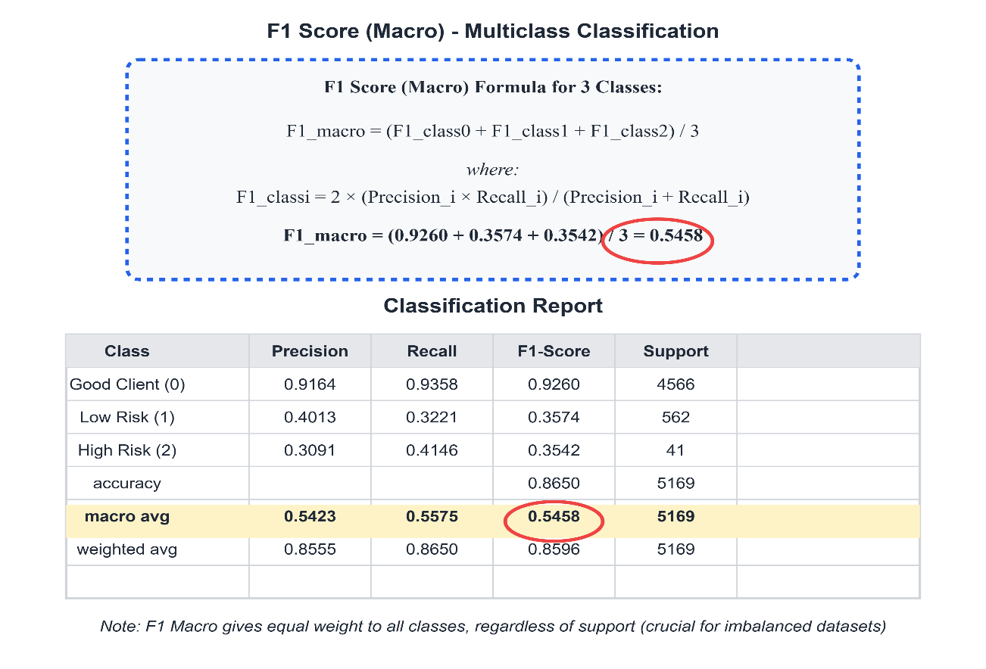
- F1 Macro Score: Chosen for its equal treatment of each class, providing a balanced view irrespective of class frequency. This was crucial to prevent the model from overfitting to Class 0.
Figure 2 F1-Macro Score Calculation and Classification Report for Random Forest Model

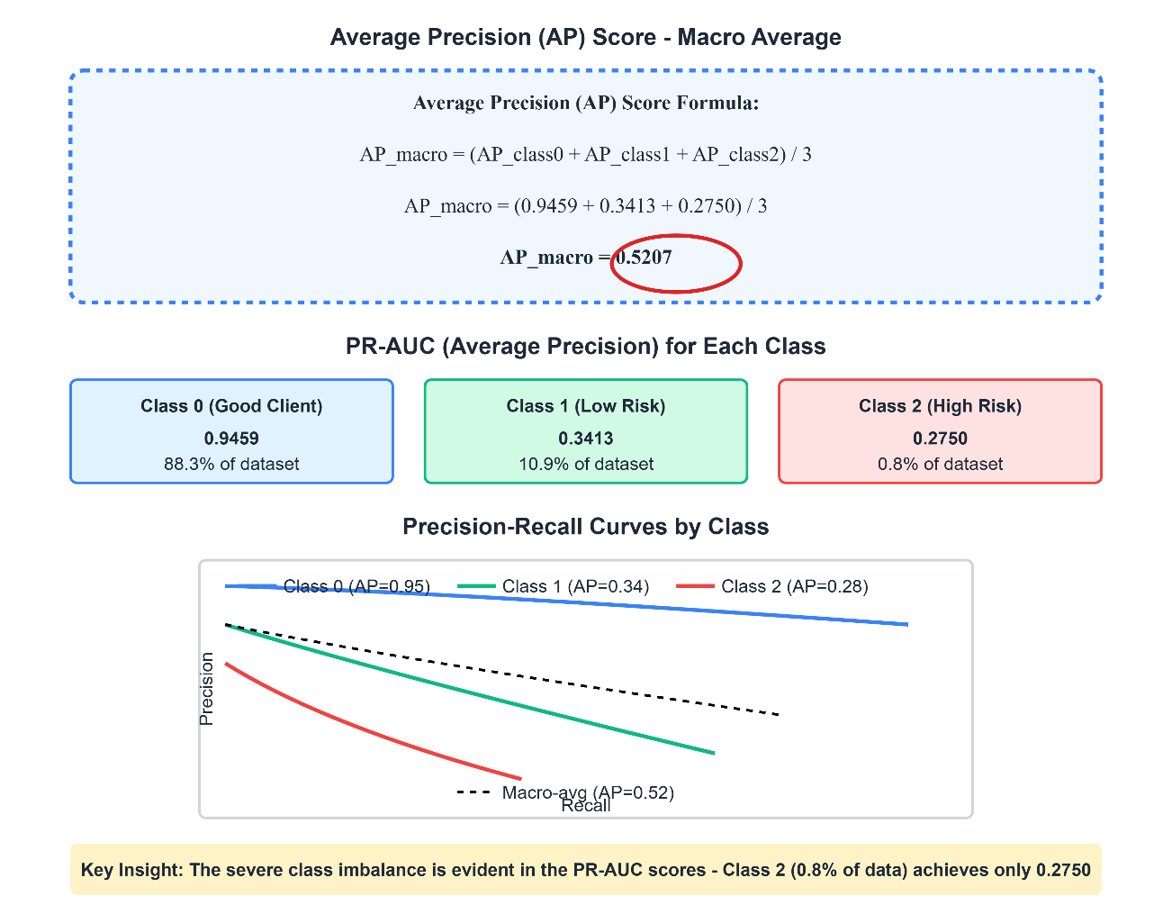
- Average Precision (AP Score): Used in both macro form and per-class analysis, particularly important to measure how well the model ranks the minority class.
Figure 3 Average Precision Score Calculation and PR-AUC Performance by Class for Random Forest Model

- AUC-ROC (One-vs-Rest): Selected to evaluate the model's ability to distinguish between classes. Measures the area under the ROC curve in multiclass provides nuanced insights for imbalanced classification.
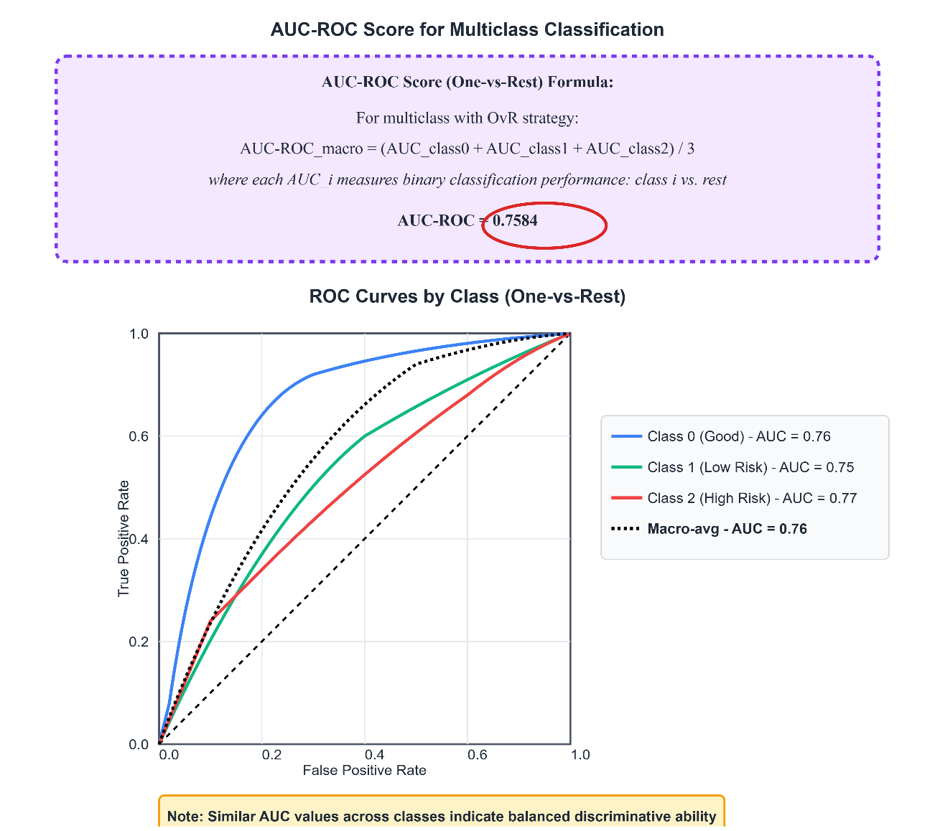
Figure 4 AUC-ROC Analysis - Multiclass One-vs-Rest Performance for RF

- Precision and Recall (Class 2): These were monitored closely during tuning and post-hoc calibration. High recall for Class 2 was prioritized due to the high cost of false negatives in identifying high-risk clients.
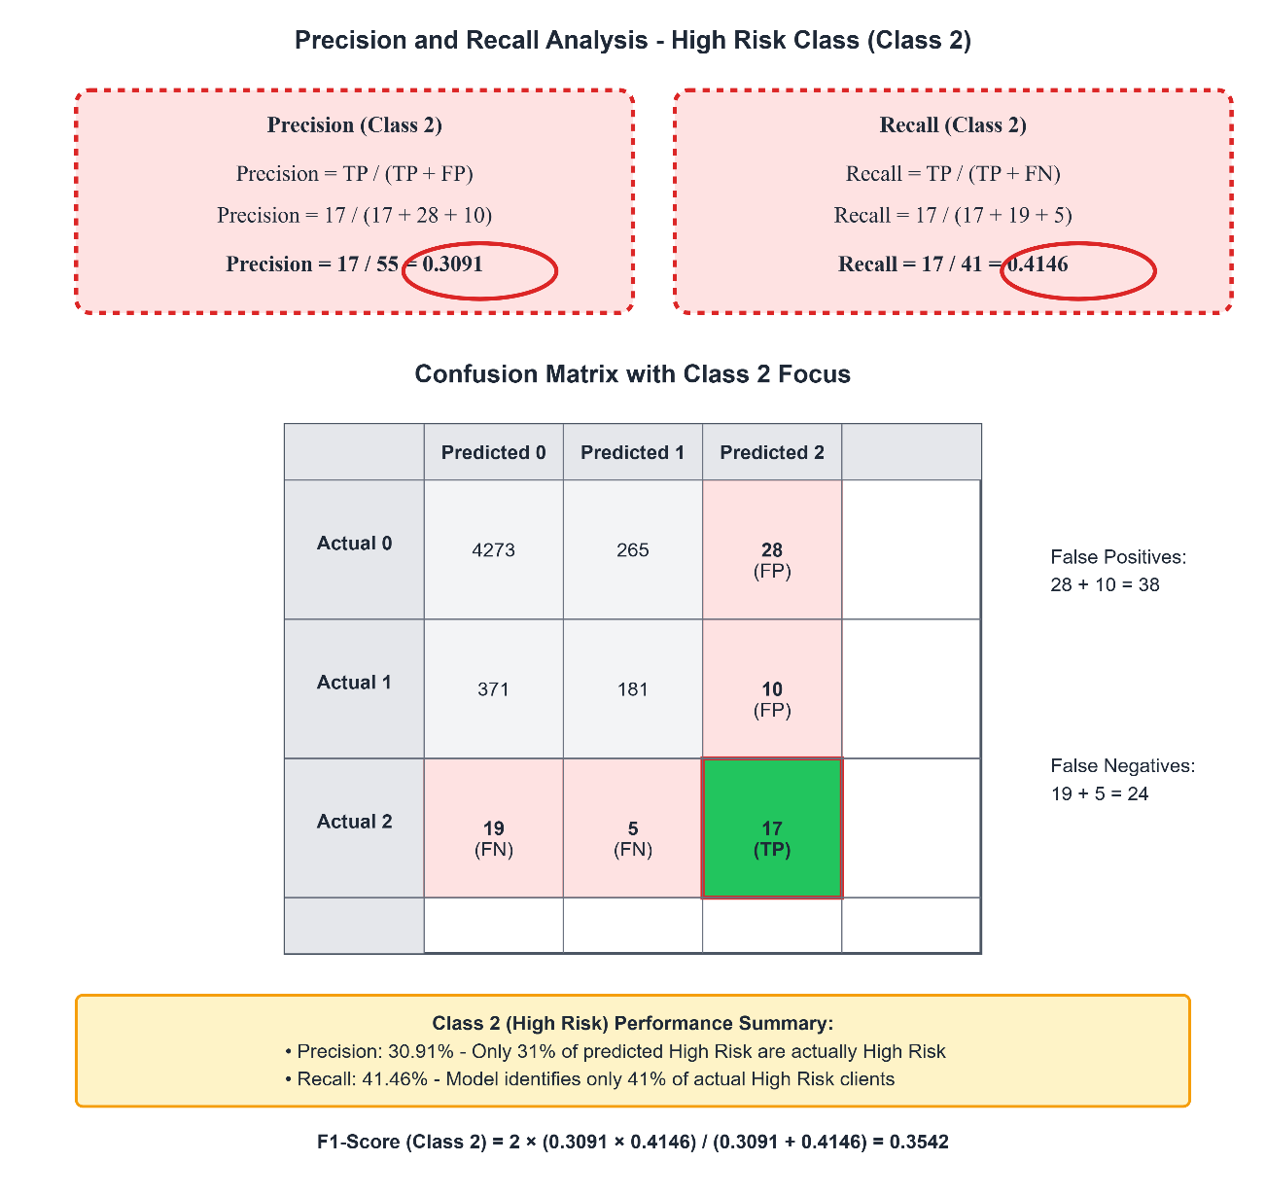
Figure 5 Precision-Recall Analysis for High Risk Class Detection for RF

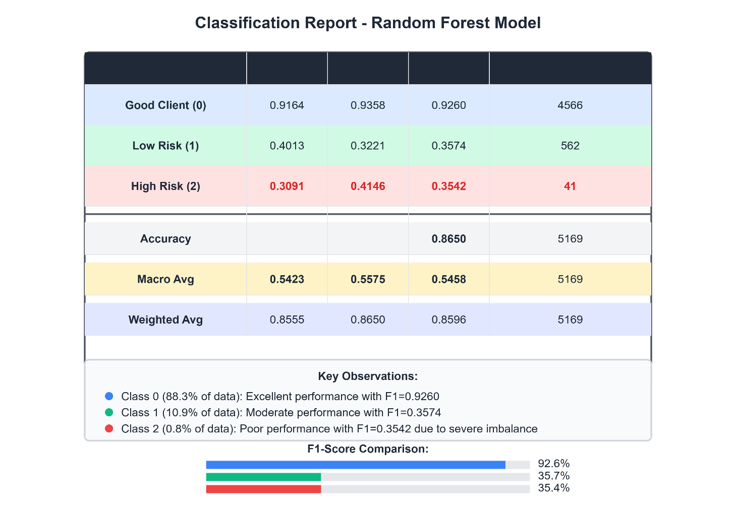
- Classification Reports: Used to evaluate precision, recall, and F1-score across all classes, helping in comprehensive model comparison.
Figure 6 Comprehensive Classification Report with Performance Metrics for RF

Accuracy was deliberately not used as a primary evaluation metric, as it can be highly misleading in imbalanced classification scenarios. For example, predicting only the majority class would yield ~87% accuracy without identifying any high-risk individuals. Metrics like F1 Macro and AP Score are widely recommended in such contexts (Saito & Rehmsmeier, 2015).

Interpretation and Fairness Tools
Beyond performance, model interpretability was addressed using:
- SHAP (SHapley Additive exPlanations): Employed to understand feature contributions on both global and local levels. SHAP values provided transparency, helping verify that models relied on meaningful attributes rather than proxies or bias-laden features.
- IBM AI Fairness 360 (AIF360): Used to audit fairness across sensitive attributes (e.g., Gender, Age, Education), enabling assessment of disparate impact, statistical parity, and equal opportunity metrics. This aligned the evaluation with ethical and regulatory standards.

Visualizations and Reporting
Evaluation results were communicated via:
- ROC Curves (per-class)
- Precision-Recall Curves (macro and per-class)
- Confusion Matrix
- SHAP summary plots and force plots
- SHAP + Fairness metrics dashboards using Streamlit Cloud
These were crucial for decision-makers and stakeholders to interpret the behavior of the final model.
While this chapter demonstrates a rigorous, best-practice methodology for developing a fair and interpretable multiclass credit risk classifier, it is essential to move beyond a descriptive presentation of results and critically interpret their implications. The integration of SHAP and AIF360 enabled not only technical performance but also transparency and fairness, directly aligning with the project’s aims and contemporary requirements in financial modeling. However, a closer examination reveals important methodological limitations and suggests clear paths for further enhancement.
The experimental approach showed notable strengths, particularly in the systematic treatment of class imbalance through layered strategies combining SMOTE/ADASYN, cost-sensitive learning, and threshold tuning each empirically grounded in recent literature. The comparative evaluation of diverse models, including advanced ensembles, and the deliberate focus on macro-averaged metrics (F1 and AP) instead of overall accuracy, ensured a robust and relevant assessment of performance in the presence of severe class imbalance. Nevertheless, interpretability and generalizability remain constrained by factors such as the risk of noisy synthetic instances from oversampling, subjective cost-sensitive weight choices, and the potential for overfitting or reduced clarity due to complex feature engineering and threshold calibration. The use of SHAP, while powerful, is computationally demanding and can be ambiguous with highly correlated features; alternative or complementary tools (such as LIME, Anchors, or Fairlearn) could address some of these challenges.
To improve future work, actionable recommendations include the adoption of model calibration techniques for more reliable probability estimates, broader fairness mitigation strategies (e.g., adversarial debiasing, reweighting), and the exploration of dimensionality reduction or automated feature selection to address feature redundancy. It is also important to acknowledge the need for inferential statistics, such as cross-tabulation or correlation analysis between key demographic and behavioral variables, to further contextualize results and guide interpretation beyond simple charting. Limitations in the current approach such as the reliance on a single dataset, possible sample bias, and the technical assumptions underlying each preprocessing and modeling step should be recognized. Ultimately, the project underscores the importance of combining technical rigor with interpretability, fairness, and continuous critical reflection, providing a robust platform for future advances in responsible credit risk modeling.

Chapter 4 – Implementation

4.1 Data Preprocessing

Data preprocessing is a critical stage in the machine learning pipeline, particularly for credit risk classification tasks involving the (Kaggle, 2020) "Credit Card Approval Prediction" datase. involving real-world financial datasets that often contain inconsistencies, missing values, and diverse variable types. The primary goal of this step was to prepare the raw dataset for robust and reproducible training and inference by transforming it into a clean, numerical, and appropriately scaled format.
The process was implemented in Python, using reproducible pipelines to ensure that the same transformations are applied to both training and new input data. All transformations were encapsulated using Pipeline and ImbPipeline constructs from scikit-learn and imbalanced-learn, with strict separation between train and test data to avoid leakage.
Special attention was given to handling missing values, encoding categorical variables, scaling numerical features, managing outliers, and selecting relevant features. Statistical tests (e.g., ANOVA, Chi-squared) guided feature selection, while robust techniques (e.g., IQR filtering, one-hot encoding, median imputation) were chosen for their suitability in noisy, imbalanced data environments.
The following subsections describe each transformation component, accompanied by code snippets and outputs, with justifications and references from the academic literature.

4.1.1 Handling Special Cases and Creating Employment Features

In the application_record.csv dataset, the column DAYS_EMPLOYED records the number of days a person has been employed, usually as a negative value (e.g., -1000 implies 1000 days of employment). However, a distinct value 365243 was observed, which falls far outside the normal range. This outlier does not indicate 1000 years of employment, rather, it is a sentinel placeholder commonly used to represent individuals
without formal employment (e.g., homemakers, retirees, unemployed). This number is approximately:
365.25 days/year × 1000 years ≈ 365250 -- > represented in the dataset as 365243.
Leaving this unprocessed would distort downstream processing, including summary statistics, boxplots, outlier detection (IQR), and scaling. Moreover, it could introduce bias into models by treating unemployment as extreme experience.
To address this:
- Replaced the 365243 placeholder in Is_Unemployed with NaN so it can be properly handled during feature engineering and preprocessing (imputation, scaling).
- A new binary variable Is_Unemployed was introduced to explicitly indicate clients lacking formal employment, 0 (Employed) / 1 (Unemployed).
- Both DAYS_EMPLOYED and DAYS_BIRTH were converted to Employment_Duration and Age respectively, expressed in human-readable years and now are positive values.
This strategy improves interpretability, preserves valuable information about employment status, and enables more equitable modeling. For instance, unemployed clients showed slightly different risk profiles.
Although the differences are subtle, they suggest that Is_Unemployed may capture mild variations in risk behaviour, justifying its retention in the feature set. This aligns with best practices in feature engineering and fairness-aware modeling (Chouldechova & Roth, 2020).
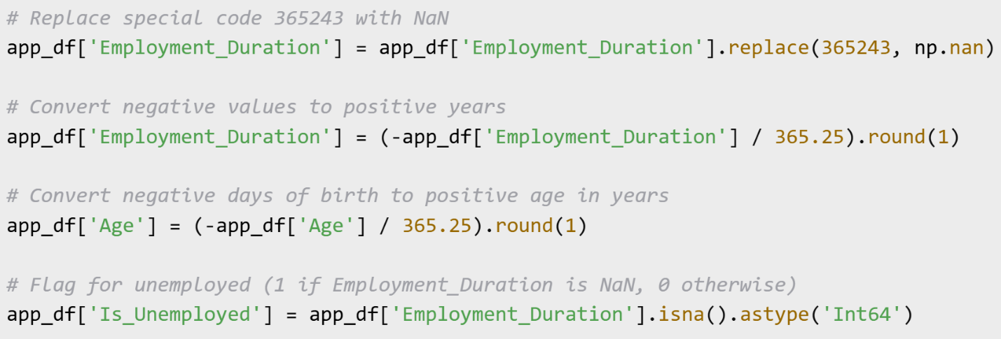
Code Screenshot 2 Handling Special Cases and Creating Employment Features

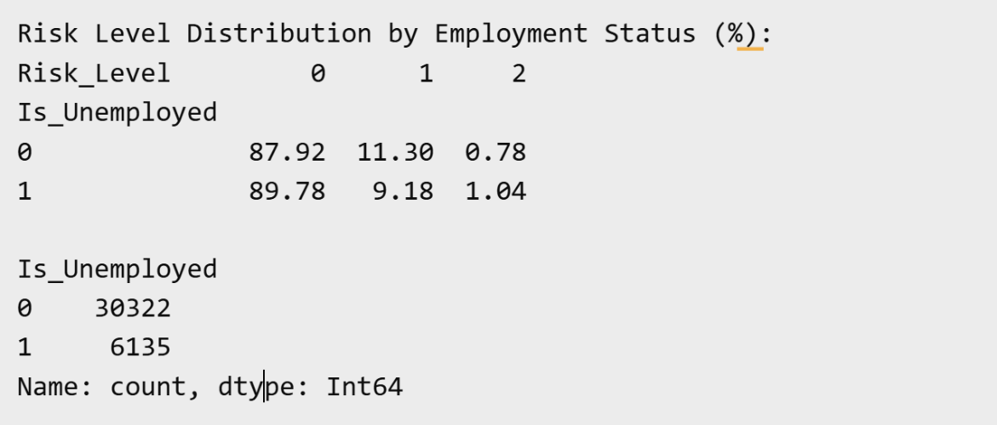
Figure 7 Output of Handling Creating Employment

4.1.2 Exploratory Data Analysis (EDA)

This section summarizes the distribution and characteristics of variables in the credit risk classification dataset after initial preprocessing. It includes analysis of missing values, distributional insights on numerical and categorical features, plots and interpretation and the imbalance in the target variable.
Data Types and Missing Values
- There are 36,457 records and 21 features.
- Most features are complete, except Occupation, which has around 30.6% missing values. This will be handled before modeling.
- `info()` showed that data types are a mix of:
    - `object` (categorical like gender, education), 8 columns
    - `int64` with 9 columns and `float64` with 4 columns (numerical like income or birth days).
Employment_Duration After replacing the special code 365243 with NaN, 16.83% of clients have missing Employment_Duration (typically indicating they have never been employed or are retirees). This percentage represents missing values, not outliers.
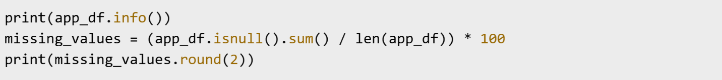
Code Screenshot 3 Check dataframe for missing values by percentage (%)

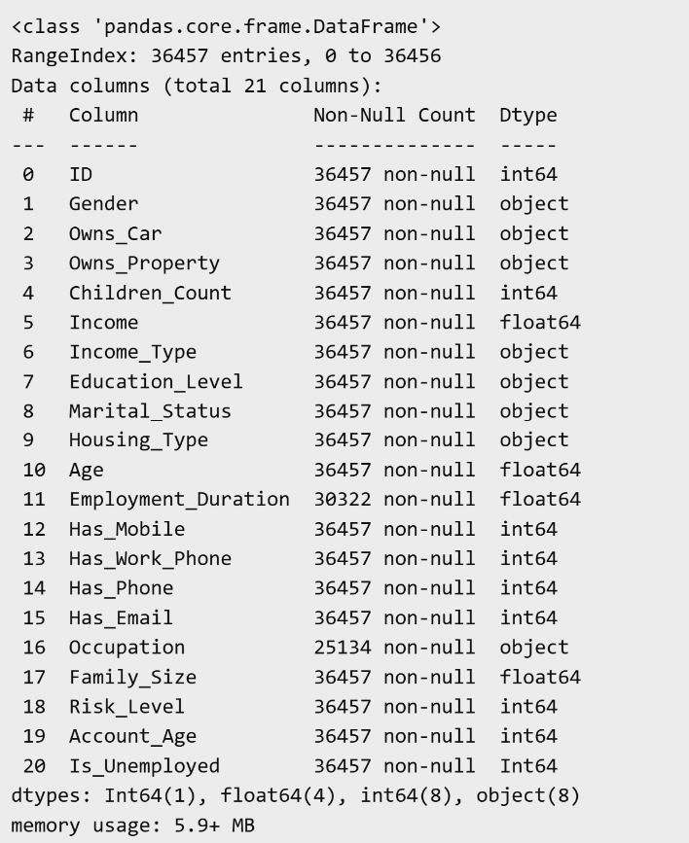 | 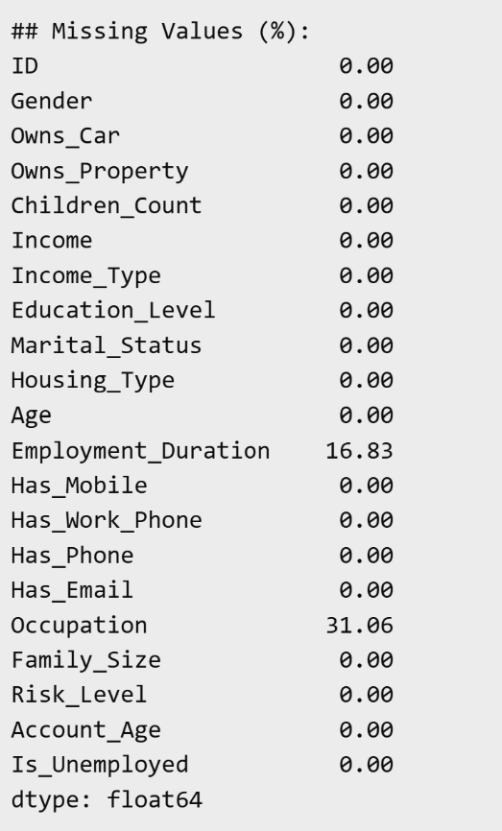
Figure 8 Missing Values Figure 9 Data types
Numerical Feature Distributions
Explored through histograms, boxplots, and summary statistics.
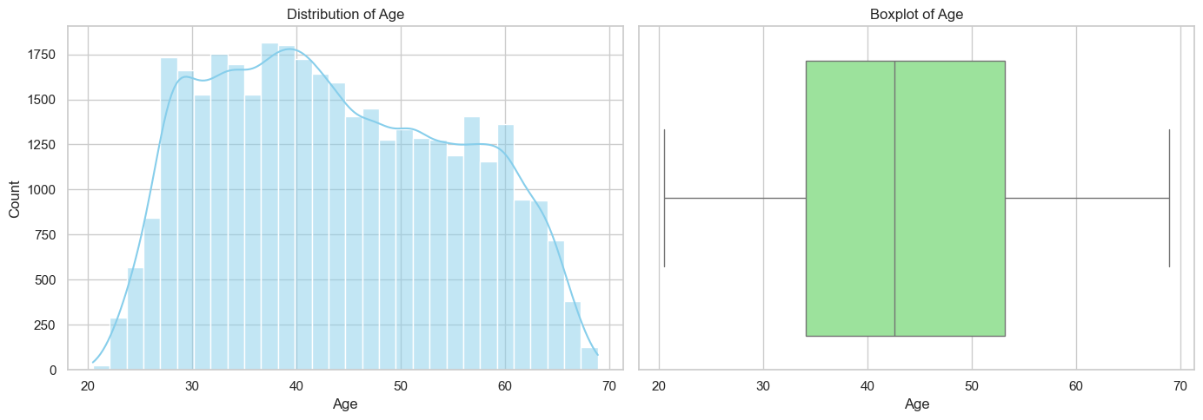
- Age Clients are primarily aged 35–55, with the full range spanning from 20.5 to 68.9 years. The distribution is slightly right-skewed, and most clients fall within the economically active adult bracket, making the data suitable for credit risk modeling.
Figure 10 Age Boxplot and Distribution
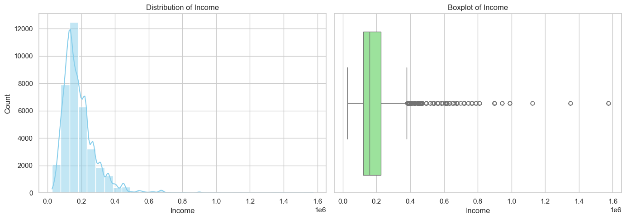
- Income Clients earn between 27,000 and 1.575 million, with a mean income of approximately 186,687. The distribution is highly skewed to the right, indicating a small number of high-income individuals. These outliers will be managed in later stages.
Figure 11 Income Boxplot and Distribution
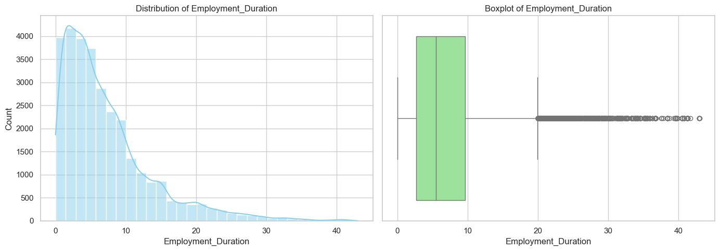
- Employment_Duration Clients show diverse employment histories. The mean duration is ~7.2 years, with most employed between 3 to 10 years. A maximum value of 43 years indicates long-term employment, while missing values (16.83%) reflect inactive individuals (Unemployed). Placeholder value 365243 was handled separately to avoid skew.
Figure 12 Employment Duration Boxplot and Distribution
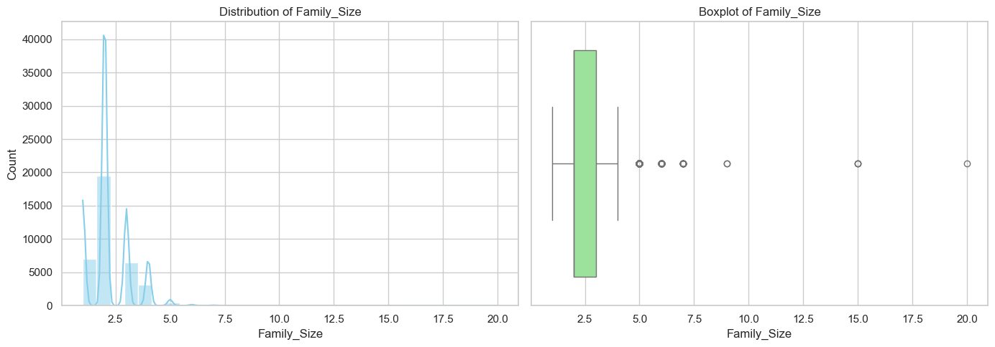
- The Family_Size variable offers insights into household responsibilities. Values range from 1 to 20, with a mean of 2.20 and a median of 2.0. The majority of clients have family sizes between 2 and 3. The maximum of 20 may indicate extended families or data entry anomalies, but these were retained. Family size may influence disposable income, living costs, and financial obligations, making it a potentially useful variable in risk modeling.
Figure 13 Family Size Boxplot and Distribution
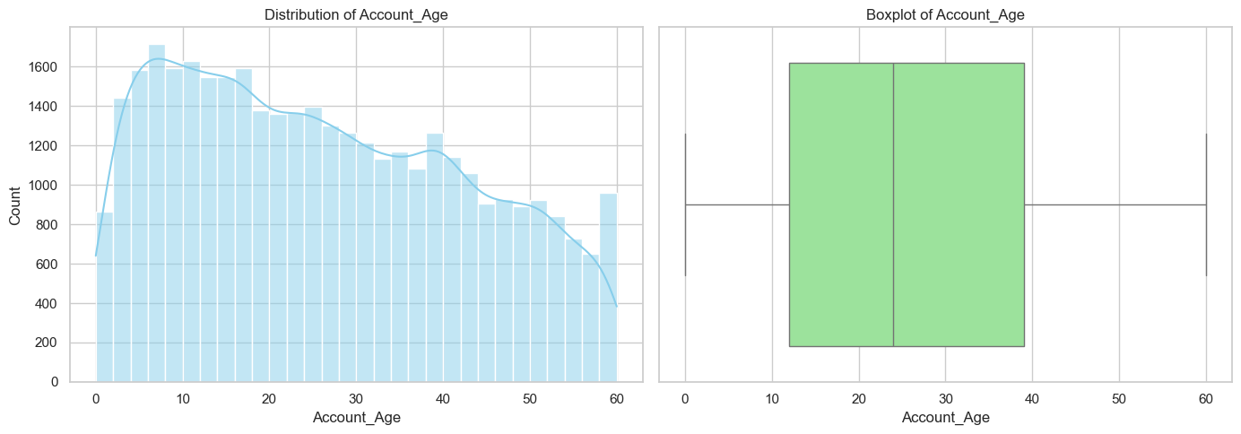
- The Account_Age variable represents the length of credit account history in months. Values span from 0 to 60 months. The mean is approximately 26.16 months, with a median of 24 months. The interquartile range (IQR) lies between 12 and 39 months. This distribution reflects a relatively recent credit history for many clients, which is consistent with financial reporting policies that mandate a retention period of five years. A longer account age may correlate with credit stability, making this a valuable predictive feature.
Figure 14 Account Age Boxplot and Distribution
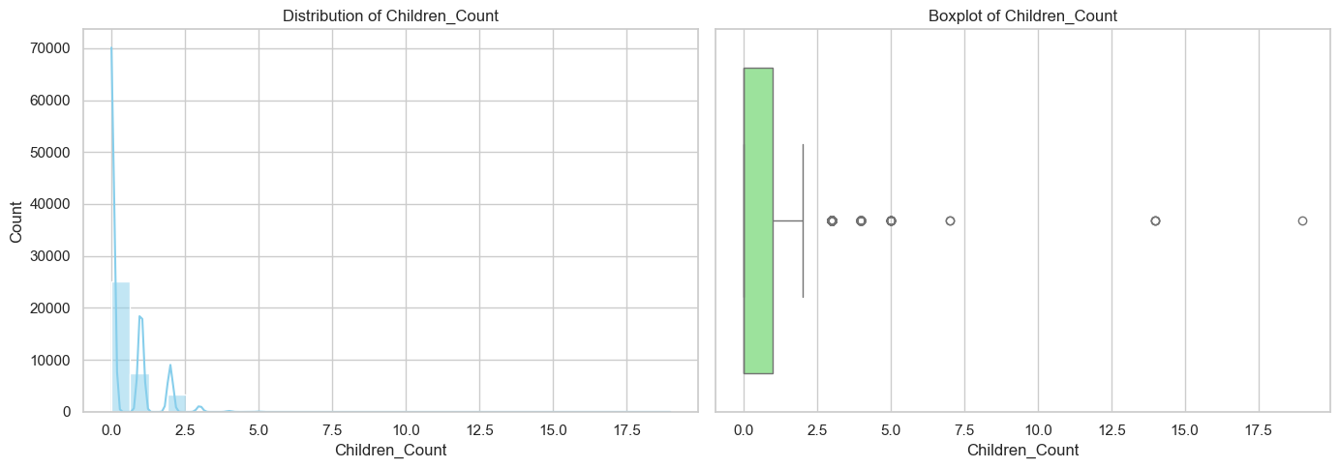
- The Children_Count variable reflects the number of dependent children. Most clients have no children, with 50% of values equal to 0. The average is 0.43, and the majority fall between 0 and 1. A few outliers have values up to 19, which may represent anomalies or extended households. While most clients appear child-free, this variable still contributes to understanding financial obligations and may interact with income or household size in risk assessments.
Figure 15 Children Count Boxplot and distribution
Categorical Feature Distributions
Explored through countplot, pie chart, and summary statistics.

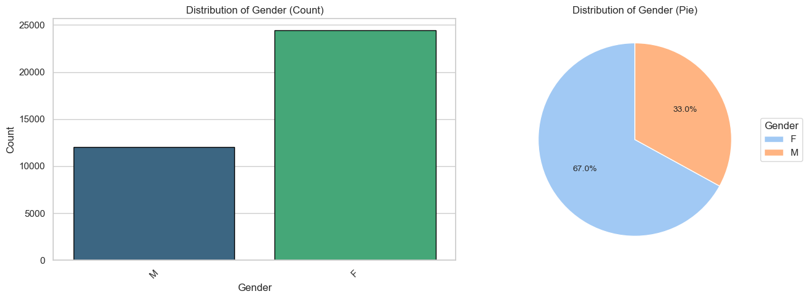
- Gender The dataset shows a skew towards female clients. 67.01% of clients are female, while 32.99% are male. This gender imbalance could reflect societal trends or data collection practices, such as higher female application rates or participation in formal credit programs. Depending on downstream fairness analysis, gender might be monitored for potential bias propagation.
Figure 16 Gender Plot and Pie Chart
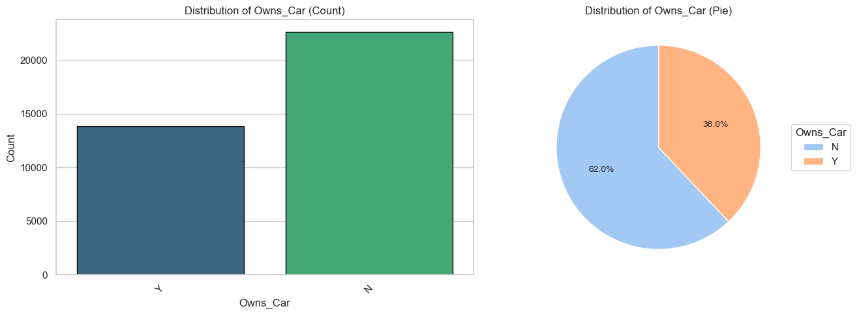
- Owns_Car Regarding car ownership. 62.03% of clients do not own a car. 37.97% of clients own a car. This may reflect income or urban residence patterns. Car ownership could be associated with financial obligations such as insurance or loan payments and may therefore contribute to understanding credit behavior.
Figure 17 Own Car Plot and Pie Chart
- The majority of clients report Owns_Property 67.22% of clients are homeowners and 32.78% of clients do not own property. This feature may act as a proxy for financial stability, as homeownership often correlates with long-term economic investment, wealth accumulation, and creditworthiness. However, it may also reflect demographic trends or regional housing policies.
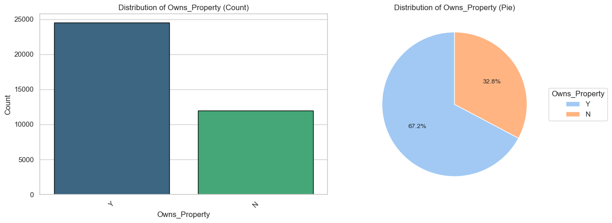
Figure 18 Own Property Plot and Pie Chart

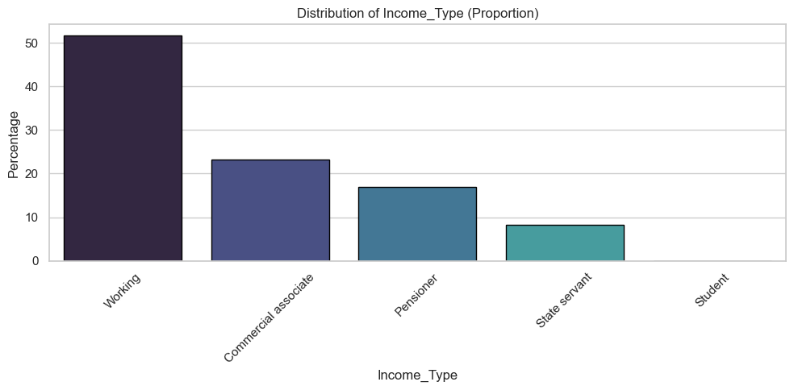
- Income_Type Most clients are working professionals. 51.62% are categorized as Working. 23.29% are Commercial associates. 16.87% are Pensioners. 8.19% are State servants and a small fraction (0.03%) are Students. These categories provide insight into job stability and earning potential, which are strong indicators of credit risk. Employment type may also reflect access to benefits, retirement income, or job turnover risk.
Figure 19 Income Type Distribution by proportion
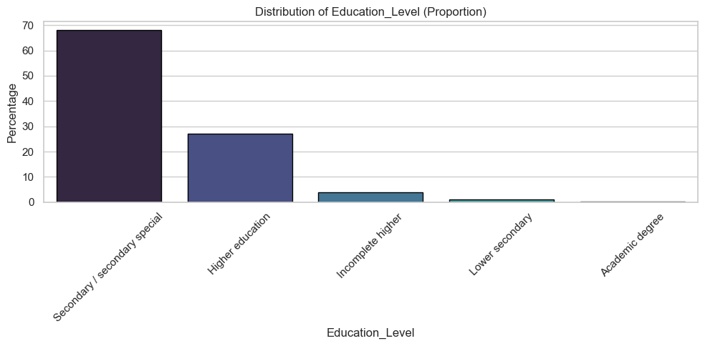
- Education_Level are relatively high. 67.96% have Secondary or equivalent education. 27.06% hold Higher education degrees and a groups include Incomplete higher (3.87%), Lower secondary (1.03%), and Academic degree holders (0.09%). Higher education is often correlated with better financial literacy and job opportunities, which can affect repayment behavior and risk category.
Figure 20 Education Level Distribution by proportion
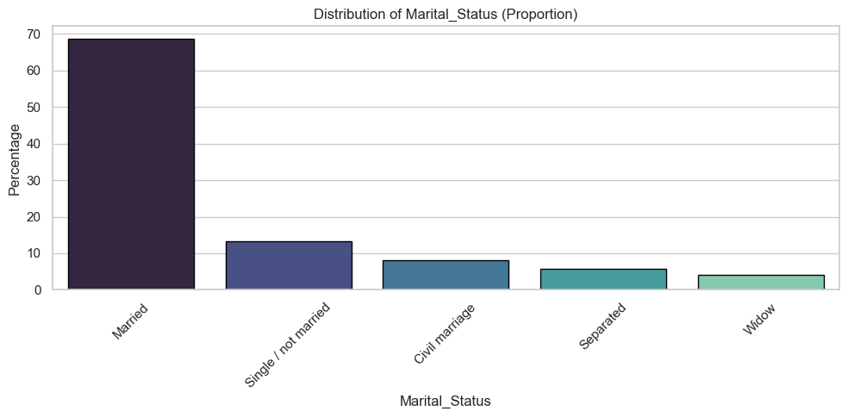
- Marital_Status Most clients are in formal partnerships. 68.71% are Married and 13.25% are Single / not married. Other categories include Civil marriage (8.08%), Separated (5.77%), and Widow (4.20%). Marital status may influence financial obligations, dual-income potential, and stability, which are relevant to creditworthiness.
Figure 21 Marital status Distribution by proportion
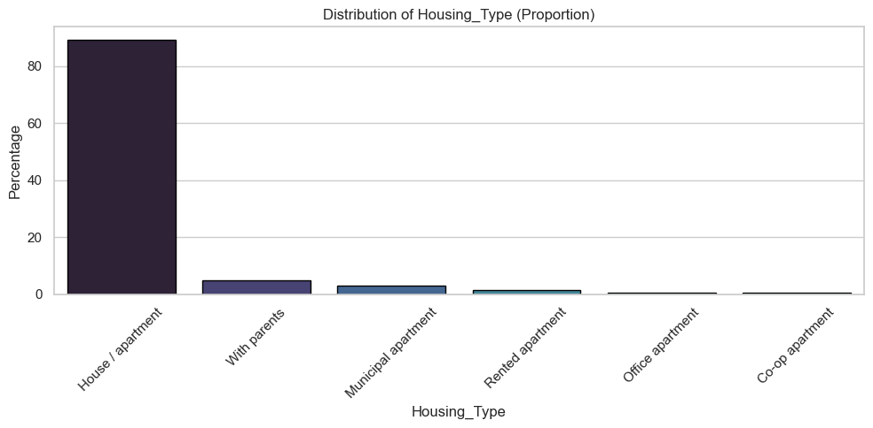
- Housing_Type The vast majority of clients live in stable housing situations. 89.28% live in a House or apartment and others live With parents (4.87%), in Municipal apartments (3.09%), or Rented spaces (1.58%). Uncommon housing types such as Office or Co-op apartments make up less than 1.5%. Housing type may indicate financial independence or urban vs. rural location.
Figure 22 Housing Type Distribution by proportion
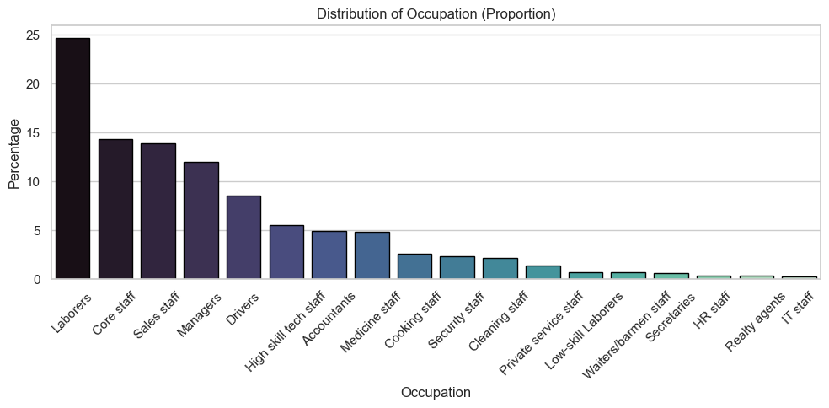
- Occupation A diverse range of job types is present. Laborers (24.71%), Core staff (14.29%), Sales staff (13.87%), and Managers (11.98%) dominate. Technical and white-collar roles such as High skill tech staff, Accountants, and Medicine staff follow. Some rare categories include IT staff (0.24%), Realty agents, and HR staff. This diversity supports broader generalization across socioeconomic strata. However, 31% of values were initially missing and were imputed as "Unknown" during preprocessing.
Figure 23 Occupation by proportion

- Risk_Level (Target Variable) The distribution of the target variable is highly imbalanced. 88.23% of clients are labeled Good Client (0). 10.94% are Low Risk (1) and only 0.83% are considered High Risk (2). This imbalance necessitated special handling through resampling techniques such as SMOTE to ensure fair model learning and evaluation. Class imbalance also motivated the use of metrics like F1-score and AUC-ROC in performance assessment.

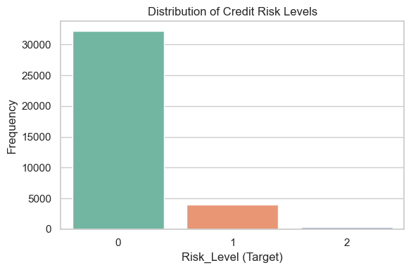
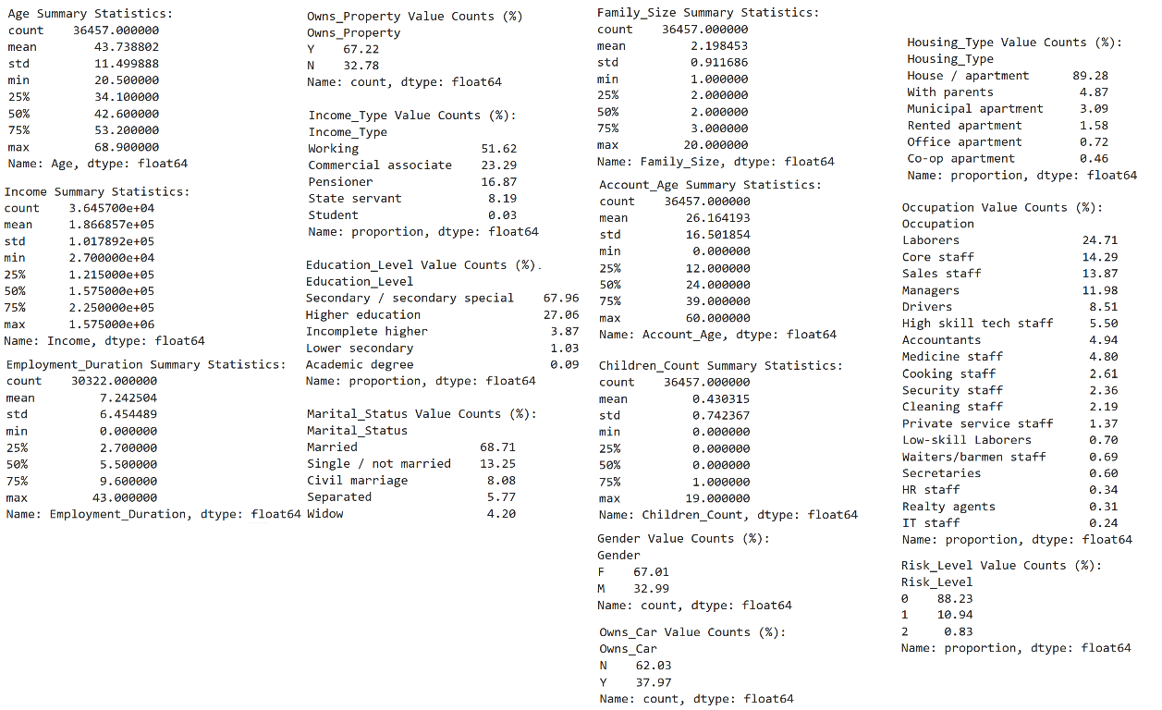
Figure 24 Risk level distribution by class
Figure 25 Statistical Summary for all features

Additional Cleaning Steps
To handle remaining issues:
- The Occupation column, with ~31% missing data, was imputed using a constant label 'Unknown', a strategy suitable for tree-based models (Brownlee, 2020).
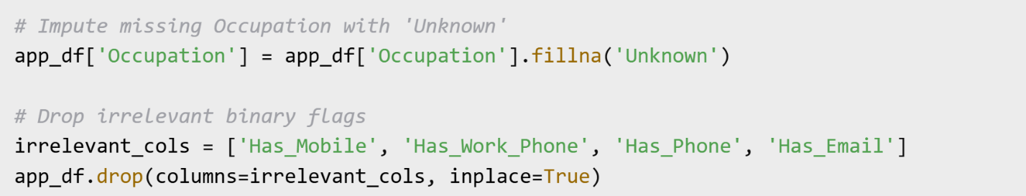
- Four binary columns (Has_Mobile, Has_Work_Phone, Has_Phone, Has_Email) were removed due to limited variance or weak correlation with the target, improving parsimony.
Code Screenshot 4 Impute Missing and Drop irrelevant columns
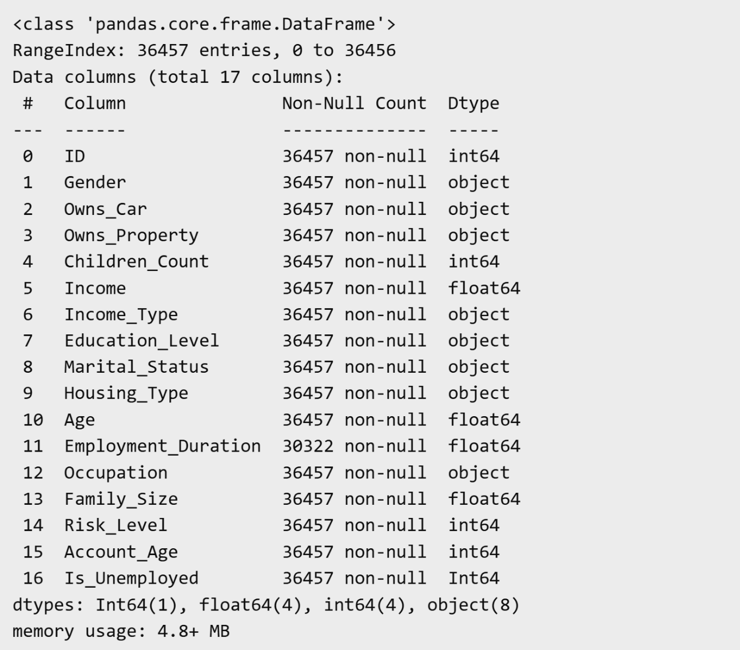
Figure 26 New Dataframe confirmation after missing and drop colums

4.1.3 Improving Data Quality: Outlier Removal, Statistical Tests, and Correlation Insights

- Outliers can severely distort the training process of machine learning models, especially in imbalanced and skewed datasets such as those used for credit risk classification. To mitigate their negative impact and improve model generalization, I applied the Interquartile Range (IQR) method, a widely accepted technique for robust outlier detection. The IQR method identifies outliers as values falling below the lower bound (Q1 − 1.5 × IQR) or above the upper bound (Q3 + 1.5 × IQR), where Q1 and Q3 are the 25th and 75th percentiles, respectively. This rule is particularly effective for non-Gaussian distributions and does not rely on assumptions of normality, making it for features like Income or Family_Size that tend to be right-skewed. (Brownlee, 2020).

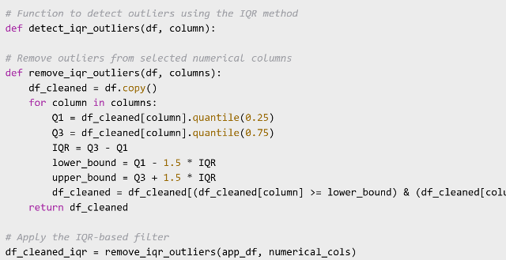 | 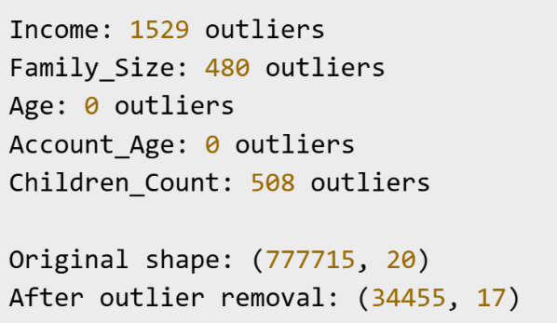
Code Screenshot 5 IQR-based cleaning logic Figure 27 IQR Output

This method was selectively applied to the features Income, Family_Size, Children_Count, Age, and Account_Age. It was not applied to Employment_Duration, as this column contains missing values that indicate a meaningful subpopulation of unemployed applicants. Removing such data could compromise both fairness and generalizability.

Table 4 IQR-method Interpretation and Results
Feature | Outliers Detected | Interpretation
Income | 1,529 | Mostly representing exceptionally high earners far beyond the 75th percentile.
Family_Size | 480 | Exceeded reasonable family sizes, likely due to data entry errors (e.g., 20 children).
Children_Count | 508 | Including implausibly high child counts
Age & Account_Age | 0 | No outliers were detected, suggesting well-bounded distributions.

The removal of extreme values resulted in a reduced and more robust dataset. Before IQR Cleaning 77,7715 rows and columns 20 and After IQR Cleaning 34,455 rows and 17 columns. The cleaning process led to the removal of approximately 55% of rows, indicating a high concentration of outliers in specific variables. Despite this, the retained dataset preserves a meaningful and diverse sample suitable for training. This strategic pruning improves statistical robustness, reduces the influence of noisy data, and enhances fairness by retaining essential segments (e.g., unemployed clients). These steps align with best practices in data cleaning for financial risk modeling and fairness-aware learning (Chouldechova & Roth, 2020)

- Chi-Squared Test. The Chi-Squared Test of Independence was applied to assess whether categorical features are statistically associated with the target variable Risk_Level. This test determines whether the observed distribution of risk classes varies significantly across the different categories of a given variable.This procedure serves multiple objectives: (i) identifying statistically informative features, (ii) reducing dimensionality by excluding non-significant predictors, and (iii) improving model transparency and fairness, especially for sensitive attributes such as gender and marital status (Kelleher, et al., 2020).
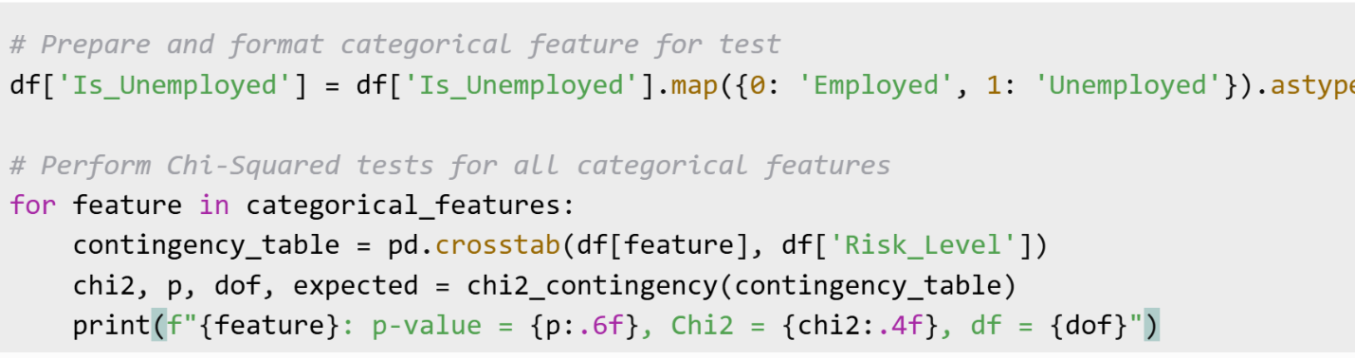
Nine categorical variables were tested: Gender, Owns_Car, Owns_Property, Income_Type, Education_Level, Marital_Status, Housing_Type, Occupation, and Is_Unemployed. Each feature was cross-tabulated with the three risk levels, and the Chi-Squared statistic, p-value, and degrees of freedom were computed.
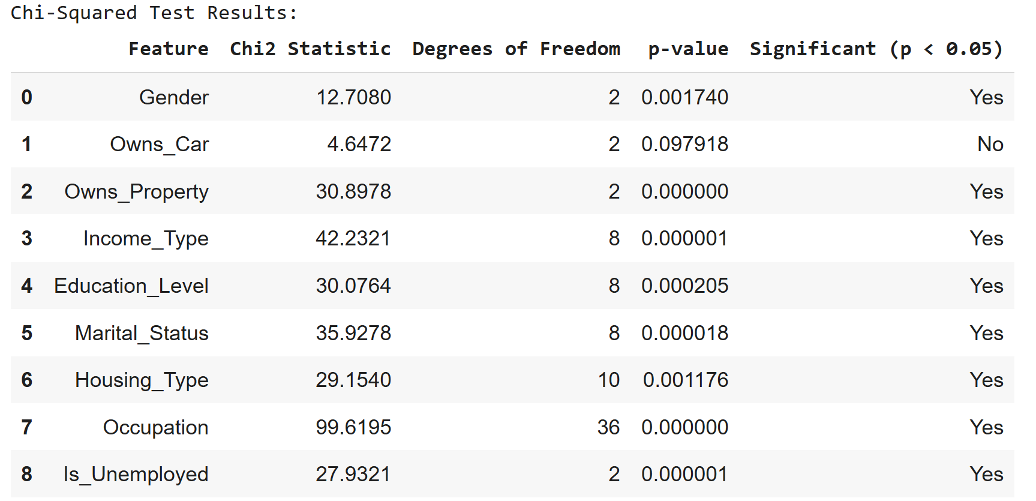
Code Screenshot 6 Chi-Squared snippet
Figure 28 Chi-Squared results

The results indicated that most categorical features were statistically associated with credit risk levels (p < 0.05). For instance, the Occupation variable remains strongly predictive (Chi2 = 99.6, p < 0.00001), while Owns_Car does not significantly impact risk prediction (p = 0.098). This evidence-based feature selection enhances both the accuracy and explainability of the final model. The updated status of Is_Unemployed as a statistically significant feature demonstrates the importance of accurate data cleaning.
- Statistical Differences in Numeric Features Using ANOVA (Analysis of Variance)
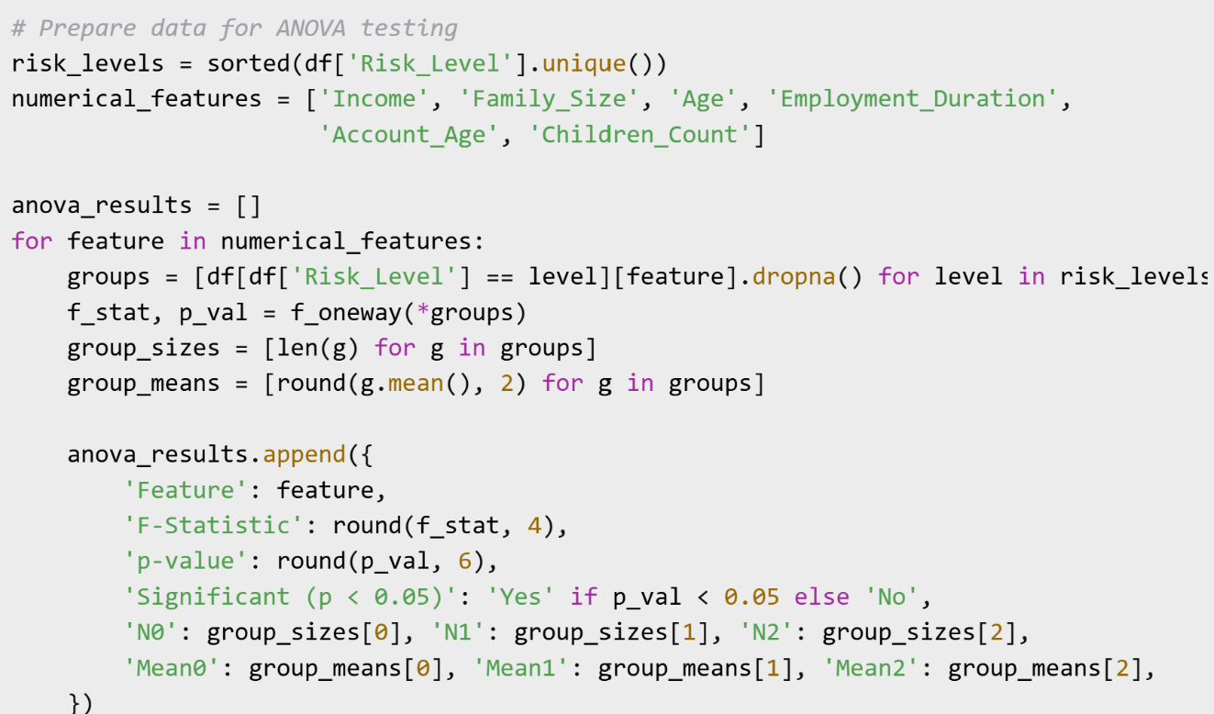
To assess the predictive potential of numerical features across credit risk categories (Class 0: Good Client, Class 1: Low Risk, Class 2: High Risk), a one-way Analysis of Variance (ANOVA) was conducted. This parametric test evaluates whether statistically significant differences exist in feature means between groups, helping identify variables that effectively discriminate between risk categories.
Code Screenshot 7 Anova testing
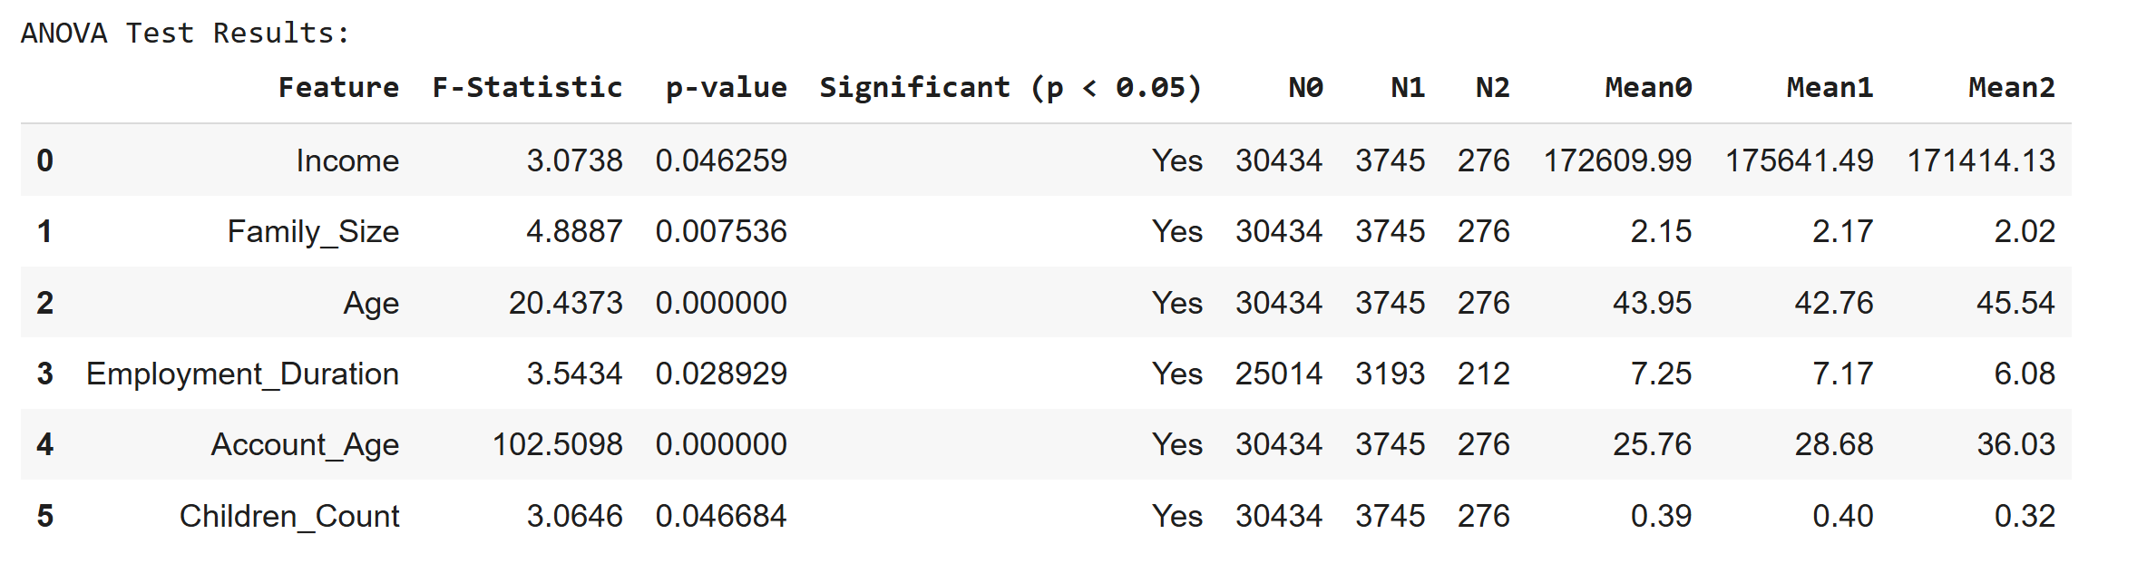
Figure 29 Anova test results

As shown in Figure 5.23 all numeric features are now statistically significant (p < 0.05), likely reflecting better class separation after data cleaning, outlier removal, and imbalanced handling. Age and Account_Age remain strong predictors: High-risk clients are typically older and have longer credit account histories. Employment_Duration: Statistically significant; high-risk clients have shorter employment histories on average. Income and Family_Size: Unlike previous results, these now show a statistically significant difference, though the practical difference (i.e., actual means) is small. This could be due to improved data quality, increased sample size after cleaning, or previously masked patterns. Children_Count: Now marginally significant; high-risk clients tend to have fewer children, but this effect is weak and should be interpreted with caution. Significant Feature Income. Means are similar (Good = 172,610; Low = 175,641; High = 171,414), but the F-test finds a statistically significant difference (p = 0.046). Interpretation: Although the difference is small, it's unlikely to be due to chance (Kuhn & Johnson, 2019)

- N0, N1, N2: The number of samples in each target class (Risk_Level) for which the mean is calculated. N0–N2 show how many clients contribute to the mean for each risk class. This helps if the groups are balanced or highly imbalanced (which affects how much can trust differences).

        - N0 = Number of “Good Client” (class 0) samples
        - N1 = Number of “Low Risk” (class 1) samples
        - N2 = Number of “High Risk” (class 2) samples

- Mean0, Mean1, Mean2: The mean value of the feature in each risk class. This help see whether a feature actually differs between classes and may be predictive.

- Mean0 = Mean value for class 0 (Good Client)
- Mean1 = Mean value for class 1 (Low Risk)
- Mean2 = Mean value for class 2 (High Risk)

- Correlation Matrix and Risk-Level Associations
To quantify the linear relationships between numeric variables and evaluate their association with credit risk, a correlation matrix was computed using Pearson’s correlation coefficient. This analysis helps identify potentially redundant features (multicollinearity) and understand the strength of relationship between input variables and the target class.

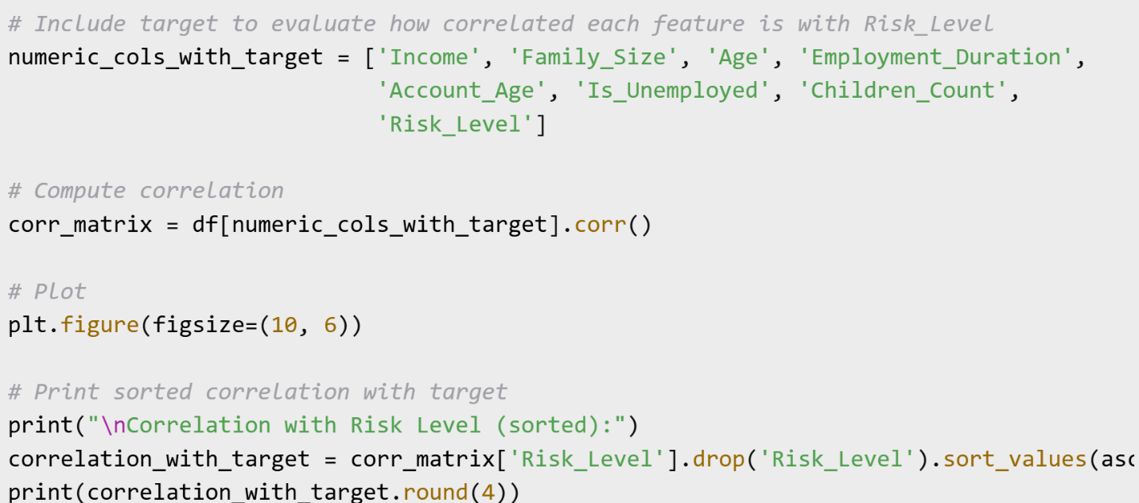
Code Screenshot 8 Correlation with target

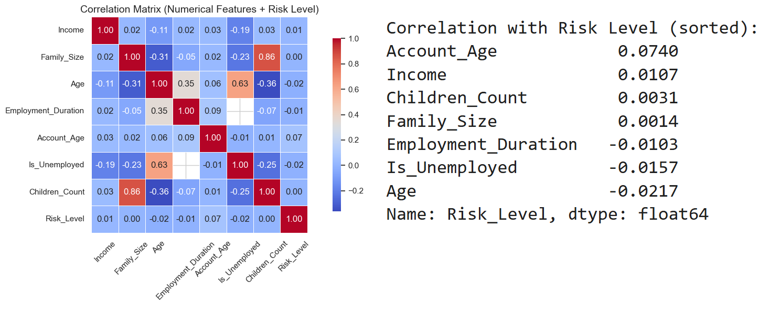
Figure 30 Correlation Matrix with target and sorted values

The correlation analysis revealed that most numerical features exhibited negligible linear relationships with credit risk (< 0.03), with Account_Age showing the strongest (albeit weak) positive association (0.07). This suggests that while no single variable demonstrates substantial predictive power independently, the weak correlation between longer account tenure and higher risk may reflect cumulative financial behaviors. Notably, the absence of strong multicollinearity (except between Family_Size and Children_Count, 0.86) supports including all features for subsequent non-linear modeling, where interaction effects and complex patterns may emerge despite weak individual correlations.

- Correlation Matrix Between Numerical Features
To detect multicollinearity and explore relationships between numeric features prior to modeling, a second correlation matrix was computed, excluding the target. This analysis provides insight into redundancy, potential feature engineering opportunities, and model-specific preprocessing.

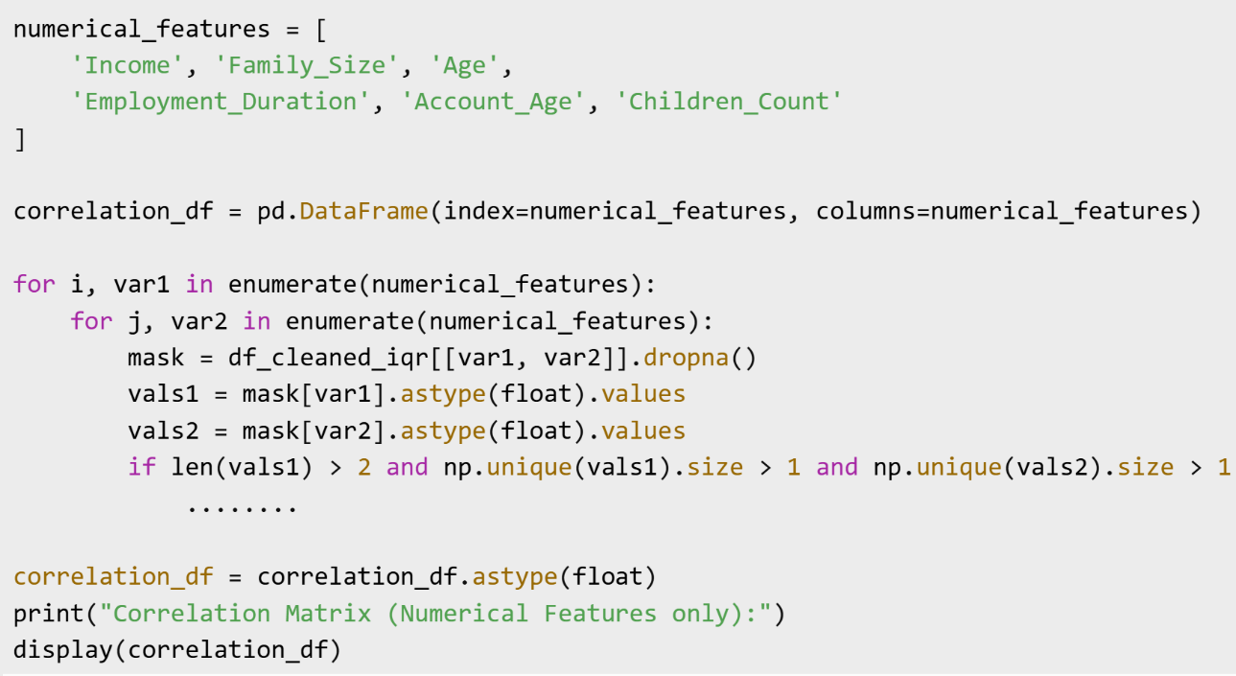
Code Screenshot 9 Correlation without target

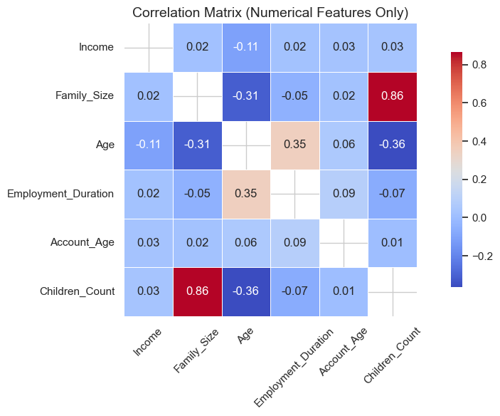
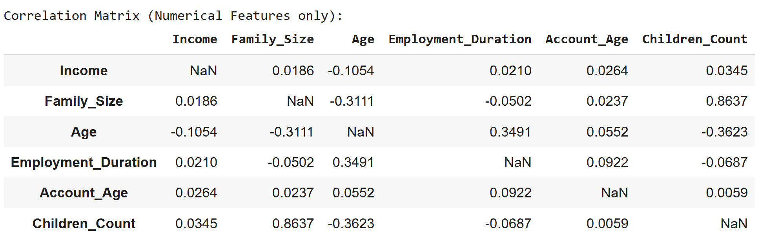

Figure 31 Correlation Matrix without target

Inferential Statistic: Association between Gender and Risk Level
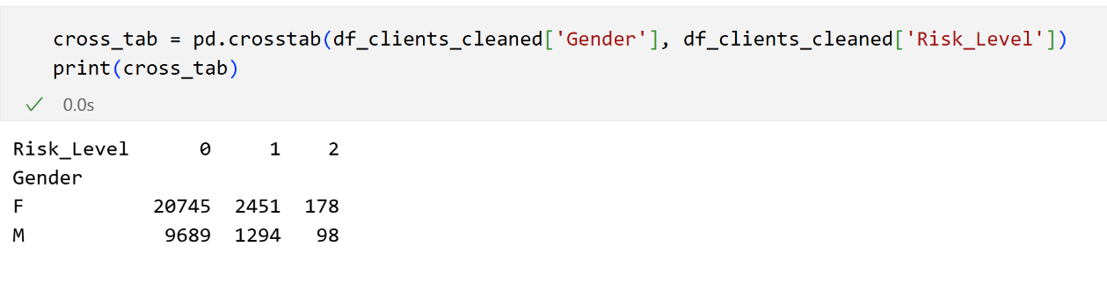
To examine the relationship between gender and credit risk classification, a chi-squared test of independence was performed using a cross-tabulation of Gender (0 = Female, 1 = Male) and Risk_Level (0 = Good, 1 = Low Risk, 2 = High Risk). The chi-squared statistic was 12.71 with a p-value of 0.0017.
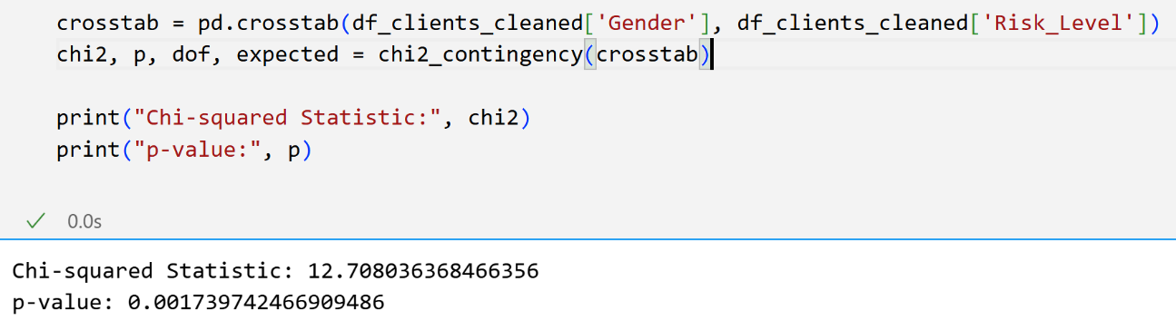
Since the p-value is less than 0.05, the result is statistically significant. This indicates that there is a significant association between gender and the assigned credit risk category in the dataset. In other words, the distribution of risk levels differs between males and females. This finding suggests that gender may have an influence either through data distribution or model behavior on credit risk classification, underlining the importance of the fairness analyses conducted later in the project.
Table Cross-tabulation of Gender and Risk Level
Gender | Good (0) | Low Risk (1) | High Risk (2)
Female | 20,745 | 2,451 | 178
Male | 9,689 | 1,294 | 98

The table provides the contingency counts used in the Chi-squared test of independence between Gender and Risk_Level. The Chi-squared result you reported (chi-squared = 12.71, p = 0.0017) indicates a statistically significant association between gender and credit risk level in your sample.

4.2 Feature Engineering

To enhance the model`s predictive power and enable it to capture complex, non-linear relationships, a comprehensive feature engineering strategy was implemented. This included domain-driven transformations and mathematical manipulations such as interactions, ratios, binning, and polynomial expansions.
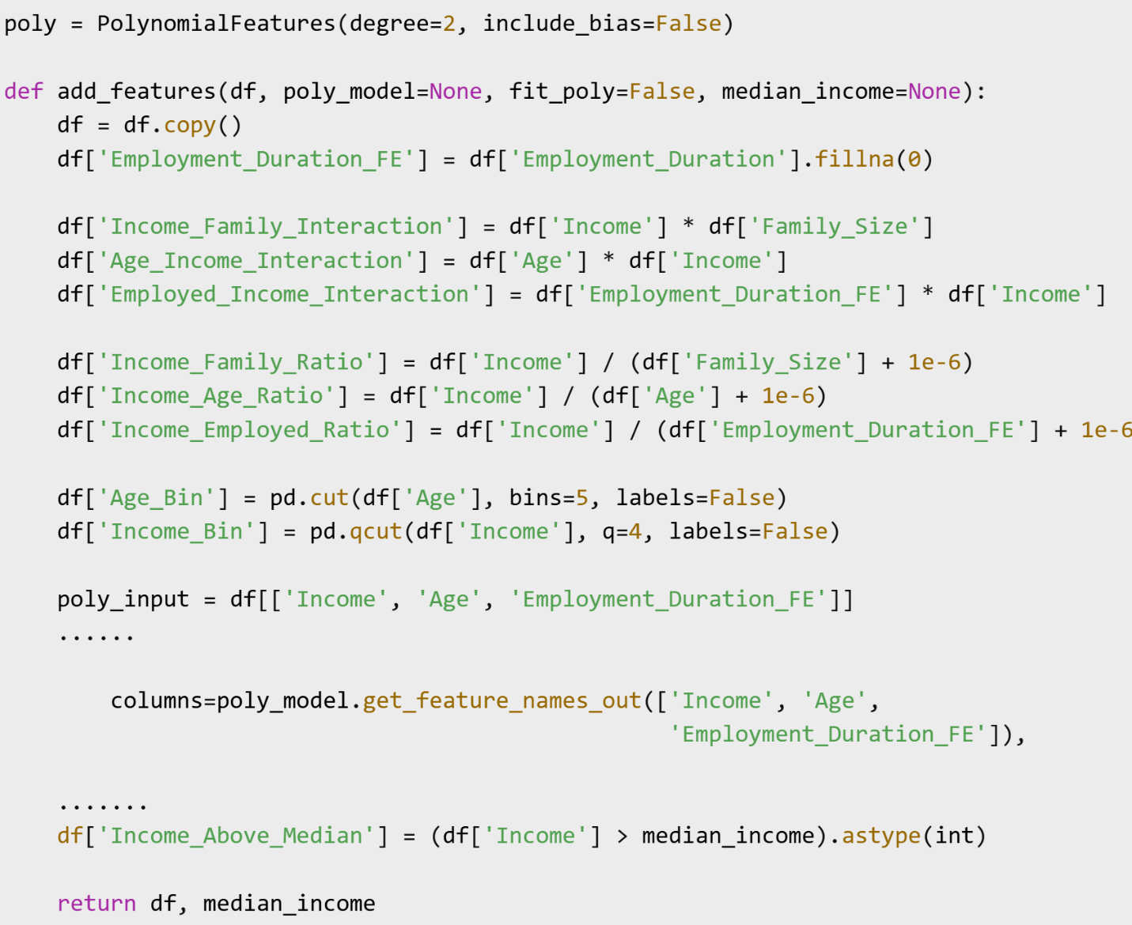
Code Screenshot 10 Feature Categories and Transformations

Feature Categories and Transformations

- Interaction Features – These capture the joint effect of two variables:
- Income_Family_Interaction: Income × Family_Size
- Age_Income_Interaction: Age × Income
- Employed_Income_Interaction: Employment_Duration × Income

- Ratio Features – These normalize features and provide proportion-based comparisons:
- Income_Family_Ratio: Income / Family_Size
- Income_Age_Ratio: Income / Age
- Income_Employed_Ratio: Income / Employment_Duration

- Binned Features – Convert continuous values into discrete bins:
- Age_Bin: Equal-width bins from Age
- Income_Bin: Quartile bins from Income

- Polynomial Features – Include squared terms and cross-product interactions:
- Income^2, Age^2, Employment_Duration^2
- Income × Age, Income × Employment_Duration, etc.
These were generated using PolynomialFeatures(degree=2) from scikit-learn.
- Domain-Specific Binary Feature:
- Income_Above_Median: Indicates whether a client’s income exceeds the training median. This is helpful for rule-based segmentation and interpretability.

Modular and Reproducible Implementation
A custom function, add_features(), was developed to apply all transformations consistently across training, validation, and test sets. It handled:
- Polynomial feature fitting with controlled leakage prevention
- Median income tracking for binary thresholding
- Internal handling of missing employment durations (Employment_Duration_FE)
This step was crucial for fair model training and evaluation, particularly for the minority High Risk class, which constituted less than 1% of all clients.
Feature engineering introduced explainable and machine-friendly variables that captured complex patterns while preserving the integrity of the original data. These engineered features laid the groundwork for improved model performance and fairness-aware analysis.

The exploratory data analysis (EDA) and feature engineering phases successfully exposed important patterns and relationships in the dataset. Statistical tests like ANOVA and Chi-squared confirmed the discriminative power of core features such as Account_Age, Age, and Employment_Duration. Correlation analysis revealed low multicollinearity, with one exception Children_Count and Family_Size which were treated accordingly. Outlier treatment using the IQR method and stratified sampling preserved data integrity while improving model readiness.
Feature engineering further improved the dataset by injecting meaningful, explainable features derived from domain logic (e.g., income ratios and interaction terms). All transformations were implemented modularly and reproducibly, with strict attention to avoiding data leakage. The combination of statistically grounded EDA and thoughtful feature construction provided a solid foundation for the downstream modeling phase.

4.3 Model Implementation

This section outlines the supervised learning models used to classify credit risk into three categories: Good Client (0), Low Risk (1), and High Risk (2). Multiple classification algorithms were trained and evaluated, with a strong emphasis on handling class imbalance and ensuring fair comparisons across models.

Data Splitting and Feature Transformation

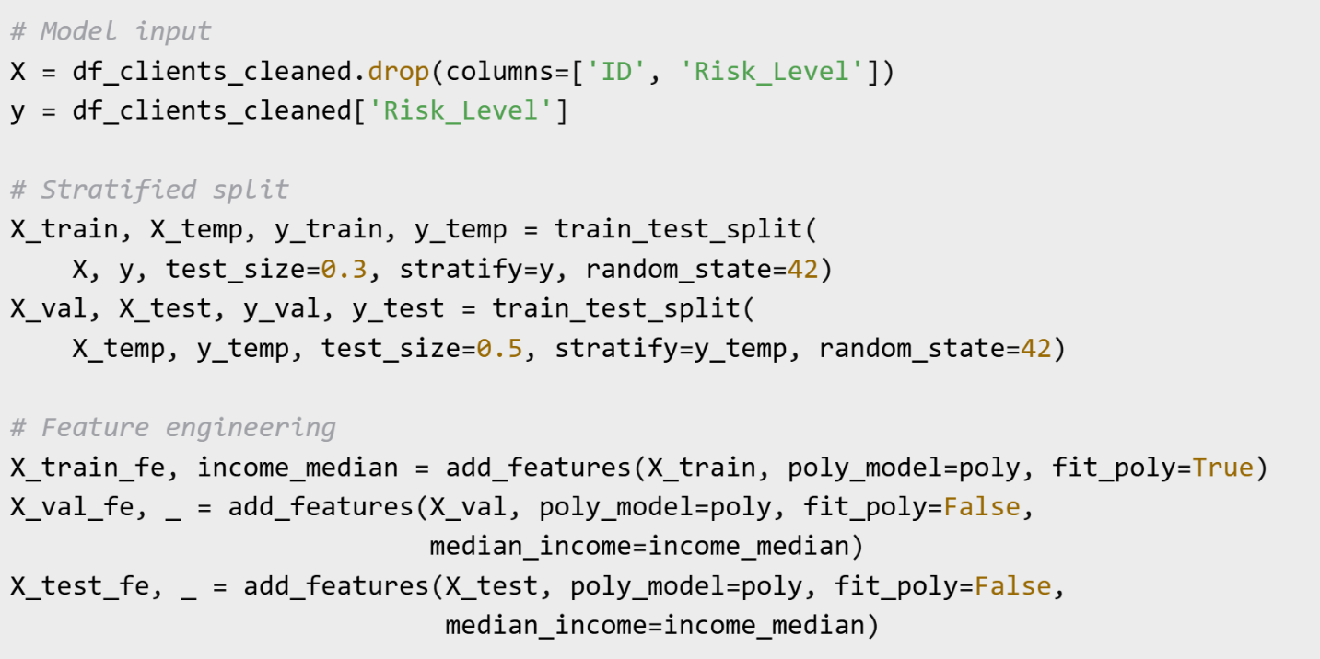
The modeling pipeline begins with isolating features and target labels from the cleaned dataset, followed by stratified splitting into train, validation, and test sets. To prevent information leakage, feature engineering is applied independently on each split.
Code Screenshot 11 Model Data splitting

The Risk_Level target variable is isolated, and the dataset is split 70/30 with class proportions preserved. Feature engineering is applied via the reusable add_features() function, ensuring consistency across sets. income_median is derived from training data only, ensuring no leakage during the binary Income_Above_Median creation. This ensures the input to every classifier is representative of a realistic, unseen test scenario.

Encoding and Scaling

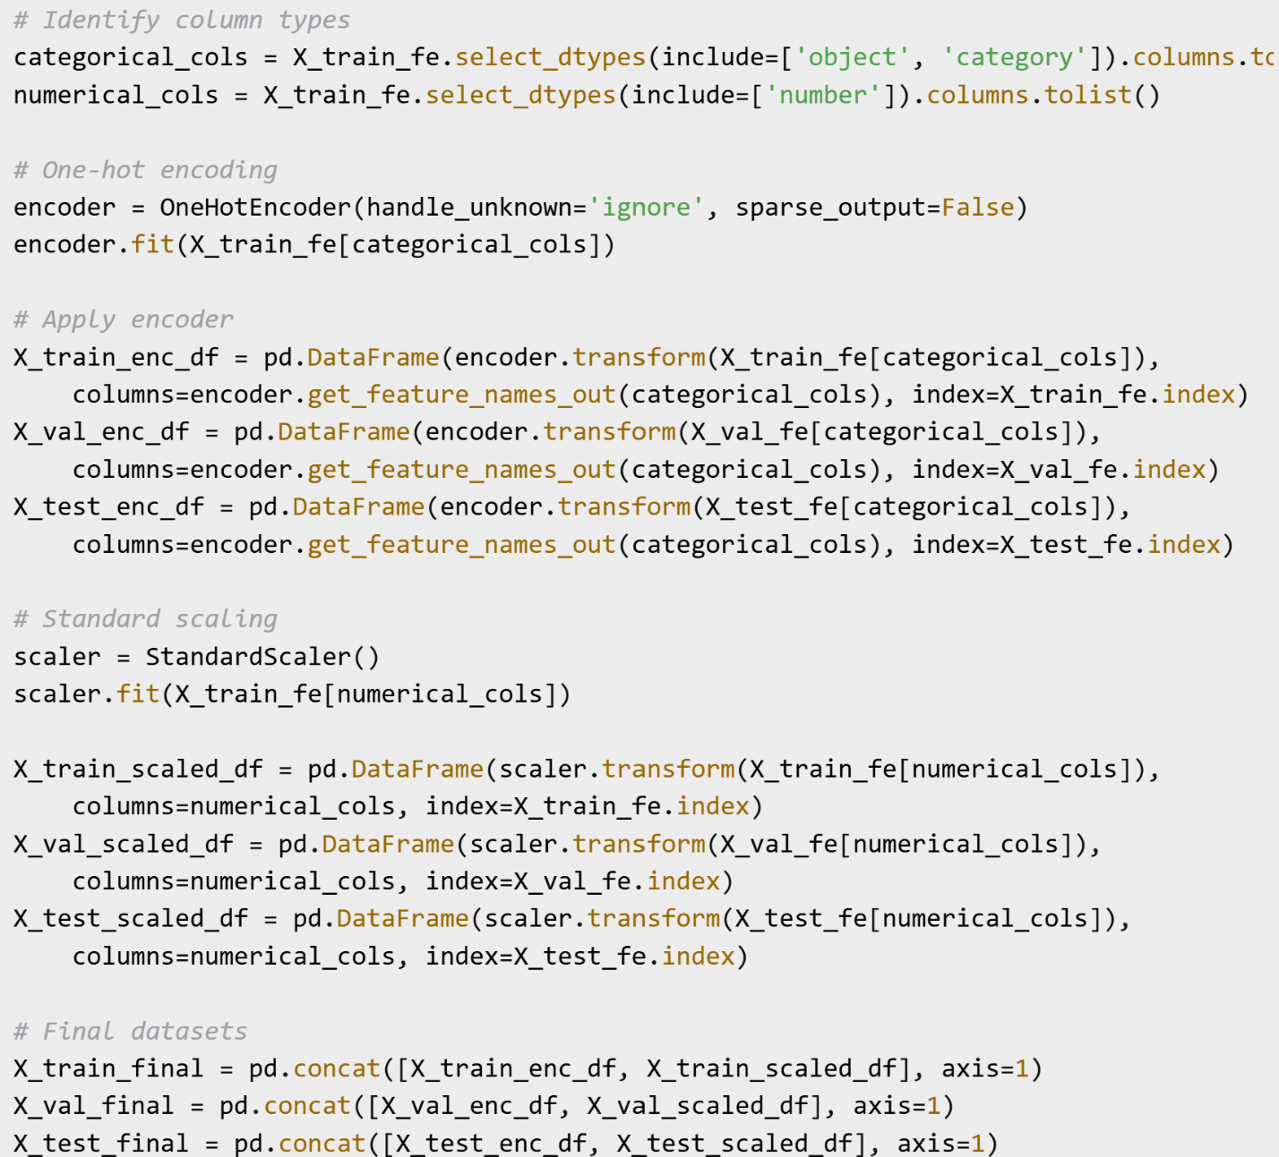
To prepare the final training and evaluation datasets, categorical variables are one-hot encoded, and numerical features are scaled using StandardScaler. The same encoders and scalers are fitted only on the training data and reused across validation and test sets.
Code Screenshot 12 Encoding and Scaling
Column types are dynamically identified to ensure reproducibility. Categorical variables are one-hot encoded to enable usage in linear and tree-based models. Numeric values are standardized (zero mean, unit variance) to support models sensitive to scale (e.g., Logistic Regression). All transformations are applied consistently across train, val, and test sets using fitted encoders/scalers from training data. The resulting datasets (X_train_final, X_val_final, X_test_final) are ready for model training and evaluation.
This process enriched the raw data with relevant, explainable features, setting a strong foundation for downstream machine learning and fairness analysis. Every transformation is reproducible and designed for transparency and auditability.
Table 5 Variables explanation
Variable | Description
X_train | Raw, unprocessed features
X_train_fe | After feature engineering (interactions, ratios, bins, etc.)
X_train_final | After one-hot encoding + scaling, ready for ML pipelines

After feature engineering, preprocessing, and one-hot encoding/scaling, the dataset was split into train, validation, and test sets using stratified sampling.
Table 6 Final Dataset before modeling
Subset | Good Client (0) | Low Risk (1) | High Risk (2)
Train | 88.3% | 10.9% | 0.8%
Validation | 88.3% | 10.9% | 0.8%
Test | 88.3% | 10.9% | 0.8%

The class proportions are highly consistent across all splits thanks to stratification. This is critical for fair evaluation, especially for the minority High Risk class, which remains under 1%. The dataset remains heavily imbalanced, so model selection and metric choice must account for minority class underrepresentation.

Model Training and Evaluation

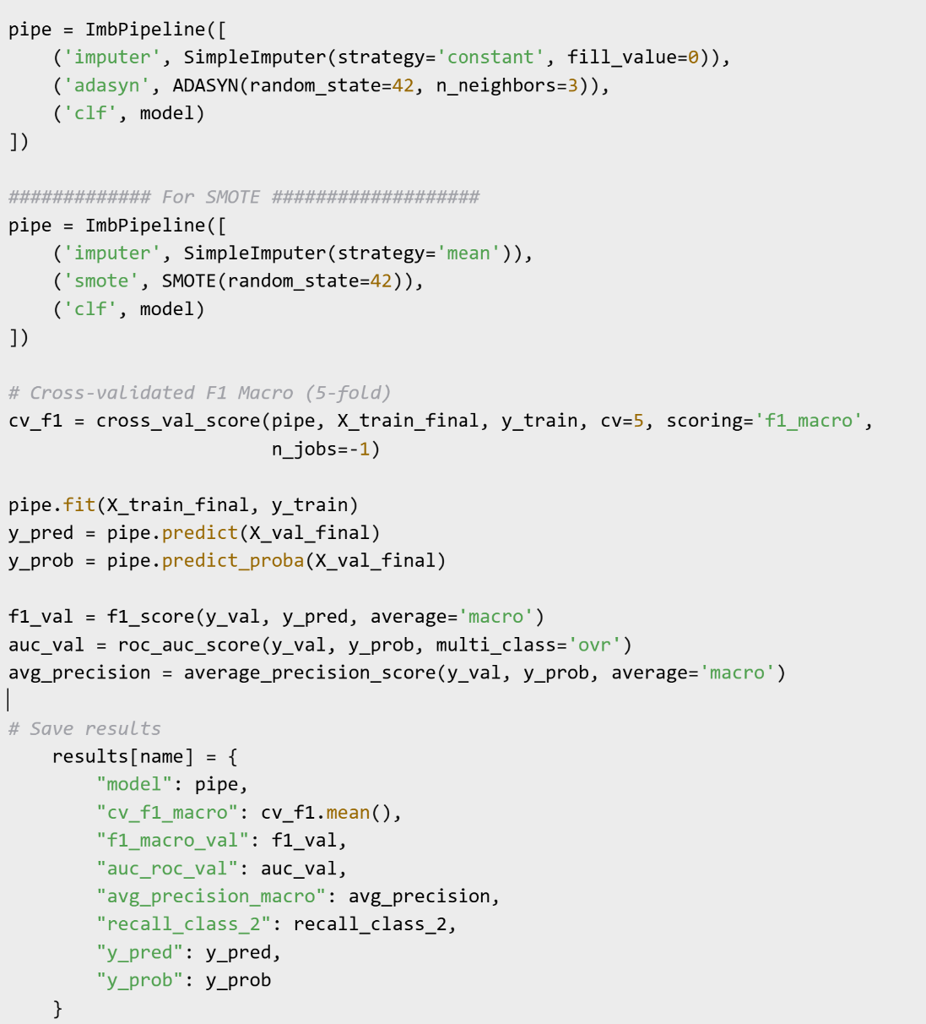
Each model was implemented using a unified pipeline approach for comparability. A loop was used to iterate over classifiers, apply preprocessing, and evaluate performance on the validation set. Fitting models with ImbPipeline() that included imputation, SMOTE/ADASYN resampling, and classification. The inclusion of SimpleImputer ensured that any missing values in the dataset were filled with the mean of each feature, a commonly used and reliable strategy in numerical preprocessing. Meanwhile, the use of Cross-Validation F1 Macro 5-folds enabled robust model performance estimation across multiple folds, reducing variance in performance reporting and guarding against overfitting. Reporting performance metrics including F1 Score, ROC-AUC, and class specific precision/recall for the minority High Risk class (label 2). Visualizing confusion matrices and precision-recall curves to support interpretability.

Code Screenshot 13 Model Training and evaluation

Each model was assessed on: Classification Report (precision, recall, F1), Confusion Matrix Heatmap, Precision-Recall Curve per class, F1 Macro (CV and Validation), AUC-ROC, Precision/Recall for High Risk class only. These evaluations ensured that models were not only accurate but also fair in handling the minority class, which is critical in credit risk prediction tasks.
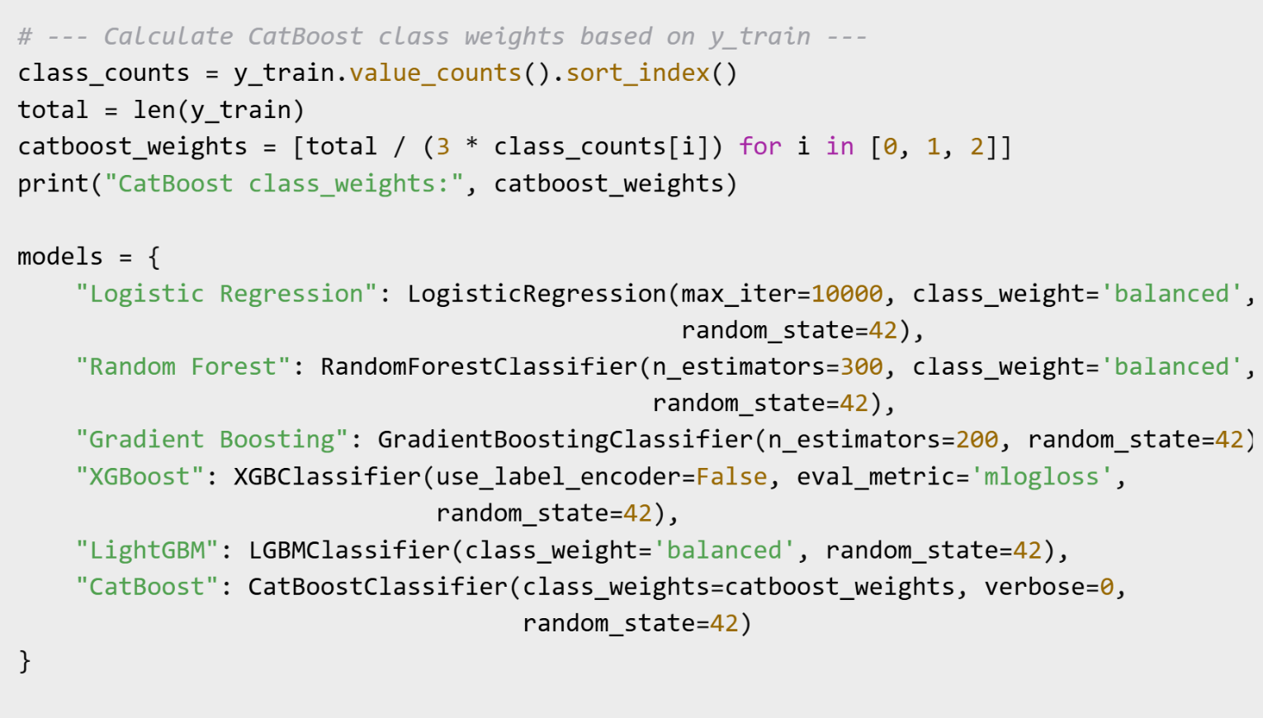
Baseline following algorithms were evaluated: Logistic Regression, Random Forest Classifier, Gradient Boosting Classifier, XGBoost Classifier, LightGBM Classifier, CatBoost Classifier. For the CatBoost model, custom class weights were calculated from the training set to counteract the strong imbalance. These weights were passed into the CatBoost constructor.
Code Screenshot 14 Baseline models fitted

Hyperparameter Tuning

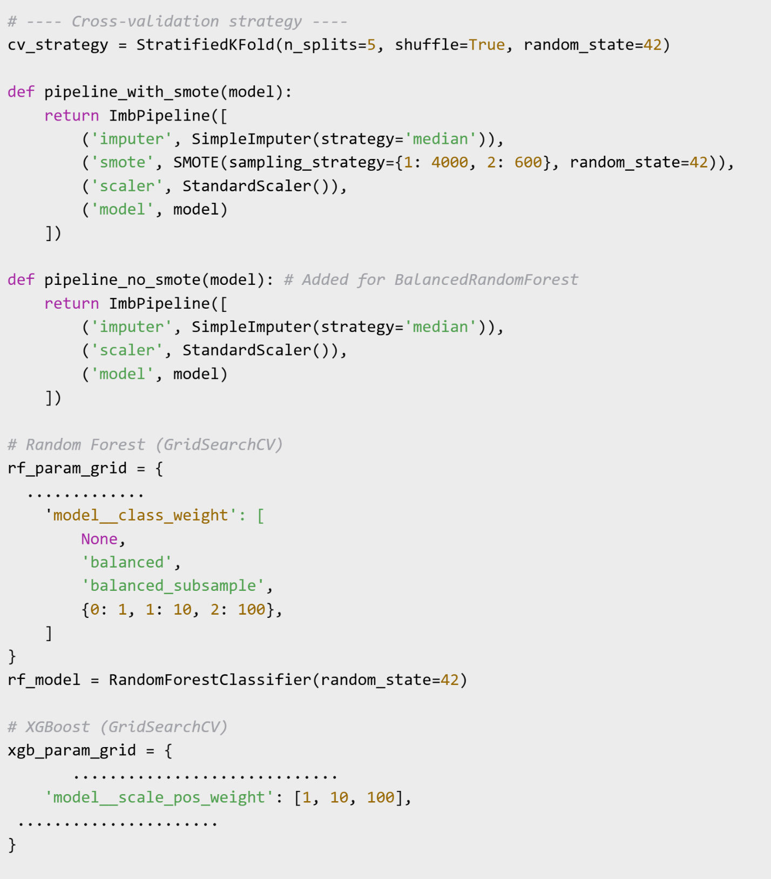
Hyperparameter tuning was applied to optimize model performance and better adapt the classifiers to the imbalanced, multiclass nature of the problem. A stratified 5-fold cross-validation strategy was employed to ensure class balance across folds. Two types of pipelines were used depending on whether resampling was appropriate. Non-Smote added for BalancedRandomForest model. Cost-Sensitive Learning in Grid Search. To improve classification for the minority High Risk class, cost-sensitive hyperparameters were explored for Random Forest (class_weight) and for XGBoost (scale_pos_weight). These hyperparameters were included in the model tuning process using GridSearchCV for Random Forest, BalancedRandomForest, XGBoost, AdaBoost and RandomizedSearchCV for LightGBM, Gradient Boosting, Logistic Regression, CatBoost depending on the model complexity and parameter space size
Code Screenshot 15 Hyperparameters tunning

Chapter 5 – Results and Analysis: Model Evaluation and Comparison

Overview

This chapter presents the results obtained from evaluating multiple machine learning classifiers for credit risk prediction. The comparison considers validation and test performance, sensitivity to class imbalance, and the impact of resampling and tuning strategies. The goal is to determine the most effective model(s) for identifying High Risk clients while maintaining good performance across all classes.
Evaluation Metrics & Rationale
In credit risk modeling, especially with imbalanced datasets where the minority (High Risk) class represents under 1% of all samples, choosing the right evaluation metrics is essential. Below are the key metrics used in this study.

- Macro F1-Score: The F1-score is the harmonic mean of precision and recall. Macro F1 computes the F1-score independently for each class, then averages them, giving equal weight to each class, regardless of their frequency. For imbalanced problems, macro F1 penalizes models that ignore rare classes, making it the best overall summary of multiclass performance (scikit-learn, 2025), (Lee, 2025).
- AUC-ROC (One-vs-Rest, Multiclass): The Area Under the Receiver Operating Characteristic Curve (AUC-ROC) measures how well the model separates each class from the rest. The `One-vs-Rest` approach averages AUC over all classes. Provides a global view of discriminative power. However, in highly imbalanced cases, ROC-AUC can be overly optimistic, precision-recall curves are often preferred for the rare class (scikit-learn, 2025), (Davis & Goadrich, 2006)
- Average Precision (AP) from the Precision-Recall Curve: Average Precision (AP) summarizes the precision-recall curve as the weighted mean of precisions at each threshold. Macro AP averages this over all classes. Unlike ROC-AUC, AP focuses directly on performance for the positive (rare) class, so it reflects the model`s real-world utility in finding high-risk cases (Saito & Rehmsmeier, 2015).
- Precision-Recall Curves (PRC): PR curves plot the trade-off between precision (positive predictive value) and recall (sensitivity) across thresholds. PR curves are preferred over ROC in severe imbalance, because they reveal the actual trade-offs between missing true positives and raising false alarms for the minority class.
- Confusion Matrix: A table that shows the number of true positives, false positives, true negatives, and false negatives for each class. Enables a direct, interpretable understanding of where each model succeeds or fails, especially for the High Risk (minority) class.
- Classification Report: Provides detailed precision, recall, and F1-score per class, along with macro and weighted averages. Offers a granular, class-level perspective, critical for diagnosing trade-offs between majority and minority class predictions.
- Precision and Recall (Class 2: High Risk Only): For the rare High Risk class, precision measures the proportion of predicted high risk clients who are truly high risk, recall measures the proportion of all actual high risk clients the model successfully flags. These are business-critical metrics: high recall means the model doesn't miss dangerous clients, high precision means it avoids unnecessary false alarms.

Train, Validation and Test Performance

Each classifier was trained on a stratified training set using either SMOTE or ADASYN resampling. Performance was evaluated using macro-averaged F1-score across 5-fold cross-validation and validated on the hold-out validation set.

Model Evaluation Results – ADASYN (Validation Set)

After building and tuning six machine learning models (Logistic Regression, Random Forest, Gradient Boosting, XGBoost, LightGBM, and CatBoost), results show evaluated their performance on the validation set using confusion matrices and Precision-Recall (PR) curves for all three credit risk classes . This approach is particularly appropriate due to the strong class imbalance (class 2 – High Risk – is under 1% of the data (only 200 samples)). The model was trained on six classification models using the following pipeline:

- ADASYN: Used instead of SMOTE for synthetic oversampling of minority classes (handles severe imbalance and rare class 2)
- StandardScaler For numerical features
- OneHotEncoder For categorical encoding
- SimpleImputer For NaN values
- Each model was evaluated on the validation set (X_val_final)
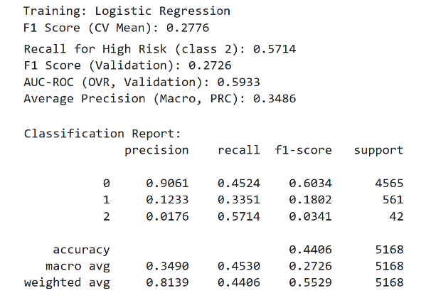  Logistic Regresion | 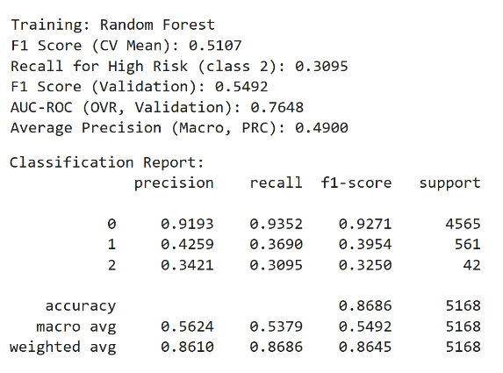  Random Forest
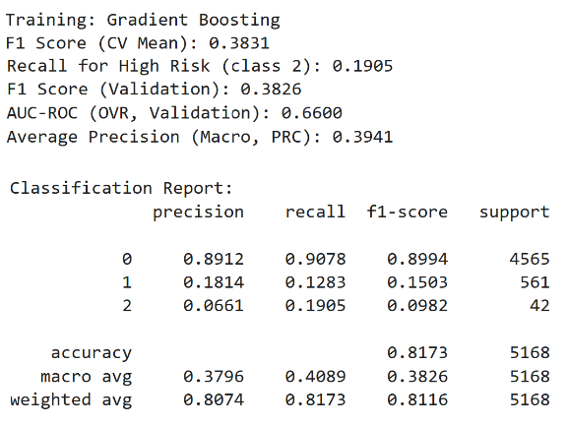  Gradient Boosting | 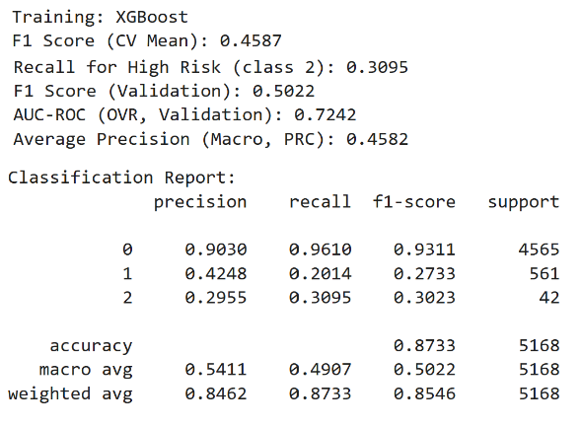  XGBoost
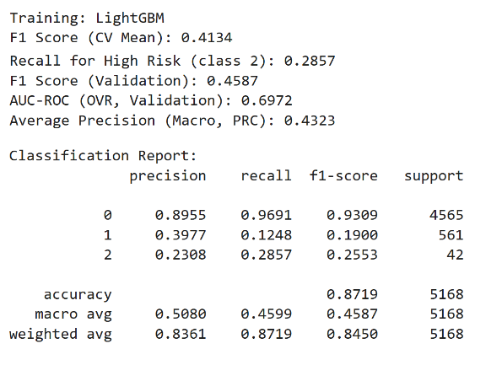  LightGBM | 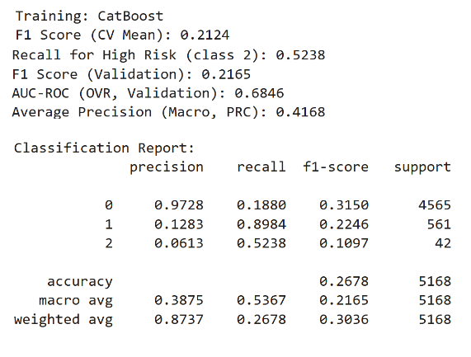  CatBoost
Figure 32 ADASYN Classification Report and results (Validation Set)

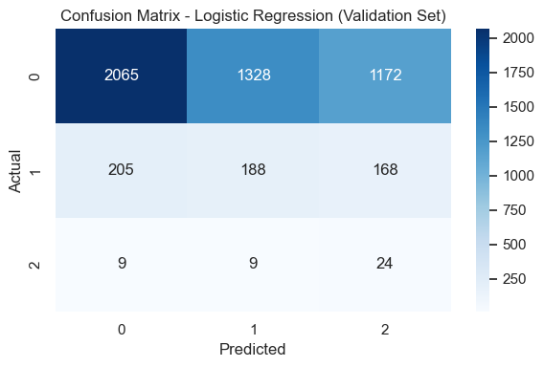 | 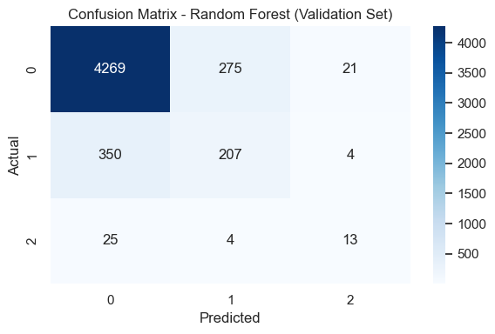
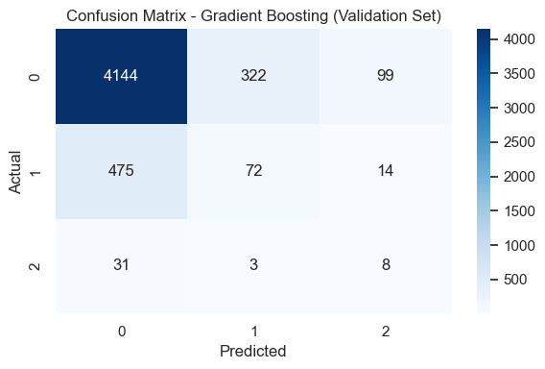 | 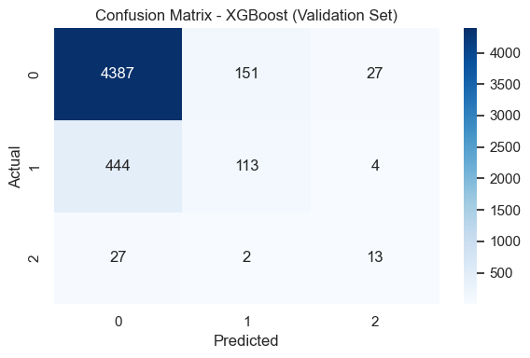
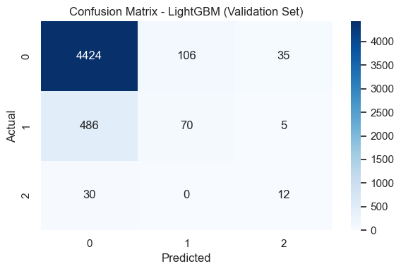 | 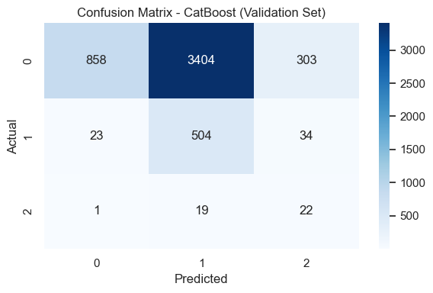
Figure 33 ADASYN Confusion Matrix

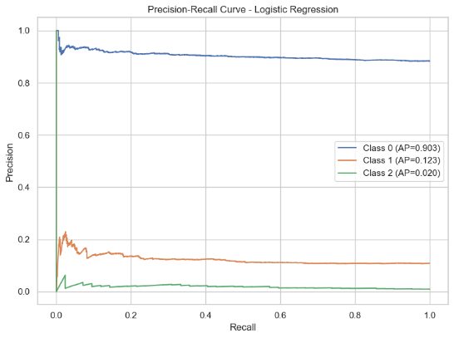 | 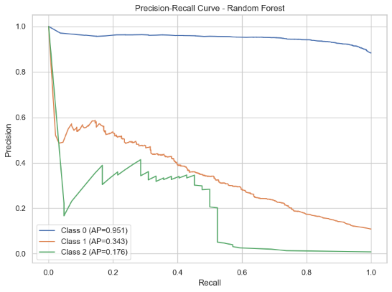
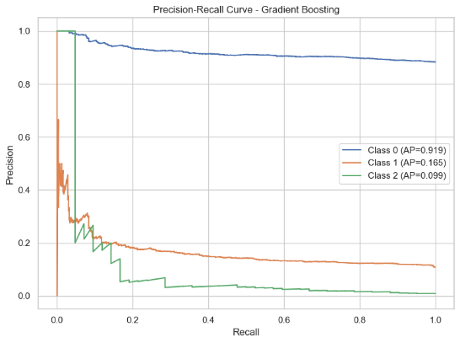 | 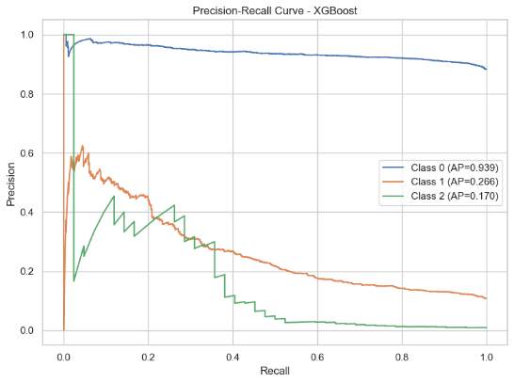
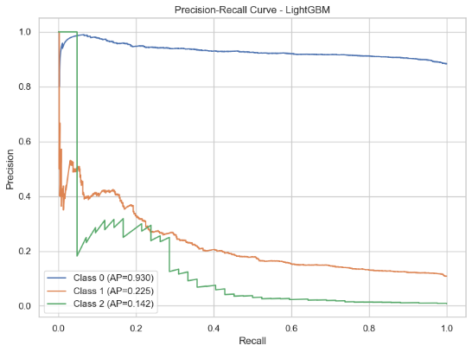 | 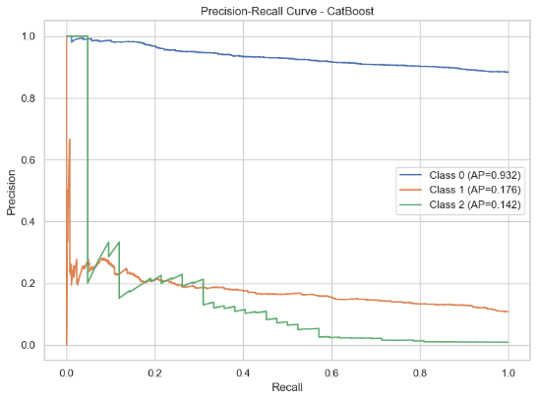
Figure 34 ADASYN Precision-Recall Curves

Table 7 ADASYN Results
Model | F1 Macro (CV) | F1 Macro (Val) | AUC-ROC (Val) | AP Macro (Val) | Class 0 AP | Class 1 AP | Class 2 AP | Recall Class 2
Random Forest | 0.511 | 0.549 | 0.765 | 0.49 | 0.95 | 0.34 | 0.18 | 0.310
XGBoost | 0.459 | 0.502 | 0.724 | 0.46 | 0.94 | 0.27 | 0.17 | 0.310
LightGBM | 0.413 | 0.459 | 0.697 | 0.43 | 0.93 | 0.23 | 0.14 | 0.286
CatBoost | — | 0.217 | 0.685 | 0.42 | 0.93 | 0.18 | 0.14 | 0.524
Gradient Boosting | 0.383 | 0.383 | 0.660 | 0.39 | 0.92 | 0.17 | 0.10 | 0.191
Logistic Regression | 0.278 | 0.273 | 0.593 | 0.35 | 0.90 | 0.12 | 0.02 | 0.571

- Random Forest and XGBoost are the most balanced, achieving the highest average precision and recall for both majority and minority classes. They outperform on macro-F1 and AP for class 1 (Low Risk) and class 2 (High Risk), which is critical in imbalanced settings.
- CatBoost delivers high recall for classes 1 and 2, but very low precision for class 0, causing an overload of false positives. This is likely a class weight or data imbalance side-effect.
- Gradient Boosting and LightGBM perform strongly for class 0, but fail to capture rare classes, especially class 2.
- Logistic Regression fails to distinguish the rarest class and has the weakest macro metrics, confirming that linear models struggle even with balanced class weights.
- PR Curves: For all models, the AP for class 0 is very high (>0.9), but AP for class 1 and especially class 2 drops significantly. This is expected due to the extreme rarity of the high-risk class.
- The PR curves for Random Forest and XGBoost show the best separation between classes and the highest AP for the minority classes, even though performance is still low in absolute terms for class 2.
- Confusion matrices show that, despite improvements, most models still have difficulty predicting true positives for class 2 without many false positives.

The dataset exhibits severe class imbalance with High Risk clients representing <1% of samples. Despite implementing advanced techniques (ADASYN resampling, class weighting), minority class detection remains challenging, with confusion matrices showing frequent misclassification to the majority class. The evaluation methodology prioritizes Precision-Recall curves over ROC curves for better rare-class assessment, using F1-macro and average precision metrics. Among tested models, only Random Forest and XGBoost achieved moderate performance on minority classes. The pipeline demonstrates no significant overfitting (minimal CV-validation gap) and establishes a foundation for fair credit risk modeling, though further improvements through domain features, threshold tuning, or ensemble methods are needed for better high-risk client identification. The study successfully implements a robust evaluation framework for imbalanced credit risk classification, prioritizing fairness and transparency, but reveals the persistent challenge of rare high-risk client detection despite advanced techniques.

Model Evaluation Results – SMOTE (Validation Set)

Like ADASYN after performing advanced feature engineering and a robust preprocessing pipeline, six classifiers on a highly imbalanced multiclass problem.
Same pipeline and evaluation metrics.
  - Logistic Regression (class_weight='balanced')
  - Random Forest (300 estimators, class_weight='balanced')
  - Gradient Boosting (200 estimators)
  - XGBoost (default, eval_metric='mlogloss')
  - LightGBM (class_weight='balanced')
  - CatBoost (custom class_weights from y_train distribution)
Table 8 SMOTE Results
Model | F1 Score (CV Mean) | F1 Score (Validation) | AUC-ROC | AP Macro (PRC) | Recall (Class 2) | Precision (Class 2)
Random Forest | 0.5126 | 0.5440 | 0.7733 | 0.4973 | 0.2857 | 0.3333
XGBoost | 0.4589 | 0.4943 | 0.7304 | 0.4654 | 0.2857 | 0.2727
LightGBM | 0.4091 | 0.4681 | 0.7055 | 0.4493 | 0.2619 | 0.2683
Gradient Boosting | 0.3821 | 0.4030 | 0.6733 | 0.4065 | 0.1429 | 0.0789
CatBoost | - | 0.2245 | 0.6884 | 0.4248 | 0.5000 | 0.0547
Logistic Regression | 0.2797 | 0.2770 | 0.5960 | 0.3503 | 0.5000 | 0.0157

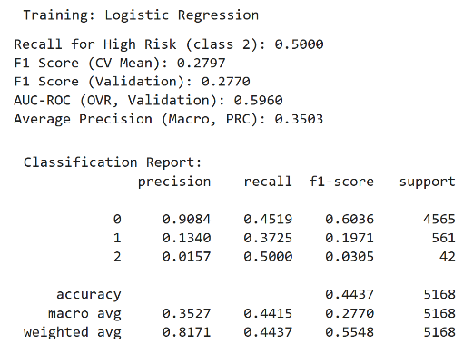 | 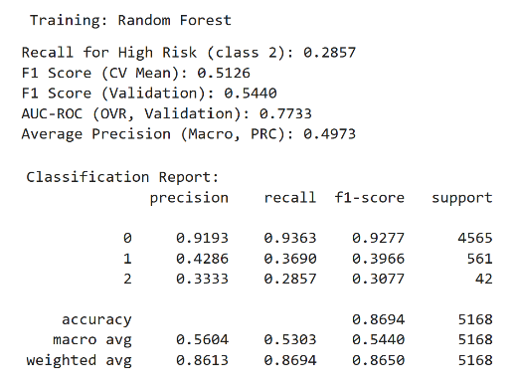
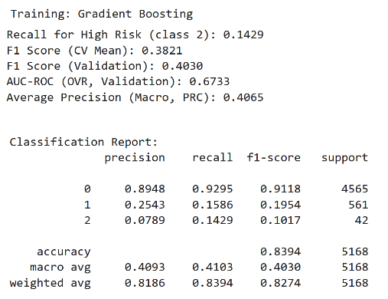 | 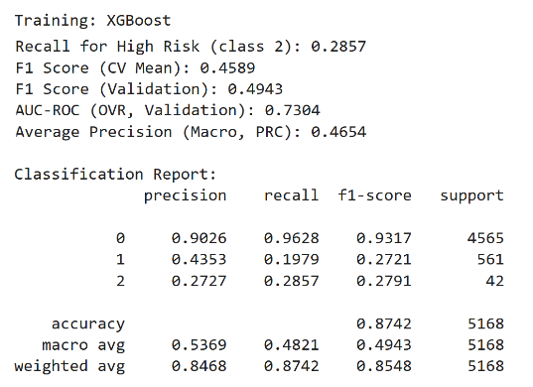
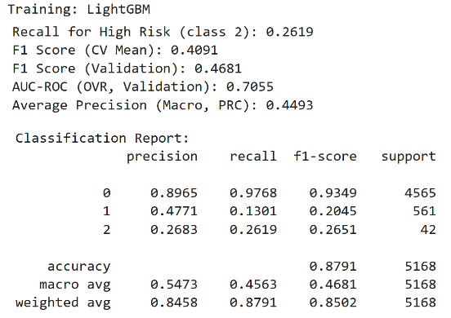 | 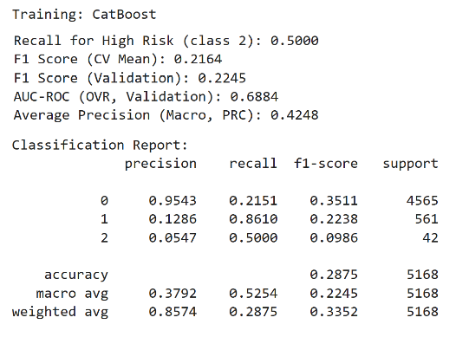
Figure 35 SMOTE Classification Report and results (Validation Set)
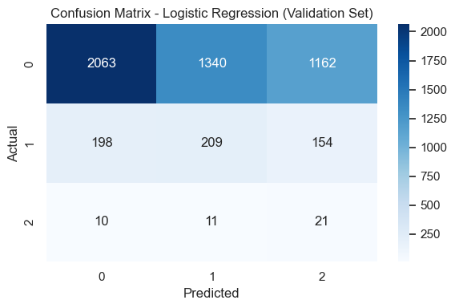 | 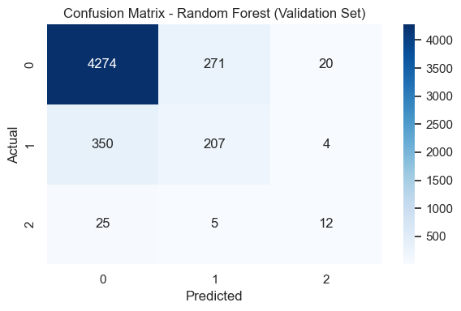
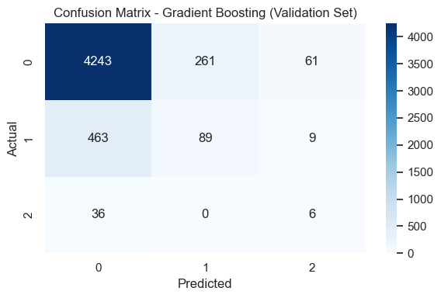 | 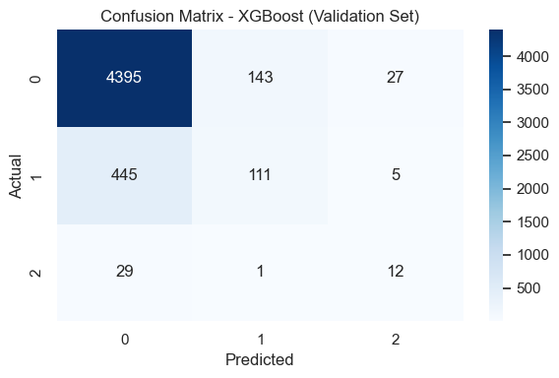
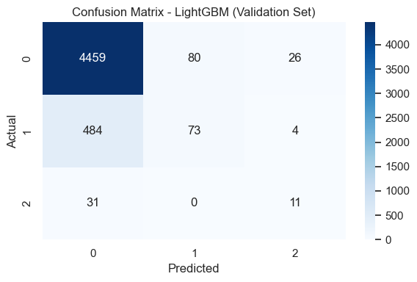 | 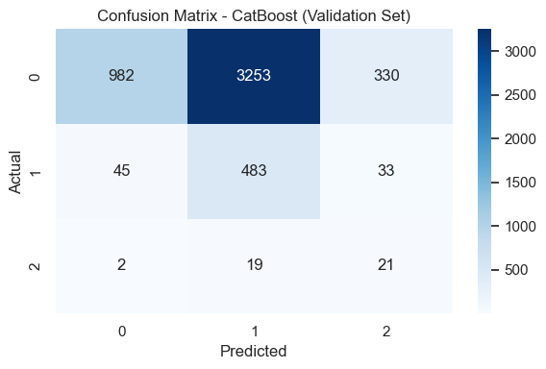
Figure 36 SMOTE Confusion Matrix

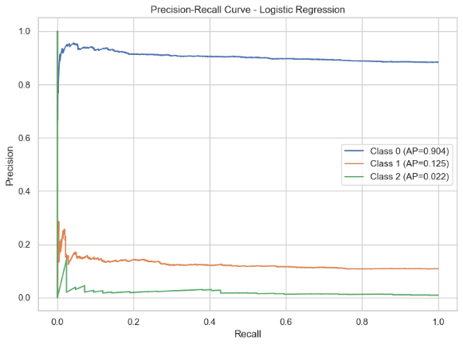 | 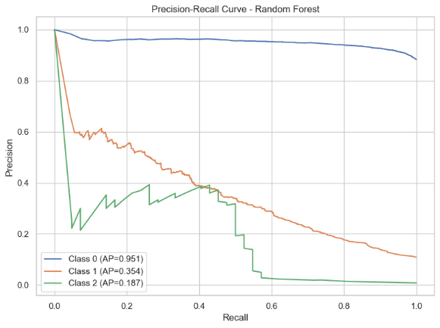
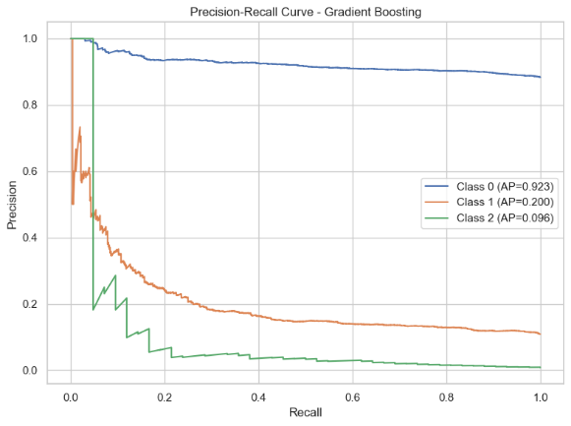 | 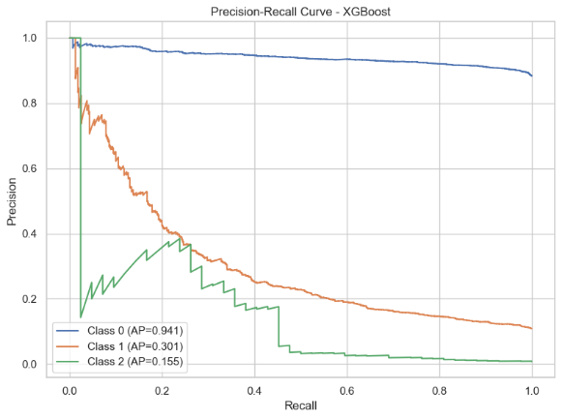
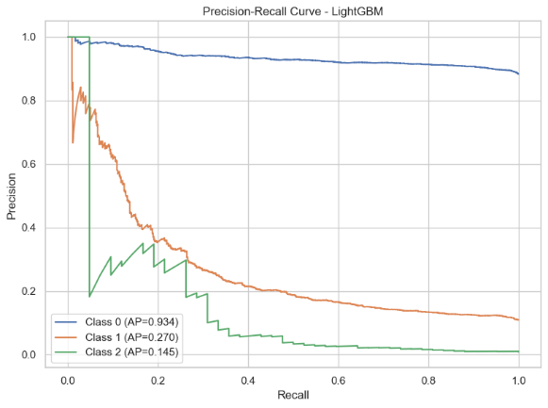 | 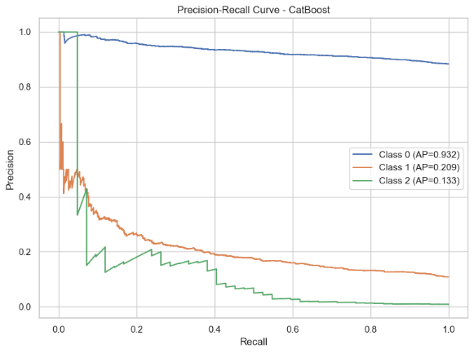
Figure 37 SMOTE Precision-Recall Curve

The recall values for class 2 (High Risk) are noticeably lower for Random Forest and XGBoost compared to ADASYN, while CatBoost and Logistic Regression still achieve high recall, but with a significant trade-off in precision. Overall, Random Forest and XGBoost continue to offer the best balance between metrics, even though the recall for class 2 does not exceed 0.31.
Note: This means that while some models can flag more high-risk cases, they do so at the cost of generating more false positives, whereas Random Forest and XGBoost maintain a better overall trade-off between detecting all classes and avoiding unnecessary alerts.
Confusion Matrix & PRC Interpretation
- All models: Excellent at classifying the majority class (0 – Good Client).
- Class 2 (High Risk): Remains the hardest to detect; only Random Forest, XGBoost, and LightGBM have non-zero recall, and even then, precision and recall are below 0.30.
- CatBoost and Logistic Regression: Tend to misclassify minority classes almost entirely (class 2 is often ignored).
- Gradient Boosting: Very strong on class 0, but performance drops sharply on class 1 and 2.
Precision-Recall Curve
- Random Forest: Macro AP increases to ~0.50. Class 0 maintains very high precision (AP=0.95), while class 1 reaches AP=0.35 and class 2 AP=0.19. This is the best trade-off found for rare class detection in the current setup.
- XGBoost: Similar to ADASYN, macro AP=0.47. Class 2 improves slightly compared to Gradient Boosting/CatBoost.
- LightGBM: Macro AP=0.45, also sees an increase in class 1/2 AP with SMOTE. Class 1 AP=0.27, class 2 AP=0.15.
- CatBoost: Even with class weights, struggles to pick up class 2, and is overly aggressive towards class 1.
- Logistic Regression: AP for class 2 is extremely low (0.02), confirming that linear models are not effective here, regardless of resampling.
- Gradient Boosting: Class 0 AP=0.92, but class 2 is only 0.096, showing inability to capture rare signals despite good AUC.
Precision-Recall curves clearly show the sharp imbalance: class 0 dominates, while even with SMOTE, AP for classes 1 and 2 remains low. There is a small but measurable improvement in class 2 detection using SMOTE over ADASYN for the best models (RF, XGBoost), but neither solves the core challenge of minority detection.
- ADASYN vs SMOTE: Both improve over raw imbalance, but SMOTE is slightly more robust in macro metrics for this dataset and task. Differences are small, but SMOTE gives marginally better detection for the rarest class.
- Best Models: Random Forest and XGBoost remain the most stable and performant. LightGBM is a close third, but sometimes drops recall on class 2.
- Class 2 Detection: No model achieves >30% precision or recall for class 2 without hurting overall performance. Further improvement may require like Post-processing (threshold tuning, cost-sensitive learning), More domain-specific features or external data or Ensemble or stacking approaches with a focus on rare class recall.
- No Overfitting: The close match between cross-validation and validation results confirms model generalization and pipeline robustness.
- Metric to report: PRC/Average Precision and macro F1 are much more informative than accuracy or even ROC-AUC in this scenario.
If deployment is requested, Random Forest (with threshold tuning for class 2) is recommended for a robust, interpretable, and stable solution.
No resampling or model alone fully addresses class 2 (High Risk) detection in such an imbalanced scenario. Pipeline improvements (like SMOTE + robust tree models) help, but real-world application will require ongoing monitoring and possibly new strategies to address this persistent limitation.

Validation Results after Hyperparameter Tuning

All reported results reflect the model's performance before/after hyperparameter optimization using stratified cross-validation, SMOTE with sampling_strategy and cost-sensitive learning.

Table 9 Validation Results Before/After Hypermarameter Tunning
Model | F1 Macro  Before/After | AUC-ROC Before/After | AP (PRC)  Before/After | Recall  (Class 2)  Before/After | Precision (Class 2) Before/After
Random Forest | 0.5440/ 0.5434 | 0.7733/ 0.7790 | 0.4973/ 0.5180 | 0.2857/ 0.3333 | 0.3333/ 0.2979
Balanced Random Forest | - / 0.3569 | - / 0.6891 | - / 0.4436 | - / 0.5476 | - / 0.0467
XGBoost | 0.4943 / 0.5253 | 0.7304 / 0.7482 | 0.4654 / 0.4852 | 0.2857 / 0.2381 | 0.2727 / 0.3704
AdaBoost | - / 0.3374 | - / 0.6296 | - / 0.3713 | - / 0.0238 | - / 1.0000
LightGBM | 0.4681 / 0.5293 | 0.7055 / 0.7471 | 0.4493 / 0.4989 | 0.2619 / 0.2857 | 0.2683 / 0.3000
Gradient Boosting | 0.4030 / 0.5184 | 0.6733 / 0.7611 | 0.4065 / 0.4907 | 0.1429 / 0.2857 | 0.0789 / 0.2553
Logistic Regression | 0.2770 / 0.3292 | 0.5960 / 0.6081 | 0.3503 / 0.3550 | 0.5000 / 0.1190 | 0.0157 / 0.0284
CatBoost | 0.2245 / 0.4840 | 0.6884 / 0.7264 | 0.4248 / 0.4899 | 0.5000 / 0.4048 | 0.0547 / 0.1753

In addition to the core set of classifiers, AdaBoost and BalancedRandomForest were included in the hyperparameter tuning phase for two main reasons.
- AdaBoost is a popular ensemble method known for its robustness and its ability to boost weak learners, making it a valuable baseline for comparison in tabular classification tasks, even when data are imbalanced. Although it is typically less effective on heavily imbalanced multiclass problems, its inclusion provides an additional reference point and may reveal useful trade-offs in recall or precision for minority classes, depending on the base estimator and hyperparameters (Freund & Schapire, 2017).
- BalancedRandomForest extends the classical Random Forest by using random under-sampling of each bootstrap sample to balance class distribution during tree construction. This technique is especially relevant in highly
imbalanced multiclass contexts, such as credit risk, where the standard Random Forest may struggle to adequately represent the rare class. Incorporating BalancedRandomForest allows for a direct comparison with cost-sensitive and resampling-based approaches (SMOTE), helping to assess whether integrated sampling in the tree-building process provides any unique advantages (Lemaître, et al., 2017).
Including both methods ensures a more comprehensive search of the solution space and a fair benchmarking against alternative strategies for handling severe class imbalance.
Overall, Random Forest achieved the highest F1 and balanced performance across classes. Balanced Random Forest achieved the highest recall for the rarest class, but with a notable drop in precision. Most models demonstrate the classic trade-off in highly imbalanced, multiclass credit risk, methods that maximize recall for Class 2 often sacrifice precision and overall accuracy. These results underscore the methodological challenge of rare event prediction in practical, multiclass risk categories tasks. The most visible improvements appear in macro F1 and average precision, indicating that models became more balanced overall, especially for minority classes.

- Random Forest: Maintains strong, balanced F1, AUC-ROC, and improved recall for Class 2 (0.2857 to 0.3333), but a slight drop in precision for rare class. Remains the most robust "all-rounder" for practical multiclass credit risk.
- XGBoost: Significant increase in F1 (0.4943 to 0.5253) and precision for Class 2 (0.2727 to 0.3704), but with a drop in recall (0.2857 to 0.2381). Indicates that the model is better at avoiding false positives for high risk, but may miss some real high-risk cases.
- LightGBM: Notable improvement in both F1 and AUC-ROC, as well as slight increases in both recall and precision for Class 2. This makes LightGBM a strong alternative to Random Forest and XGBoost for imbalanced multiclass tasks.
- Gradient Boosting: Marked improvement in all metrics after tuning, especially recall for Class 2 (0.1429 to 0.2857) and F1. Indicates much better detection of rare high risk after tuning.
- CatBoost: F1 almost doubled (0.2245 to 0.4840) and precision for Class 2 improved notably (0.0547 to 0.1753), though recall for Class 2 fell slightly. CatBoost now performs reasonably, but is still outperformed by Random Forest, XGBoost, and LightGBM.
- Logistic Regression: Still underperforms on all metrics after tuning.
Best Models and Recommendations
- Random Forest remains the most balanced and reliable model after tuning, especially when considering all metrics.
- LightGBM and XGBoost have improved substantially, now matching or even surpassing Random Forest in some metrics, especially for F1 and precision on rare class.
- Gradient Boosting made the most substantial leap in performance for the rare class (recall).
Hyperparameter tuning led to clear, quantifiable improvements in most model's ability to generalize and detect rare high-risk clients. Random Forest, LightGBM, and XGBoost are the best candidates for further tuning (thresholds tunning). The results suggest to focusing on these models for deployment and further evaluation.

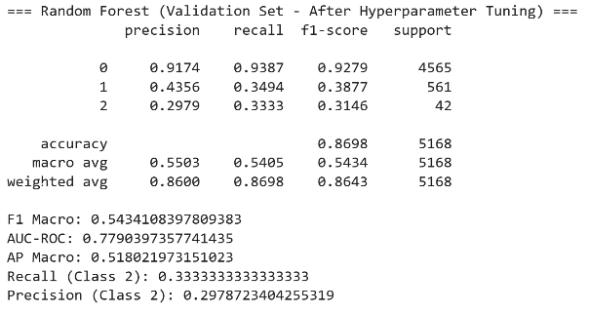 | 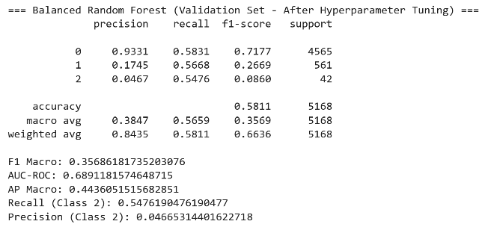
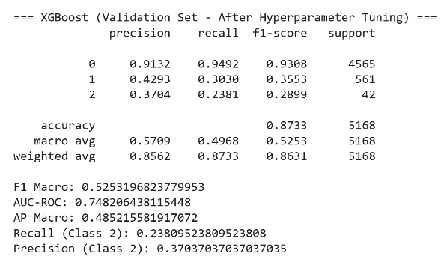 | 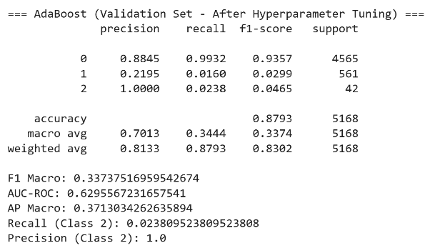
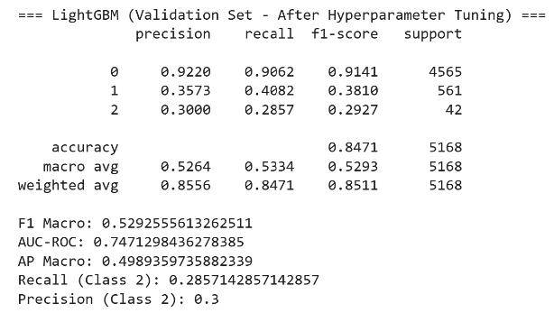 | 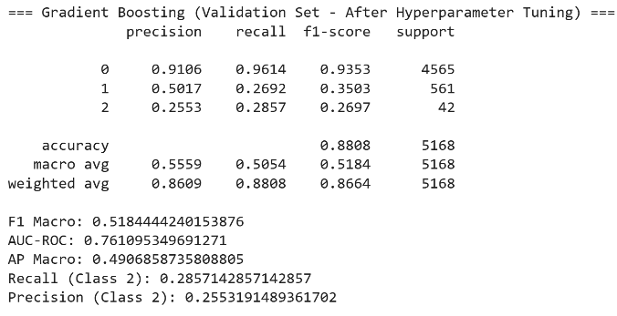
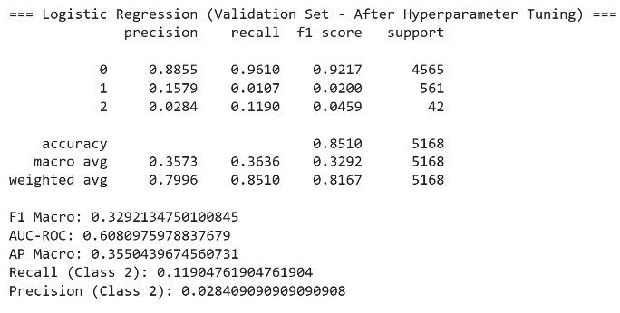 | 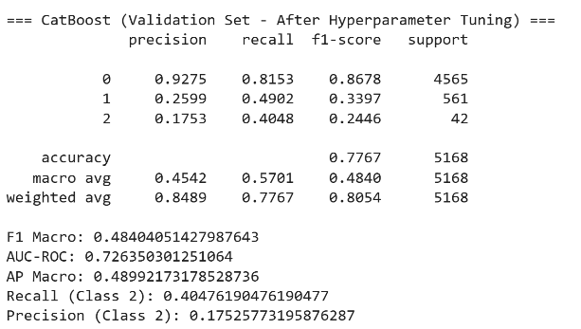
Figure 38 After Hyperparameter Tuning results and Classification Report

Threshold Tuning on Selected Models

Threshold tuning is the process of adjusting the decision boundary (the probability cutoff) at which a classifier assigns a sample to a particular class, rather than always selecting the class with the highest predicted probability (the default "argmax" rule). In multiclass classification, this typically involves increasing the sensitivity for a specific class, such as the rare High Risk group, by lowering the probability threshold required to predict that class (Lipton, et al., 2014).
In highly imbalanced datasets like credit risk, the default threshold often leads to poor recall for rare classes, because the model is biased towards the majority class. By tuning the threshold for the High Risk class, the model can be made more sensitive to identifying rare, high-impact cases, potentially increasing recall and F1-score for that class, even if it comes at a small cost to overall accuracy. In this project, threshold tuning was applied specifically to the High Risk (class 2) predictions at 0.20 and 0.30 cutoffs, allowing the model to flag more potential high-risk clients. This approach helps mitigate the under-detection of rare but critical cases in financial risk management.

LightGBM Threshold Tuning Results – Validation Set
Table 10 LightGBM Threshold results
Metric / Class | Default (argmax) | Tuned (Best F1, thr=0.45) | Tuned (Recall ≥ thr=0.00)
F1 (Class 2) | 0.2651 | 0.2619 | 0.0161
Precision (Class 2) | 0.2683 | 0.2619 | 0.0081
Recall (Class 2) | 0.2619 | 0.2619 | 1.0000
Macro F1 | 0.4681 | 0.4671 | 0.0055

Default multiclass argmax: The model captures some High Risk clients, but both precision and recall are low. Most true positives remain undetected. Threshold tuning for best F1: Threshold tuning does not bring any improvement for LightGBM, F1, precision, and recall for the rare class remain identical to the default. The F1-vs-threshold curve confirms the maximum is at 0.45, but the value is unchanged. Extreme threshold: Recall is perfect (all High Risk clients are detected), but at the cost of unusable precision, almost all predictions are false positives. This is not practical for real-world use.
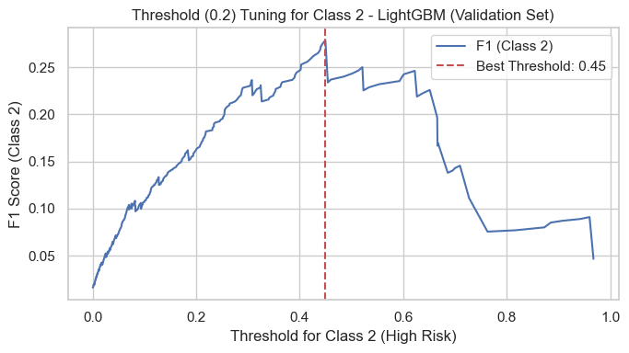 | 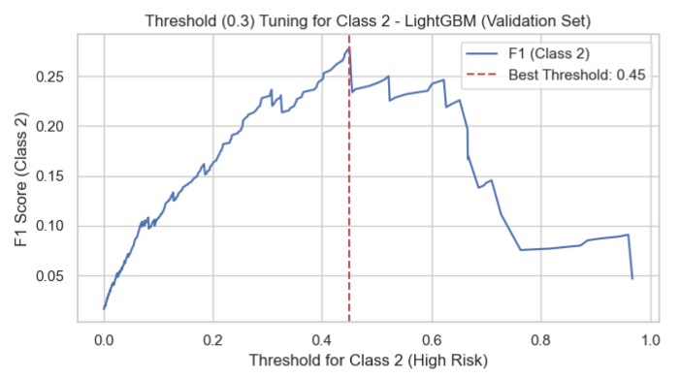
Figure 39 Threshold Tuning Curve for Class 2 – LightGBM (Validation Set)

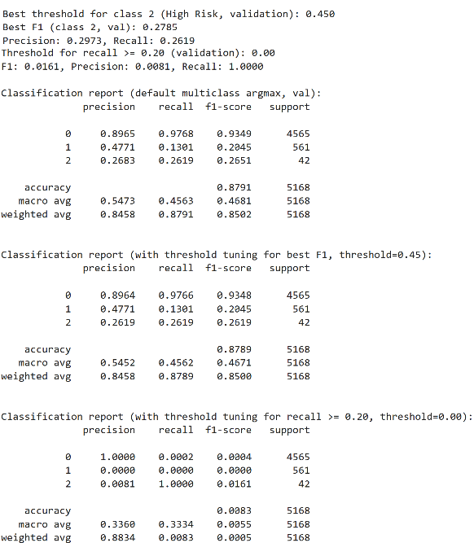 | 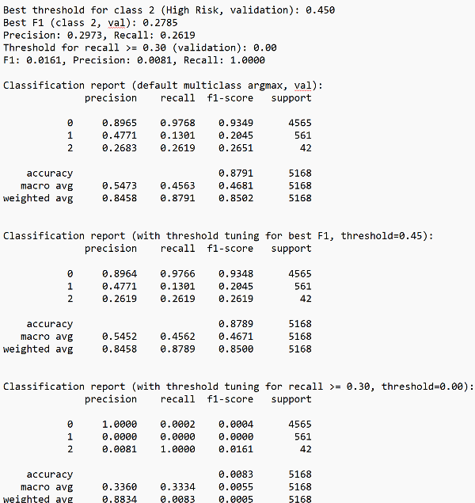
Figure 40 Classification Report for LightGBM (Threshold=0.45, Validation Set)

Random Forest Threshold Tuning Results – Validation Set

Table 11 Random Forest Threshold results
Metric / Class | Default (argmax) | Tuned (Best F1, thr=0.28) | Tuned (Recall ≥ thr=0.00)
F1 (Class 2) | 0.3077 | 0.3908 | 0.0272
Precision (Class 2) | 0.3333 | 0.3778 | 0.0139
Recall (Class 2) | 0.2857 | 0.4048 | 0.8095
Macro F1 | 0.544 | 0.5720 | 0.3327

Random Forest detects the rare class better than LightGBM, but precision and recall are still modest. Only about a third of high-risk predictions are correct. Here, threshold tuning brings a clear benefit. F1, precision, and recall for High Risk class all improve substantially, showing that Random Forest is responsive to threshold optimization. This offers a more balanced trade-off for rare class detection. Recall is very high, but almost all predictions are false positives, so precision drops to near zero and F1 collapses.

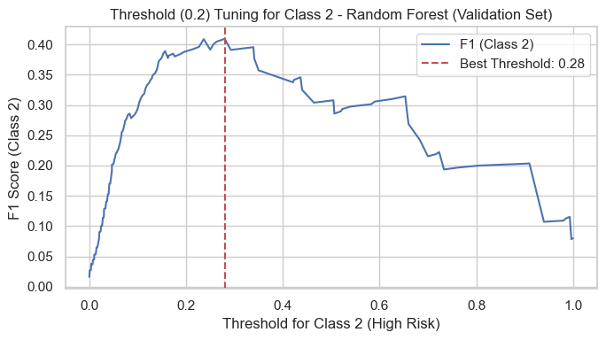 | 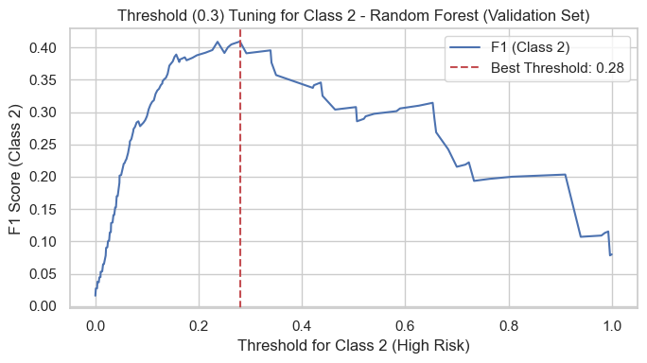
Figure 41 Threshold Tuning Curve for Class 2 – Random Forest (Validation Set)

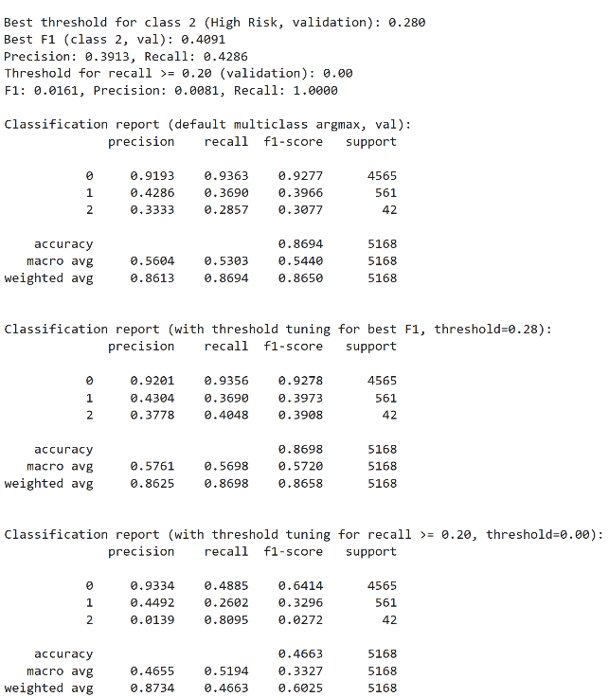 | 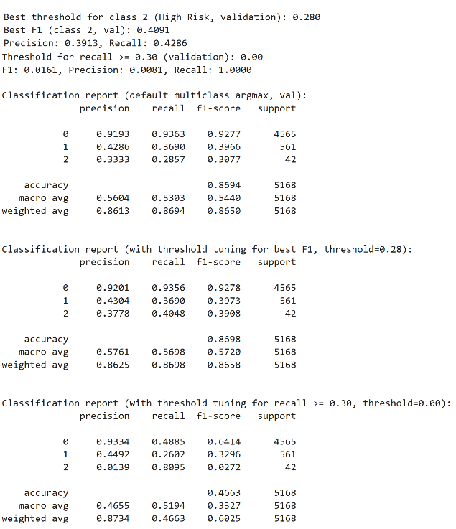
Figure 42 Classification Report for Random Forest (Threshold=0.28, Validation Set)

XGBoost Threshold Tuning Results – Validation Set
Table 12 XGBoost Threshold results
Metric / Class | Default (argmax) | Tuned (Best F1, thr=0.57) | Tuned (Recall ≥ thr=0.00)
F1 (Class 2) | 0.2791 | 0.2791 | 0.0161
Precision (Class 2) | 0.2727 | 0.2727 | 0.0081
Recall (Class 2) | 0.2857 | 0.2857 | 1.0000
Macro F1 | 0.4943 | 0.4943 | 0.0055

Performance on the rare class is similar to LightGBM. The model struggles to detect true High Risk clients, with both precision and recall remaining low. No improvement with threshold tuning—metrics for Class 2 are identical to the default. XGBoost does not benefit from threshold adjustment for rare class detection in this setup. Recall reaches 1, but precision and F1 score become nearly zero due to the huge number of false positives.
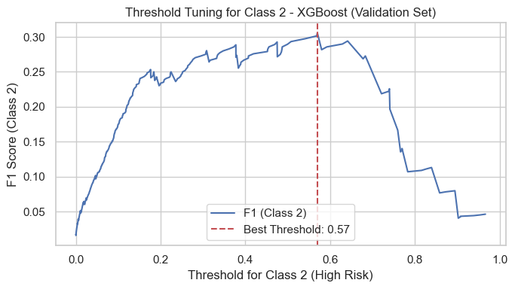 | 
Figure 43 Threshold Tuning Curve for Class 2 – XGBoost (Validation Set)

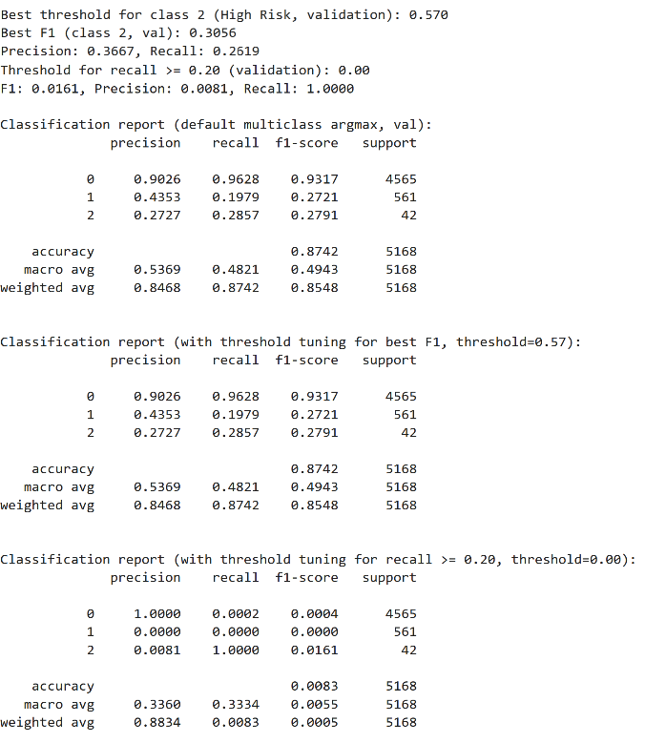 | 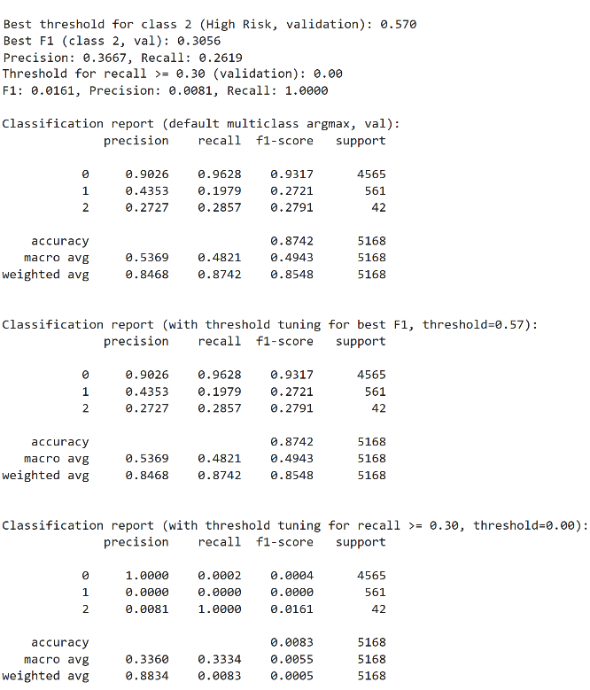
Figure 44 Classification Report for XGBoost (Threshold=0.57, Validation Set)

Threshold tuning leads to a substantial improvement only for Random Forest. Both F1 and recall for the High Risk class increase notably without sacrificing too much precision or overall macro F1. LightGBM and XGBoost show little or no improvement with threshold tuning for the rare class. Their best achievable F1 and recall remain at the default multiclass settings. Extremely low thresholds ( 0.00) are not practical for any model. They yield perfect recall but make the models unusable due to a flood of false positives and nearly zero precision. The best practical approach for rare class detection in this context is threshold tuning with Random Forest (optimal threshold ~0.28). Both recall and precision improve, making it more suitable for real-world use where High Risk clients must be detected without overwhelming the system with false alarms.

Threshold Optimization for Minority Class (High Risk)
Table 13 Threshold optimization all models
Model | Best threshold | F1 Score (Class 2) | Precision (Class 2) | Recall  (Class 2) | F1 Macro
Random Forest | 0.28 | 0.4091 | 0.3913 | 0.4286 | 0.5720
XGBoost | 0.57 | 0.3056 | 0.3667 | 0.2619 | 0.4943
LightGBM | 0.45 | 0.2785 | 0.2973 | 0.2619 | 0.4671

Threshold tuning is a powerful lever, but works best when the model already has learned meaningful signals for the rare class, as in the case of Random Forest. It is less effective when the base model is weak for the minority class. All models are fundamentally limited by the extreme class imbalance. No threshold can fully compensate for the lack of minority samples without hurting performance elsewhere. Precision-recall trade-offs become stark as the threshold is reduced too much (leading to many false positives). XGBoost and LightGBM, while robust in general, struggle to significantly boost recall for the High Risk class—a crucial metric in credit risk scenarios where missing true high-risk clients can have severe business implications.
Random Forest emerges as the most effective model for minority class detection after threshold tuning, balancing both recall and precision, and achieving the highest overall macro F1.
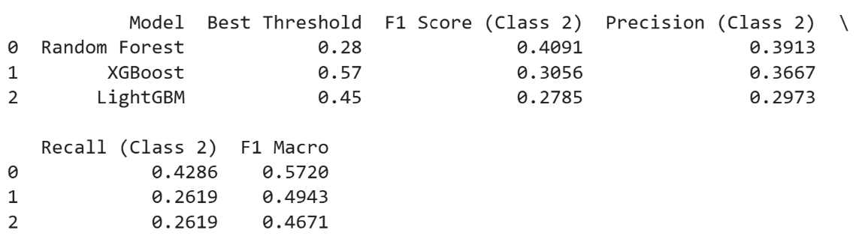
Figure 45 Minority Class Threshold Optimization

Final Model Evaluation Results (Test Set)

After model development, feature engineering, and hyperparameter optimization are complete, the final evaluation of all models is performed on a separate test set. The test set serves as an unseen, untouched portion of the data that simulates how the model will behave on new, real-world cases. Its primary purpose is to provide an unbiased estimate of model performance and generalization, unaffected by previous training, validation, or tuning steps.
The test set acts as the ultimate benchmark, revealing how well the model is likely to perform when deployed. It helps to detect overfitting by showing whether high performance on training and validation data actually carries over to truly unseen data. The test set is strictly isolated during all earlier stages. No rows or information from the test set are used for feature engineering, hyperparameter tuning, or resampling. No resampling techniques such as SMOTE, ADASYN, or class weighting are ever applied to the test set. These are only used during model training to help the algorithm learn from imbalanced data, but the final evaluation must reflect the natural, imbalanced class distribution as it occurs in practice. The model pipeline is fit on the full training set, with all hyperparameters and preprocessing steps determined in advance. The test set predictions are made using the trained model, and all relevant metrics are computed on these raw, unaltered test samples. Fit on the entire training set (after all tuning, no resampling) . Fit, predict and evaluate on test set (X_test_final)
Table 14 Summary Test Set Model Performance
Model | F1 Macro | AUC-ROC | AP Macro | Recall  (Class 2) | Precision  (Class 2)
Logistic Regression | 0.3564 | 0.6103 | 0.3757 | 0.1463 | 0.1132
Random Forest (Threshold) | 0.5458 | 0.7584 | 0.5208 | 0.4146 | 0.3091
Random Forest | 0.5481 | 0.7584 | 0.5208 | 0.3171 | 0.4062
Gradient Boosting | 0.4075 | 0.7260 | 0.4079 | 0.1707 | 0.0483
XGBoost | 0.5061 | 0.7624 | 0.4838 | 0.1951 | 0.4444
LightGBM | 0.5132 | 0.7658 | 0.5013 | 0.1951 | 0.3636
CatBoost | 0.4998 | 0.7519 | 0.4788 | 0.2683 | 0.2500
AdaBoost | 0.3126 | 0.6022 | 0.3659 | 0.0000 | 0.0000
Balanced Random Forest | 0.3450 | 0.6768 | 0.4470 | 0.5854 | 0.0508

- Random Forest (with threshold tuning) delivers the best trade-off between overall performance and high-risk client detection, with a solid F1 macro (0.546), high AUC-ROC, and strong recall for class 2 (0.41). Threshold tuning improves recall for rare cases, making it suitable for risk-sensitive applications, even though there is a small trade-off in precision.
- Standard Random Forest achieves the highest F1 macro (0.548) and precision for class 2 (0.41), but its recall for high-risk clients is slightly lower than with threshold tuning.
- XGBoost and LightGBM offer competitive F1 macro and AUC-ROC values, and the highest precision for class 2 (0.44 and 0.36 respectively), but their recall remains modest. They are robust, but not optimal for maximizing rare event capture.
- CatBoost is stable, achieving balanced performance across all metrics, but neither recall nor precision for class 2 is leading.
- BalancedRandomForest achieves the best recall for class 2 (0.59), but at the expense of extremely low precision (0.05), resulting in many false positives. This makes it less practical for deployment, as most flagged high-risk cases would be incorrect.
- Logistic Regression and AdaBoost perform poorly in all metrics, confirming their unsuitability for this highly imbalanced multiclass credit risk task.
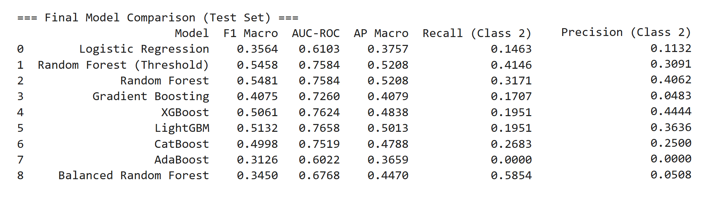
- Gradient Boosting (scikit-learn) is outperformed by XGBoost and LightGBM in all aspects, especially for the minority class.
Figure 46 Final evaluation Test Set

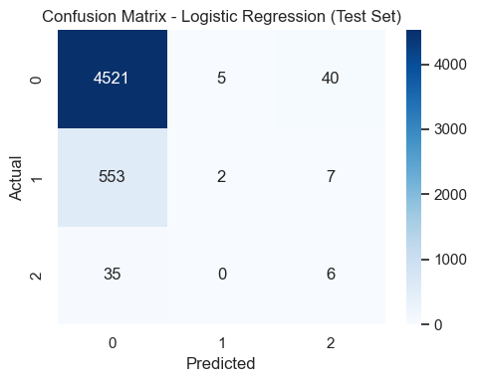 | 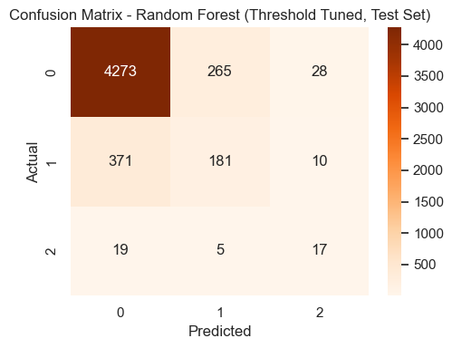 | 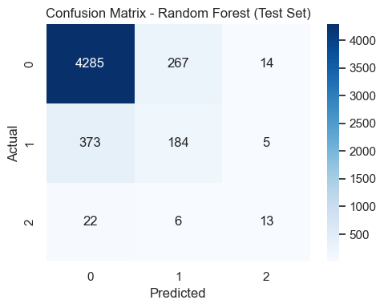
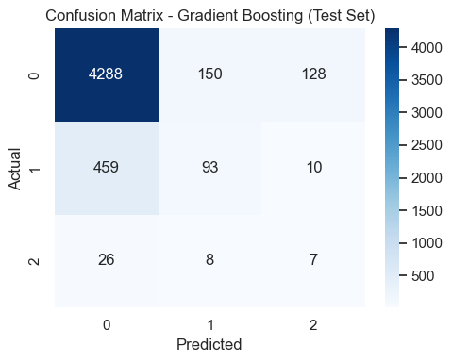 | 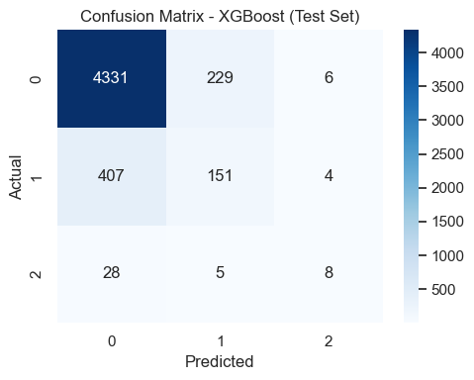 | 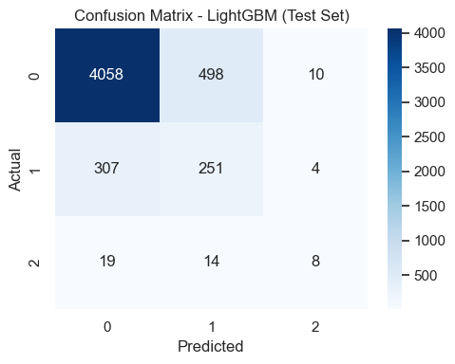
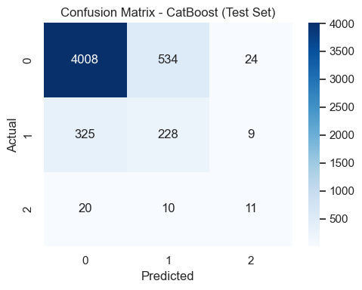 | 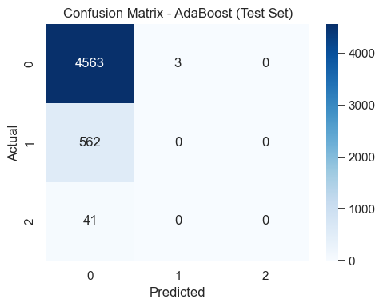 | 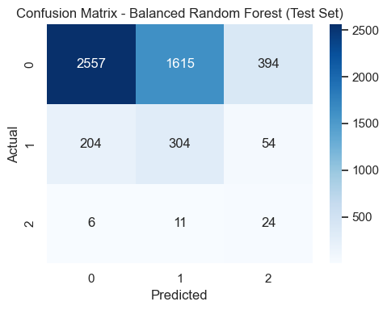
Figure 47 Confusion Matrix Test Set

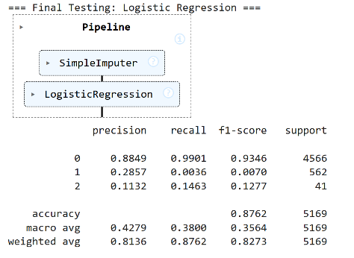 | 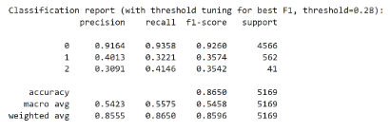 | 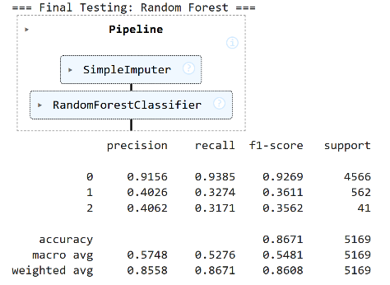
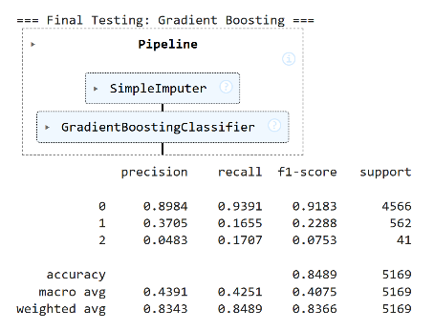 | 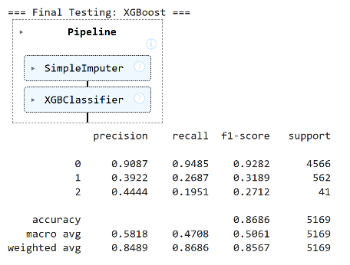 | 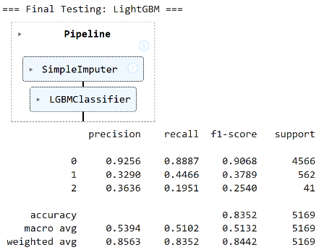
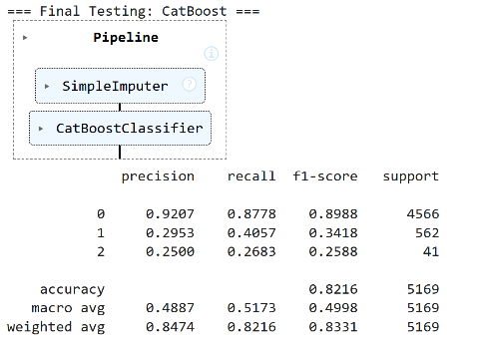 | 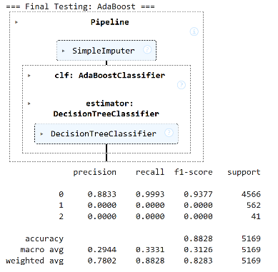 | 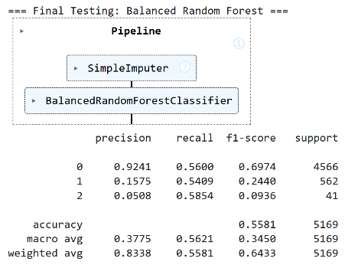
Figure 48 Classification Report Test Set

Final Model Selection and Justification

After extensive evaluation, Random Forest with threshold tuning was selected as the recommended model for deployment. This choice is grounded in both project goal objectives and rigorous benchmarking against established performance standards.
The primary business goal in credit risk assessment is to maximize detection of high-risk clients while ensuring robust overall performance. Among all candidate models, Random Forest with threshold tuning delivered the best recall for the rare High Risk class (0.41), while maintaining strong macro F1 (0.54), AUC-ROC (0.75) and AP macro (0.52) scores. These results place the model solidly in the “Good” category according to industry benchmarks (Table 2), and above the “Acceptable” threshold for all major metrics.
This outcome is especially important given the cost asymmetry in credit risk: false negatives (missed high-risk clients) typically lead to significant financial losses, while false positives (flagging some safe clients as risky) have a lesser business impact. The improved recall comes with a reasonable decrease in precision, but this is a justifiable compromise in most financial settings.
In summary, Random Forest with threshold tuning stands out as the most balanced, robust, and operationally sound model for credit risk multiclass classification in this study. Its superior recall for the rarest and most critical class supports fair, explainable, and business-relevant decision-making.

Table 15 Summary Best Model Performance
Model | F1 Macro | AUC-ROC | AP Macro | Precision Class 2 | Recall  Class 2
RF (Threshold) | 0.5458 | 0.7584 | 0.5208 | 0.3091 | 0.4146

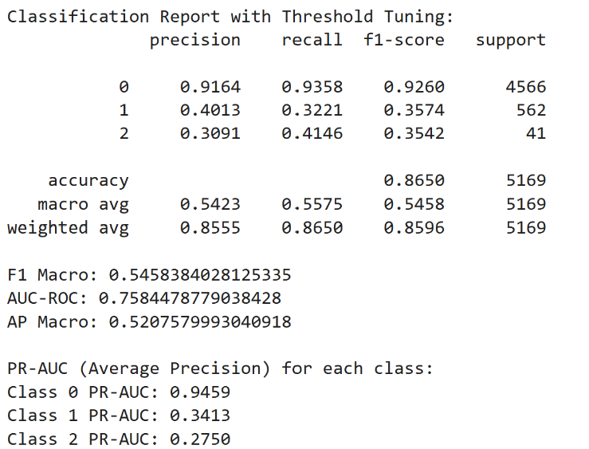 | 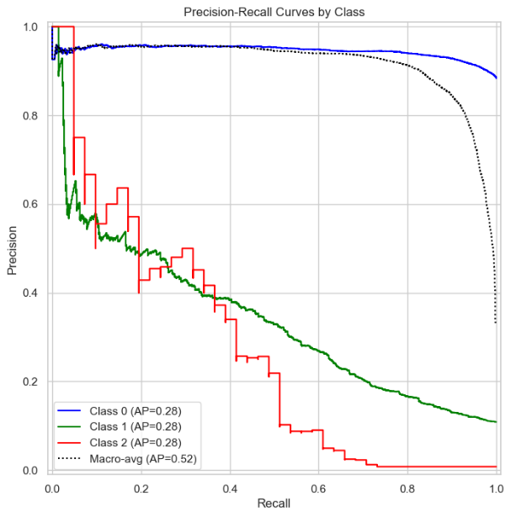
Figure 49 Final Model Classification Matrix, results and PR Curves by class

Despite notable improvements, several limitations remain. Even with advanced resampling (SMOTE), cost-sensitive learning, and threshold tuning, the detection rates for the rare High Risk class are still moderate in absolute terms. This reflects the inherent difficulty of minority class prediction in highly imbalanced real-world datasets. Precision for class 2 remains below 0.35, indicating that a portion of flagged high-risk clients are in fact lower risk, a trade-off accepted in operational credit risk.
Alternative techniques, such as ensemble stacking, more granular risk segmentation, or the integration of external behavioral data, could further improve rare event detection. Finally, all results should be interpreted in the context of business and project goal objectives and regulatory constraints, not solely in terms of statistical metrics.

Feature Importance

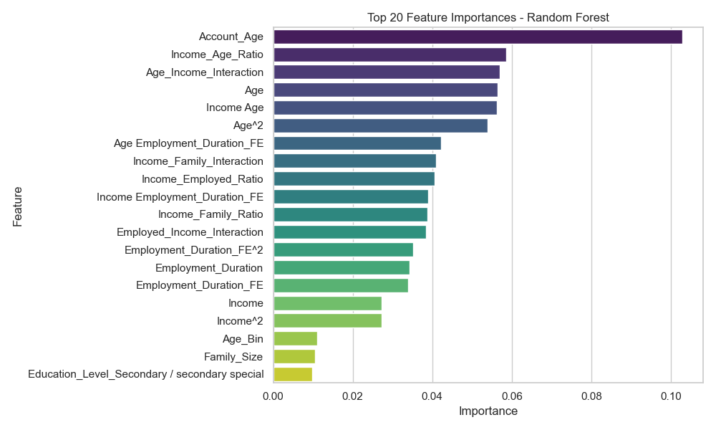
Feature importance analysis was conducted on the final Random Forest model to enhance interpretability and support transparency for stakeholders. The following discussion summarises the ranking and practical implications of the top predictive features identified by the model. In the case of Random Forest, feature importance scores are obtained via the feature_importances_ attribute from the pipeline clf.
Figure 50 Random Forest Feature Importances

The most influential feature is Account_Age, which consistently exhibited the highest importance score. This variable, representing the duration of a client’s credit history, aligns with established findings in credit risk literature, where longer credit history is associated with lower risk (Hand & Henley, 1997). Several engineered variables, particularly interaction and ratio features such as Income_Age_Ratio, Age_Income_Interaction, and Income_Family_Interaction, were also among the most important predictors. These features were designed to capture complex, non-linear relationships, and their prominence confirms the added value of domain-driven feature engineering in risk modelling. Core demographic and financial variables, including Age, Income, and Employment_Duration_FE, maintained significant influence, reflecting their continued relevance in both academic and industry practice. Polynomial and binned features (e.g., Age^2, Income^2, Age_Bin) appeared in the top 20, suggesting that non-linear transformations contribute to the model’s ability to capture nuanced patterns within the data. Overall, the feature importance analysis indicates that both domain-specific engineered variables and traditional financial indicators are essential for effective credit risk classification. The interpretability offered by this analysis supports model transparency, which is increasingly recognised as a critical requirement in responsible AI applications in finance (Doshi-Velez & Kim, 2017).

SHAPE Explainability

SHAP (SHapley Additive exPlanations) is a state-of-the-art framework for model interpretability, developed to explain the output of machine learning models by attributing each feature’s contribution to a given prediction. SHAP values are grounded in cooperative game theory, specifically the concept of Shapley values, providing a theoretically consistent approach to measure feature impact (Lundberg & Lee, 2017). In the context of credit risk classification, SHAP enables the decomposition of each model prediction into the sum of feature contributions, thus offering both local (individual prediction) and global (dataset-level) interpretability.
The primary objective of applying SHAP in this study was to provide transparency into the decision-making process of the Random Forest model, the final recommended classifier for credit risk segmentation. SHAP was used to:
- Identify the most influential features globally, across all test samples (global importance).
- Interpret individual predictions for real clients, highlighting which features contributed positively or negatively to the models output (local explanation).

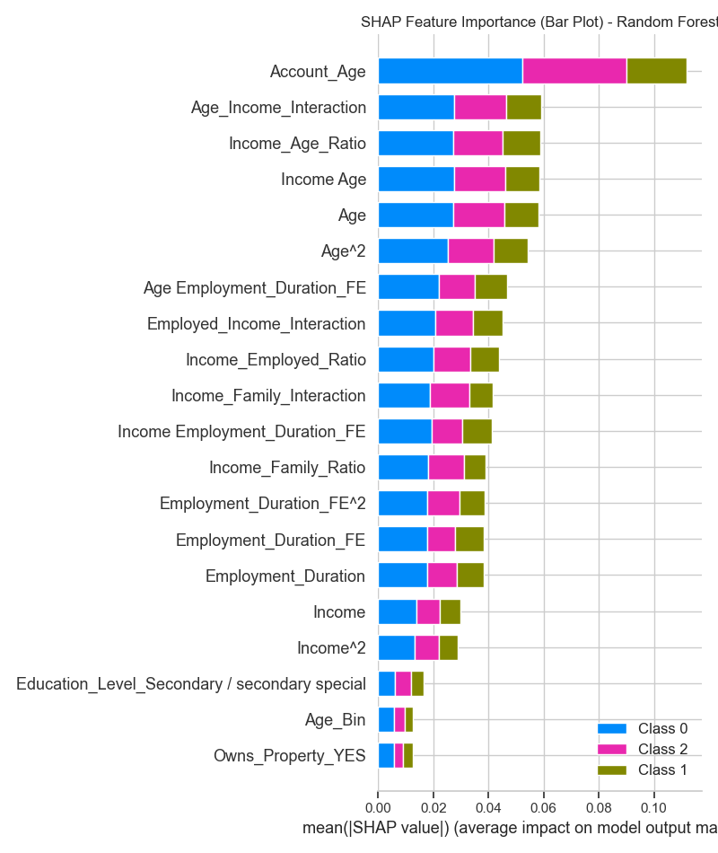
Figure 51 SHAPE Feature Importance Boxplot

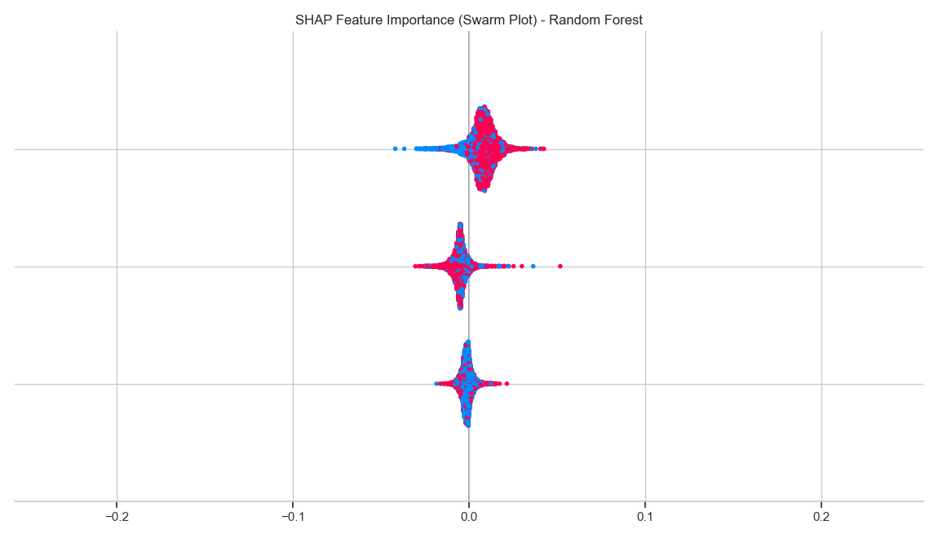
Figure 52 SHAPE Feature Importance Swarm Plot

The workflow consisted of generating SHAP values for all test set instances and visualizing them using both bar plots (for global feature importance) and force plots (for individual clients from each risk class). The bar plot summary ranks features according to their mean absolute SHAP value, indicating their overall impact on model predictions. Swarm plots provide additional insights into the direction and distribution of feature effects.
Features such as Account_Age, Income, and certain interaction or ratio variables (e.g., Income_Age_Ratio) were consistently among the top contributors to the model’s risk prediction, as indicated in the global SHAP summary plot.
Local force plots for individual clients demonstrate the nuanced way in which features interact: for example, a high Account_Age may reduce predicted risk, while high Income_Family_Ratio may have the opposite effect depending on context.

By integrating SHAP explanations, the model predictions become more interpretable and auditable, supporting regulatory compliance and stakeholder trust. These explanations also highlight which features drive high-risk classifications, which is critical in sensitive domains such as finance. SHAP's implementation encounters three key limitations: substantial computational overhead particularly with large-scale datasets and ensemble methods, the complexity of translating cooperative game theory concepts for non-technical audiences despite visualization aids, and the risk of inaccurate feature attributions when analyzing correlated financial variables due to inherent independence assumptions (Molnar, 2022).

Case Study: SHAP Force Plot Explanation
To demonstrate the local explainability of the Random Forest model, a force plot was generated using SHAP for a real client from the test set (original_idx = 0), classified as Good Client (Class 0). This visualization provides insight into the specific features and values that contributed to the model prediction.
Table 16 Selected Client Details
ID 5008806  Gender M  Owns Car Y  Owns Property Y  Children Count 0  Income 112,500.0  Income Type Working  Education Level Secondary / secondary special  Marital Status Married  Housing Type House / apartment  Age 58.8  Employment Duration 3.1  Occupation Security staff  Family Size 2.0  Risk Level 0 (Good Client)  Account Age 29  Is Unemployed 0 | 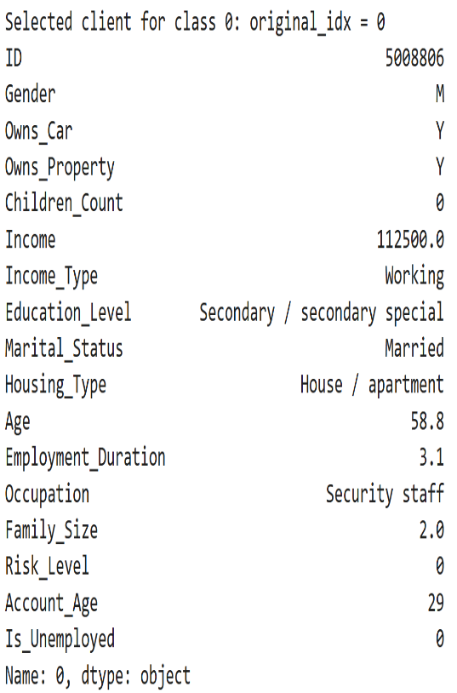

The force plot for this client idx=0, illustrates how individual features influenced the model output towards the "Good Client" class.
Figure 53 Force plot for client idx=0
The force plot visualizes how the individual feature contributions, expressed as SHAP values, shift the model output from the base value (expected model prediction) towards a high probability for class 0. The predicted probability for class 0 (Good Client) is 0.94, substantially above the base value of 0.33, which is the average prediction for this class across all clients in the test set.
The most influential positive contributions (red, arrows to the right) include:
- Income_Age_Ratio (0.475): A higher ratio of income to age, which suggests that the client earns significantly more relative to their age group, indicating strong financial stability.
- Age_Income_Interaction (0.4603) and Income Age (0.4603): Both features capture the joint effect of age and income, showing that higher values here strongly increase the likelihood of being classified as low risk.
Smaller positive effects are visible from other interaction features.
Features that have a minor negative impact (pulling left, but not strong enough to offset the positive) include:
- Age_Employment_Duration_FE (–0.7254) and Income_Employed_Ratio (–0.4141): These features may indicate that employment duration relative to age or income is lower than the training mean, but the negative impact is outweighed by the client's income and age profile.
- Account_Age (–0.2516): While a longer account age generally supports creditworthiness, in this case, its effect is negative, possibly due to feature interactions.
The overall effect of these feature contributions is to push the model’s output decisively towards class 0. This means the client is strongly predicted to be low risk, with financial and demographic indicators reinforcing the model’s confidence. The force plot provides clear, interpretable evidence for the model’s decision, making it suitable for both regulatory transparency and client-facing explanations.

AIF360 and Fairness Evaluation

Ensuring algorithmic fairness is a fundamental requirement for machine learning applications in credit risk assessment, especially given the ethical, legal, and regulatory constraints in the financial sector (Barocas, et al., 2019), ( Bellamy, et al., 2018), (European Commission, 2021). Credit risk models trained on historical data can inadvertently encode or amplify social biases present in the data, potentially leading to unfair treatment of individuals belonging to protected groups. To address this risk, this dissertation applies a comprehensive fairness analysis using the IBM AI Fairness 360 (AIF360) toolkit, following best practices in both academic and industry settings.
AIF360 is an open-source library that provides standardized implementations for detecting and quantifying bias, as well as algorithms for mitigation, across multiple protected attributes. In this project, three legally and ethically significant attributes were assessed: Gender, Age, and Education Level. This selection reflects both the literature (Barocas, et al., 2019) and current financial compliance standards.
For each attribute, four established group fairness metrics were computed:
- Statistical Parity Difference (SPD) measures the absolute difference in the probability of receiving a positive outcome between unprivileged and privileged groups. A value of zero indicates perfect fairness, where both groups have the same likelihood of being assigned a favorable outcome by the model. Positive or negative values indicate potential group-level bias.
- Disparate Impact (DI) is the ratio of the probability of a positive outcome for the unprivileged group to that for the privileged group. A value close to 1 indicates parity, while values below 0.8 or above 1.25 may indicate problematic bias, according to standard legal and regulatory thresholds (Feldman, et al., 2015).
- Equal Opportunity Difference (EOD) evaluates the difference in true positive rates (TPR, or recall) between unprivileged and privileged groups, considering only those instances where the actual outcome is positive. This metric assesses whether both groups have equal opportunity to receive a correct positive prediction. Values close to 0 indicate that the model provides equal opportunity for favorable outcomes to both groups.
- Average Odds Difference (AOD) is the average of the differences in true positive rates and false positive rates between unprivileged and privileged groups. This metric offers a more comprehensive measure of fairness by considering both correct and incorrect positive predictions. Values close to 0 suggest similar prediction behavior (in terms of both errors and successes) across groups.

All test data and predictions were aligned using a unique identifier (index alignment), and ensuring binary/numeric encoding ensuring exact correspondence between model outputs and the fairness analysis dataset df_test_fairness, in accordance with best practices for AI fairness assessment.
This is essential to avoid sample misalignment in fairness computations. The final Random Forest classifier (with optimal threshold tuning for the High Risk class) was used to generate predictions on the test set.
Test data, true labels, and predictions were converted to AIF360-compatible StandardDataset objects. Each protected attribute was separately encoded to define privileged and unprivileged groups:

- Gender: Male (privileged) vs. Female (unprivileged)
Table 17 Fairness Metrics (Gender as protected attribute)
Metric | Value | Interpretation
Statistical Parity Difference (SPD) | -0.0045 | Close to 0, almost no bias in selection rate between males and females.
Disparate Impact (DI) | 0.95 | Near the ideal value of 1.0, no significant disparate impact.
Equal Opportunity Difference (EOD) | -0.0033 | Near 0, opportunity is equally distributed.
Average Odds Difference (AOD) | -0.0084 | Near 0, both true positive and false positive rates are balanced.

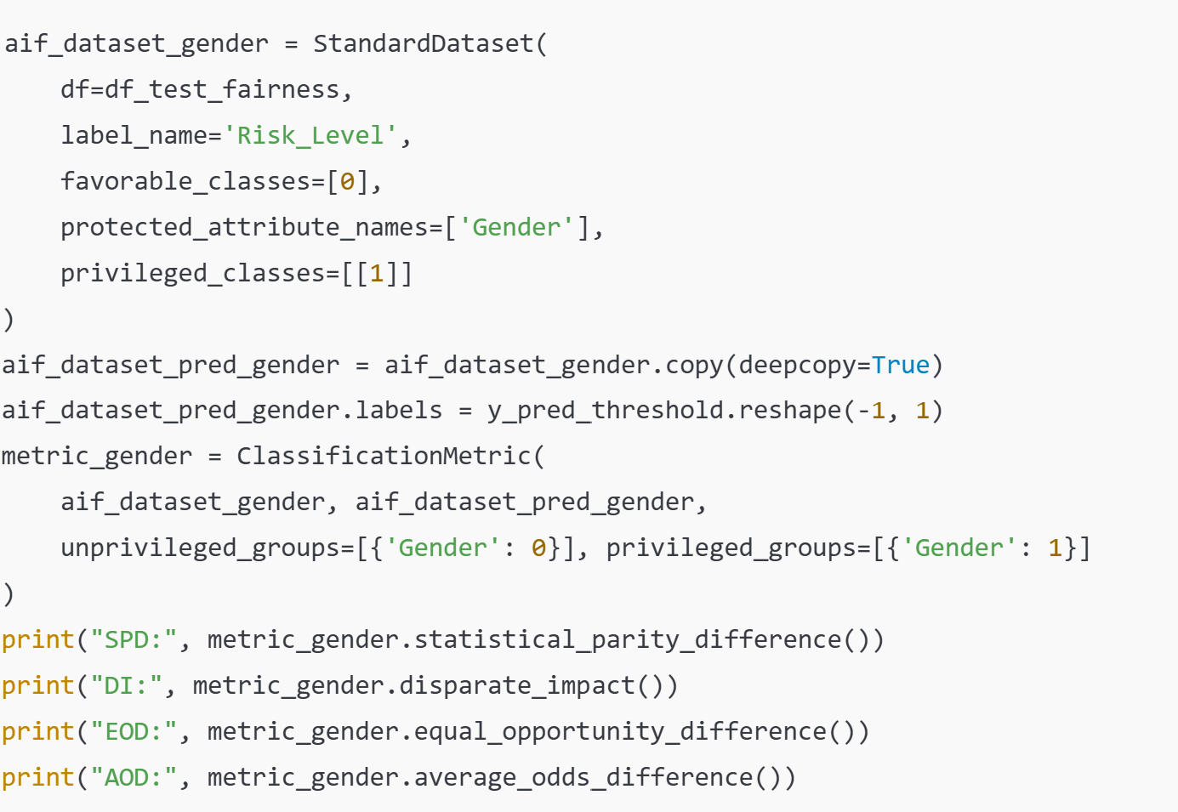
Code Screenshot 16 Age predictions assigned to AIF360
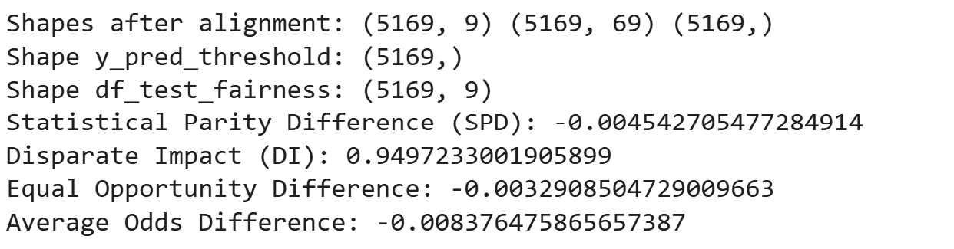
Figure 54 Gender output predictions

All core group fairness metrics are close to the ideal values (0 for differences, 1 for ratios). The results suggest that, on the test set, the Random Forest model does not exhibit significant gender bias in predicting credit risk.

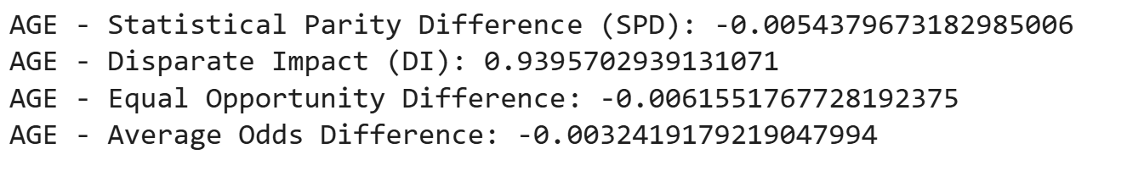
- Age: Age ≥ median (privileged) vs. Age < median (unprivileged)

Figure 55 Age output predictions

Fairness metrics computed with age as the protected attribute (privileged group: clients with age above the median). All fairness metrics are close to their ideal values, indicating the model does not display significant age-based bias in its predictions.
For fairness analysis with respect to age, the sample median (42.6 years) was used as a threshold to define privileged and unprivileged groups. This approach is standard practice when no domain-specific cut-off is available, as it ensures balanced group sizes and unbiased metric computation ( Bellamy, et al., 2018) (Barocas, et al., 2019).

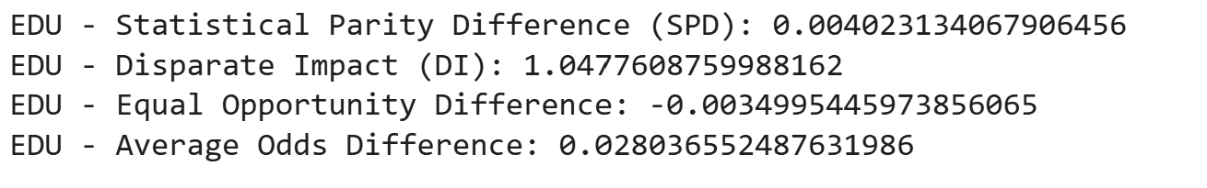
- Education: Higher/Academic degree (privileged) vs. Other (unprivileged)
Figure 56 Education output predictions
Using education level as the protected attribute (privileged: clients with higher education or academic degree), fairness evaluation reveals Figure 5.24. The proximity to ideal fairness thresholds demonstrates minimal bias related to educational background.
Table 18 Summary of All Fairness Metrics Results
Protected Attribute | Statistical Parity Difference (SPD) | Disparate Impact (DI) | Equal Opportunity Difference | Average Odds Difference
Gender | -0.0045 | 0.9497 | -0.0033 | -0.0084
Age (≥ median) | -0.0054 | 0.9396 | -0.0062 | -0.0032
Education Level | 0.0040 | 1.0478 | -0.0035 | 0.0280

All fairness metrics are within a neutral or “no-bias” range. SPD and EOD are close to zero, indicating minimal disparity in acceptance and opportunity across groups. DI is close to 1 for all attributes, indicating parity in positive prediction rates between privileged and unprivileged groups. AOD is near zero, suggesting no significant imbalance in odds across groups. These results indicate that the final model, as evaluated on the holdout test set, does not introduce significant bias with respect to gender, age, or education, under the adopted definitions and sample distribution.
Visualizations
These visualizations provide an at-a-glance summary of all fairness metrics across the three protected attributes.
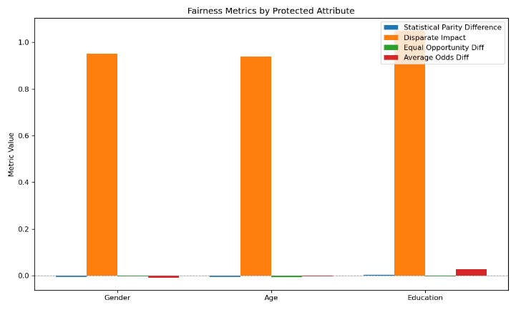 | 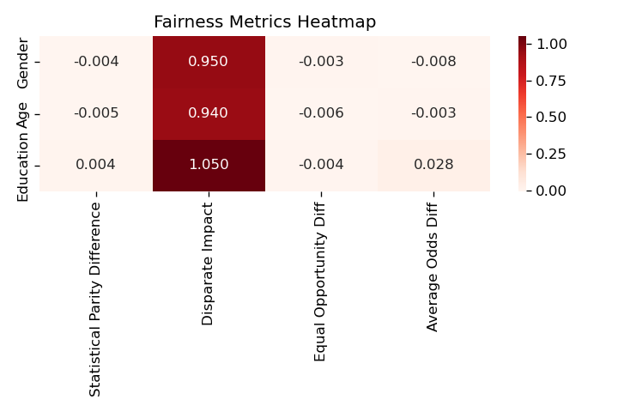
Figure 57 Fairness Metrics Barplot and Heatmap

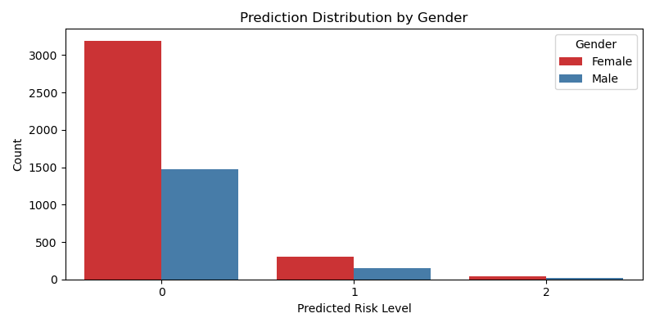
For each attribute (gender, age group, education level), visualizations were constructed side-by-side the true distribution of risk classes and the predicted distribution. This provides a direct visual check for bias or systematic errors in the model's decisions. To further understand model behavior, comparative visualizations of the distribution of predicted risk classes for each subgroup (e.g., Age < median vs Age ≥ median). These plots help reveal if certain groups are systematically assigned to higher or lower risk.
Figure 58 Protected Distribution by Gender
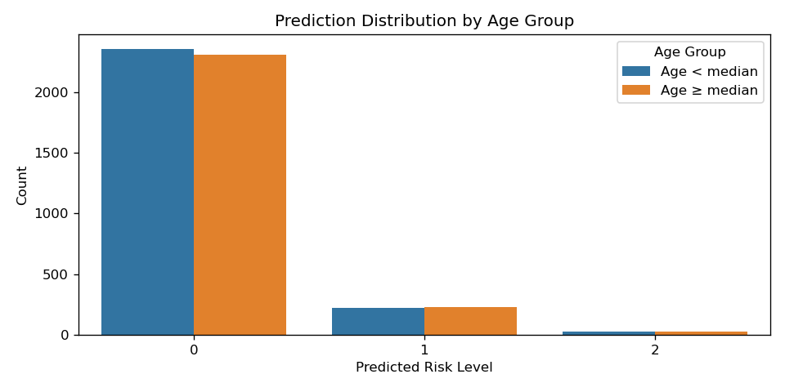
Figure 59 Protected Distribution by Age

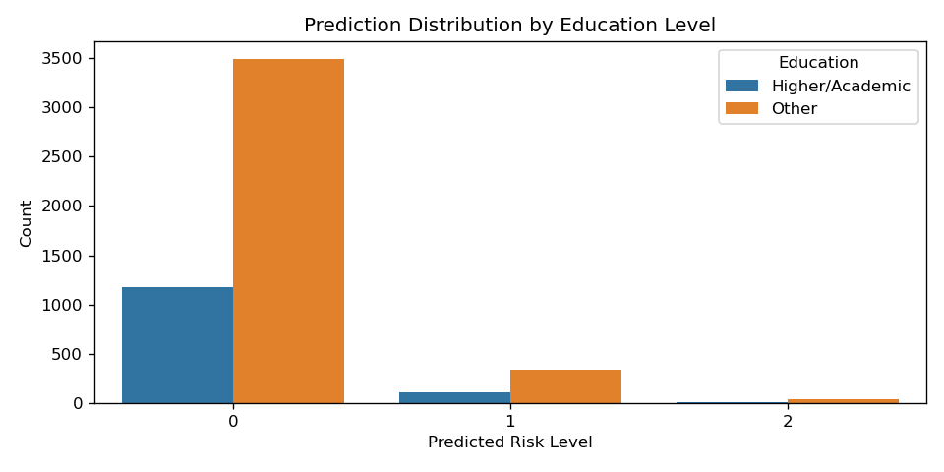
Figure 60 Protected Distribution by Education

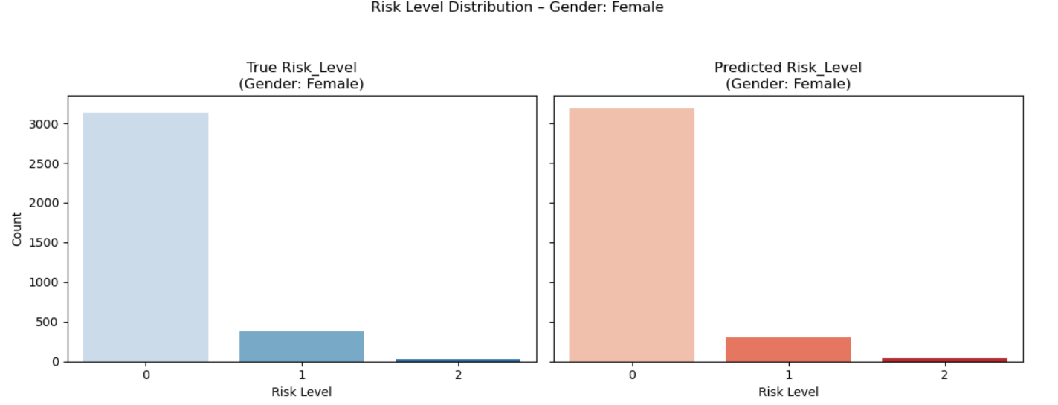
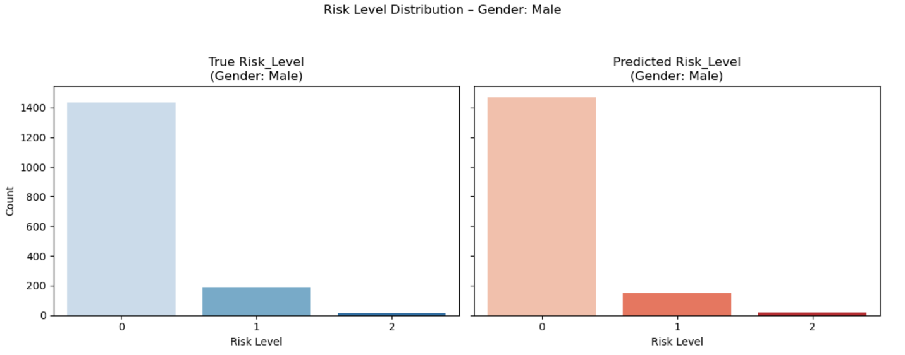
Figure 61 Risk Level Distribution by Protected Attribute Gender

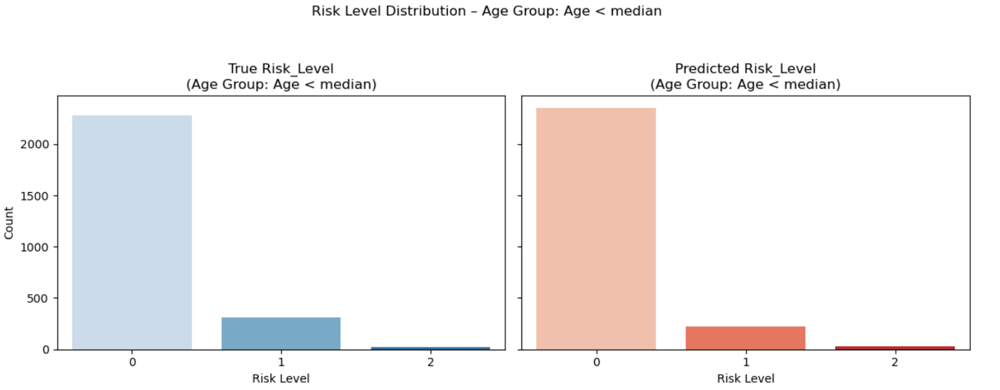
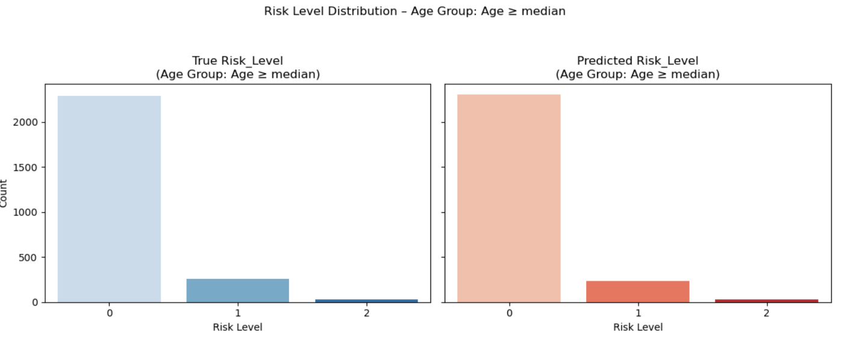
Figure 62 Risk Level Distribution by Protected Attribute Age

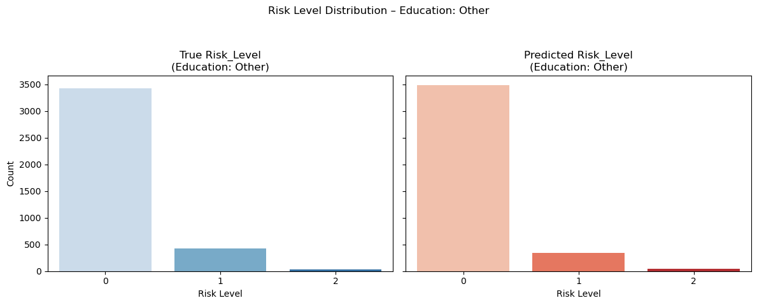
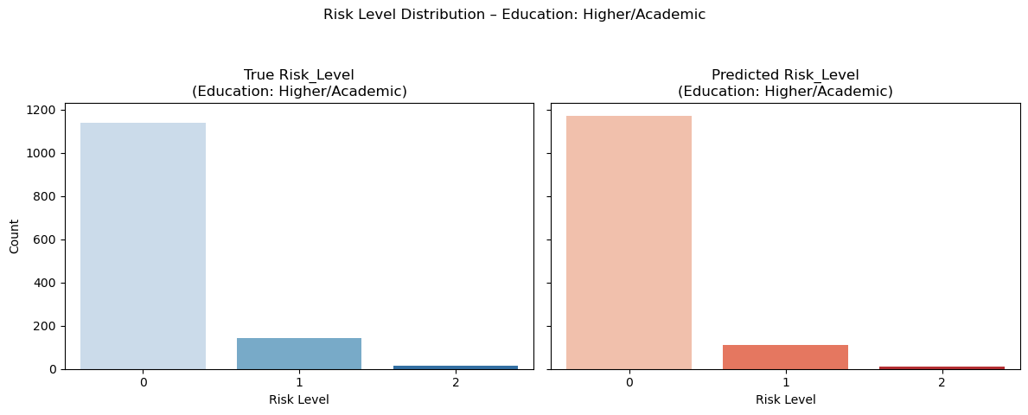
Figure 63 Risk Level Distribution by Protected Attribute Education
While the Random Forest model with threshold tuning achieves robust overall predictive performance, the fairness analysis demonstrates that its deployment does not create disparate impact or treatment across key demographic groups, as measured by standard group fairness metrics. These findings support the model’s suitability for real-world deployment from a fairness perspective.
However, fairness metrics alone do not guarantee absence of bias under all possible definitions, nor do they account for intersectional or subgroup effects. The fairness assessment is also contingent on the sample distribution and labeling in the test set. Continued monitoring is recommended should the model be applied in a dynamic or changing population.

Chapter 6 – Deployment

Deployment Methodology

The deployment of the credit risk classification system was implemented as an interactive web dashboard using Streamlit Cloud, a cloud-based platform that enables fast and reproducible deployment of Python applications. Streamlit was selected due to its open-source nature, minimal infrastructure requirements, and the ability to integrate advanced model interpretability and fairness tools directly within a user-facing application. This approach is aligned with current best practices in AI productization, where explainability and accessibility for end-users and stakeholders are required (Saarela & Podgorelec, 2024).
The model chosen for deployment was the Random Forest classifier with threshold tuning for the High Risk class. All preprocessing steps, feature engineering, and model artifacts were serialized and loaded at runtime to ensure consistency between training and deployment. The pipeline includes:

- Median imputation for missing values
- All feature encodings
- The final trained Random Forest model
- SHAP (SHapley Additive exPlanations) values and explainer for global and local interpretability
- Precomputed fairness metrics (using AIF360) across Gender, Age, and Education Level

This live dashboard enables interactive exploration of model predictions, fairness metrics, and SHAP explanations, supporting transparency for both technical and non-technical users.

To ensure reproducibility and facilitate deployment, all relevant project files were systematically organized and made available in a public GitHub repository. The repository includes the main application script app.py, preprocessed datasets (final_datasets), serialized model artifacts (models), SHAP explainers, generated plots (plots), utility functions (utils), and essential configuration files such as requirements.txt and README.md. This structure enables straightforward code execution, review, and future extension by both academic and industry practitioners.

The Streamlit dashboard is hosted online and is publicly accessible at:
https://fair-and-explainable-ai-for-credit-risk-classification-iwyjlgb.streamlit.app/

Deployment assets are version-controlled and hosted via GitHub repository at:
https://github.com/victorctin/Fair-and-Explainable-AI-for-Credit-Risk-Classification

UI Design and Usability

The user interface (UI) was designed to prioritize clarity, transparency, and accessibility for business analysts, risk officers, and non-technical stakeholders. The dashboard is divided into five main navigation sections:
- Fairness Overview: Presents global group fairness metrics, including Statistical Parity Difference, Disparate Impact, Equal Opportunity Difference, and Average Odds Difference, for Gender, Age, and Education. Results are shown in both tabular and graphical (barplot, heatmap) formats.
- Client SHAP & Fairness: Allows users to select any test client and view their raw features, predicted risk level, individual SHAP force plot (explaining the model's decision), and their protected attributes. This supports individual-level auditing and bias detection.
- Global Feature Importance: Displays global SHAP bar and beeswarm plots, helping users understand which features most influence model predictions across the test set.
- Feature Distribution: Enables visualization of feature distributions by predicted risk class, supporting data-driven exploration of variable importance and risk segmentation.
- Download Reports & Plots: Provides access to downloadable metrics, visualizations, and model artifacts, facilitating external reporting and compliance audits.
Key usability features include: Intuitive sidebar navigation for easy access to all sections. Explanatory legends for protected attribute encoding. Download buttons for all reports and visualizations and real-time recalculation of fairness metrics, enabling rapid testing of different prediction scenarios.

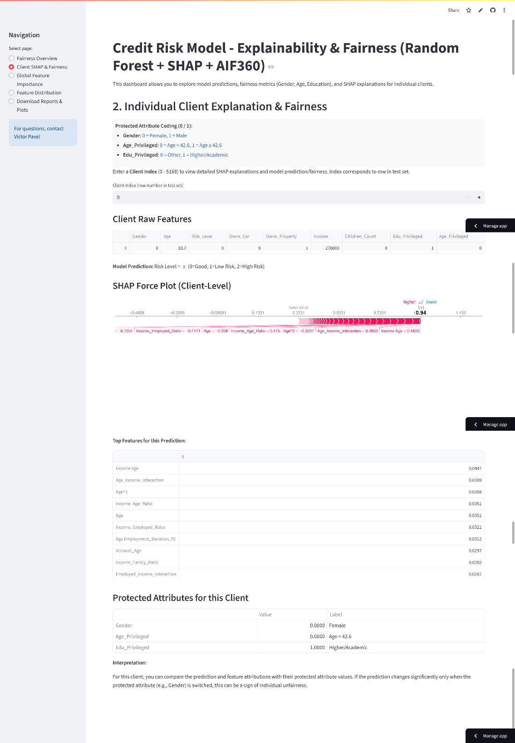
Screenshots and sample outputs are included in the appendix as case studies, illustrating the usability and transparency of the dashboard. These examples demonstrate how the platform enables both technical and non-technical users to audit model predictions and assess fairness in real-world scenarios.
Figure 64 Streamlit Dashboard

Chapter 7 - Discussion and Critical Evaluation

This dissertation investigated the integration of fairness and explainability techniques within an advanced machine learning pipeline designed for multiclass credit risk classification. The project successfully achieved its primary goals by developing and deploying a robust Random Forest model enhanced through synthetic oversampling (SMOTE), threshold tuning, and fairness-aware methodologies.
The model fulfilled its primary requirement of accurately identifying high-risk clients (Class 2), achieving a recall of 0.41, aligning closely with the predefined 'good' benchmark range. While this significantly improved detection of high-risk cases, it came at the cost of slightly reduced precision, indicating that the model may label more applicants as high risk than strictly necessary. Nevertheless, this trade-off was justified by the critical financial implications of missed high-risk identifications.
The implementation of the SHAP method successfully addressed the interpretability requirement, providing clear, intuitive visualizations that explain individual predictions and global model behavior. However, SHAP's computational overhead, especially for large datasets, represented a limitation, highlighting the need for efficient and scalable alternatives in future work.
The fairness analysis using IBM's AIF360 toolkit demonstrated that the model exhibits minimal bias regarding gender, age, and educational level, with all fairness metrics (SPD, DI, EOD, AOD) closely aligned with ideal values. This confirms that the methodology effectively mitigated potential discriminatory effects, satisfying both ethical and regulatory standards.
Despite these achievements, some constraints were evident. The severe class imbalance, with less than 1% of the dataset classified as high risk, posed significant challenges, particularly affecting the reliability of synthetic data generated via SMOTE. The generalizability of the model also warrants caution, as results might differ across other datasets or demographic contexts.
Additionally, the choice of Streamlit Cloud for deployment provided a user-friendly prototype but lacked advanced features necessary for a robust production environment, such as real-time monitoring and user authentication.
Critical Evaluation and Recommendations for Future Experiments
While this study successfully developed a fair and explainable credit risk classification system achieving notable performance (F1-macro: 0.546, High Risk recall: 0.41) through a rigorous and comprehensive methodology that systematically addressed data imbalance, fairness, explainability, and usability, several limitations warrant consideration: the aggressive IQR-based outlier removal eliminated 55% of the data potentially discarding valid extreme cases, SMOTE/ADASYN may have generated unrealistic synthetic samples near decision boundaries, and the post-hoc fairness assessment could be enhanced through in-processing constraints during model training. Future experiments should prioritize temporal validation splits to simulate real-world deployment conditions, implement business-oriented metrics (expected loss, profit curves) alongside alternative statistical measures (Matthews correlation coefficient, Cohen's kappa, Brier score), explore advanced ensemble or deep learning models specifically designed for severe imbalance (RUSBoost, EasyEnsemble, stacking), and investigate comprehensive sampling strategies combining oversampling and undersampling (SMOTETomek, SMOTEENN, NearMiss, Tomek Links). Additionally, integrating external domain-specific datasets (credit bureau reports, transactional behavior), experimenting with anomaly detection and semi-supervised learning for the extremely rare High Risk class (0.83%), automating feature engineering (using featuretools or tsfresh) with Bayesian-optimized threshold tuning, adopting a two-stage modeling approach to first identify then segment high-risk cases, expanding explainability beyond SHAP to include LIME, Anchors, and counterfactual explanations, and developing a production-ready MLOps pipeline with automated drift detection would significantly enhance the model's robustness, fairness, and rare-event detection capabilities while ensuring continuous adaptation to evolving economic conditions and customer behavior patterns.

Chapter 8 - Conclusion and Reflection

This study successfully delivered a fair and explainable multiclass credit risk classification model capable of effectively distinguishing high-risk applicants. The developed Random Forest classifier, enhanced by threshold tuning, demonstrated strong performance across key evaluation metrics, especially in critical minority class recall, thus fulfilling the project's primary commercial and ethical aspirations.
Key contributions of this research include the integration of state-of-the-art fairness assessment tools (IBM AIF360) and explainability methods (SHAP), aligning the model with contemporary ethical standards and regulatory compliance. The deployment of a Streamlit-based dashboard provided practical insights into the potential usability of the model in real-world contexts, emphasizing stakeholder understanding and transparency.
However, the experience gained revealed important limitations, notably the inherent difficulties in accurately modeling extremely imbalanced classes and the complexities involved in deploying robust production-level AI systems. The need for scalable interpretability techniques, automated fairness mitigation strategies, and robust model monitoring were identified as critical areas for future research.
Reflecting personally, undertaking this dissertation significantly advanced my technical and methodological competencies, particularly in fairness-aware machine learning, interpretability techniques, and systematic evaluation methods for complex datasets. The project emphasized the importance of interdisciplinary knowledge in AI, including ethical considerations, regulatory compliance, and practical deployment constraints, preparing me effectively for professional roles in data science and machine learning.
In summary, this dissertation not only contributed a practical, fair, and explainable solution for credit risk classification but also highlighted avenues for future innovation, reinforcing the continuous evolution of responsible AI in financial applications.

References
Bellamy, R. K. E. et al., 2018. AI Fairness 360: An Extensible Toolkit for Detecting, Understanding, and Mitigating Unwanted Algorithmic Bias. [En ligne]
Available at: https://arxiv.org/abs/1810.01943
[Accès le 15 7 2025].
Aggarwal, C. C., 2017. Outlier Analysis. [Online]
Available at: https://link.springer.com/book/10.1007/978-3-319-47578-3
[Accessed 5 7 2025].
Anang, A. N., Sonubi, T. O., Nwafor, K. & Ajewumi, O. E., 2024. Explainable AI in financial technologies: Balancing innovation with regulatory compliance. [Online]
Available at: https://www.researchgate.net/publication/384677035_EXPLAINABLE_AI_IN_FINANCIAL_TECHNOLOGIES_BALANCING_INNOVATION_WITH_REGULATORY_COMPLIANCE
[Accessed 20 7 2025].
Anderson, R., 2023. The Credit Scoring Toolkit: Theory and Practice for Retail Credit Risk Management and Decision Automation Get access Arrow. [Online]
Available at: https://academic.oup.com/book/53158
[Accessed 5 7 2025].
Arrieta, A. B. et al., 2020. Explainable Artificial Intelligence (XAI): Concepts, Taxonomies, Opportunities and Challenges toward Responsible AI. [En ligne]
Available at: https://arxiv.org/abs/1910.10045
[Accès le 20 7 2025].
Arya, V. et al., n.d. [Online].
Baesens, B., 2017. Benchmarking state-of-the-art classification algorithms for credit scoring. [En ligne]
Available at: https://www.tandfonline.com/doi/full/10.1057/palgrave.jors.2601545
[Accès le 5 7 2025].
Barocas, S., Hardt, M. & Narayanan, A., 2019. Fairness and machine learning: Limitations and Opportunities. [Online]
Available at: https://fairmlbook.org/
[Accessed 1 7 2025].
Batista, G. E. A. P. A., Prati, R. C. & Monard, M. C., 2004. A study of the behavior of several methods for balancing machine learning training data. [En ligne]
Available at: https://dl.acm.org/doi/10.1145/1007730.1007735
[Accès le 5 7 2025].
Blagus, R. & Lusa, L., 2013. SMOTE for high-dimensional class-imbalanced data. [Online]
Available at: https://bmcbioinformatics.biomedcentral.com/articles/10.1186/1471-2105-14-106
[Accessed 5 7 20215].
Breiman, L., 2001. Random Forests. [En ligne]
Available at: https://link.springer.com/article/10.1023/A:1010933404324
[Accès le 5 7 2025].
Brown, I. & Mues, C., 2012. An experimental comparison of classification algorithms for imbalanced credit scoring data sets. In: Expert Systems with Applications. s.l.:s.n., p. 3446–3453.
Brownlee, J., 2020. Data Preparation for Machine Learning: Data Cleaning, Feature Selection, and Data Transforms in Python. [En ligne]
Available at: 10
[Accès le 7 5 2025].
Cattell, R., 2011. Scalable SQL and NoSQL data stores. [Online]
Available at: https://dl.acm.org/doi/10.1145/1978915.1978919
[Accessed 20 7 2025].
Chawla, N. V., Bowyer, K., Hall, L. O. & Kegelmeyer, W. P., 2002. SMOTE: Synthetic Minority Over-sampling Technique: Journal of Artificial Intelligence Research. [Online]
Available at: https://www.researchgate.net/publication/220543125_SMOTE_Synthetic_Minority_Over-sampling_Technique
[Accessed 1 7 2024].
Chawla, N. V., Bowyer, K. W., Hall, L. O. & Kegelmeyer, W. P., 2002. SMOTE: Synthetic Minority Over-sampling Technique. [Online]
Available at: https://www.jair.org/index.php/jair/article/view/10302
[Accessed 1 7 2025].
Chen, C., 2004. Using Random Forest to Learn Imbalanced Data. [En ligne]
Available at: https://statistics.berkeley.edu/sites/default/files/tech-reports/666.pdf
[Accès le 5 7 2025].
Chen, J., Song, L., Wainwright, M. J. & Jordan, M. I., 2022. Learning to Explain: An Information-Theoretic Perspective on Model Interpretation. [En ligne]
Available at: https://arxiv.org/abs/1802.07814
[Accès le 20 7 2025].
Chicco, D. & Jurman , G., 2020. The advantages of the Matthews correlation coefficient (MCC) over F1 score and accuracy in binary classification evaluation. [Online]
Available at: https://bmcgenomics.biomedcentral.com/articles/10.1186/s12864-019-6413-7
[Accessed 1 7 2025].
Chouldechova, A. & Roth, A., 2020. A snapshot of the frontiers of fairness in machine learning. [Online]
Available at: https://dl.acm.org/doi/10.1145/3376898
[Accessed 10 7 2025].
Chouldechova, A. & Roth, A., 2020. A snapshot of the frontiers of fairness in machine learning. [Online]
Available at: https://dl.acm.org/doi/10.1145/3376898
[Accessed 10 7 2025].
Dal Pozzolo, A., Caelen, O., Johnson, R. A. & Bontempi, G., 2016. Calibrating Probability with Undersampling for Unbalanced Classification. [Online]
Available at: https://ieeexplore.ieee.org/document/7376606
[Accessed 5 7 2025].
Dal Pozzolo, A., Caelen, O., Le Borgne, Y.-A. & Waterschoot, S., 2016. Learned lessons in credit card fraud detection from a practitioner perspective. [En ligne]
Available at: https://www.sciencedirect.com/science/article/abs/pii/S095741741400089X
[Accès le 20 7 2025].
Date, C. J., 2004. An Introduction to Database Systems (8th Edition). [Online]
Available at: https://www.academia.edu/44914621/An_Introduction_to_Database_Systems_8e_By_C_J_Date
[Accessed 20 7 2025].
Davis, J. & Goadrich, M., 2006. The relationship between Precision-Recall and ROC curves. [Online]
Available at: https://dl.acm.org/doi/10.1145/1143844.1143874
[Accessed 15 7 2025].
Dongen, B. F. v., Medeiros, A. K. A. d. & Wen , L., 2011. Process Mining: Overview and Outlook of Petri Net Discovery Algorithms. [Online]
Available at: https://link.springer.com/chapter/10.1007/978-3-642-00899-3_13
[Accessed 20 7 2025].
Doshi-Velez, F. & Kim, B., 2017. Towards A Rigorous Science of Interpretable Machine Learning. [Online]
Available at: https://ar5iv.labs.arxiv.org/html/1702.08608
[Accessed 15 7 2025].
European Commission, 2021. Proposal for a Regulation on a European approach for Artificial Intelligence.. [Online]
Available at: https://op.europa.eu/en/publication-detail/-/publication/e0649735-a372-11eb-9585-01aa75ed71a1/language-en
[Accessed 20 7 2025].
Fandango, A., 2017. Python for Data Analysis (2nd Edition). [Online]
Available at: https://books.google.co.uk/books?hl=ro&lr=&id=qrkrDwAAQBAJ&oi=fnd&pg=PP1&dq=Python+for+Data+Analysis+(2nd+Edition)&ots=YqaWLa1vSl&sig=IB9OrdBc4Ubz9T-Sj-74IrOvUEU&redir_esc=y#v=onepage&q=Python%20for%20Data%20Analysis%20(2nd%20Edition)&f=false
[Accessed 20 7 2025].
Feldman, M. et al., 2015. Certifying and Removing Disparate Impact. [Online]
Available at: https://dl.acm.org/doi/10.1145/2783258.2783311
[Accessed 15 7 2025].
Fernández, A. et al., 2018. Learning from Imbalanced Data Sets. [Online]
Available at: https://link.springer.com/book/10.1007/978-3-319-98074-4
[Accessed 1 7 2025].
Freund, Y. & Schapire, R. E., 2017. A Decision-Theoretic Generalization of On-Line Learning and an Application to Boosting. [Online]
Available at: https://www.sciencedirect.com/science/article/pii/S002200009791504X
[Accessed 15 7 2025].
geeksforgeeks, 2024. Statistics For Machine Learning. [Online]
Available at: https://www.geeksforgeeks.org/machine-learning/statistics-for-machine-learning/
[Accessed 5 7 2025].
Geeksforgeeks, 2025. Feature Selection Techniques in Machine Learning. [En ligne]
Available at: https://www.geeksforgeeks.org/machine-learning/feature-selection-techniques-in-machine-learning/
[Accès le 20 7 2025].
Gov.uk, 2023. Nvidia: Explainable AI for credit risk management: applying accelerated computing to enable explainability at scale for AI-powered credit risk management using Shapley values and SHAP. [Online]
Available at: https://www.gov.uk/ai-assurance-techniques/nvidia-explainable-ai-for-credit-risk-management-applying-accelerated-computing-to-enable-explainability-at-scale-for-ai-powered-credit-risk-management-using-shapley-values-and-shap
[Accessed 1 7 2025].
Gramegna, A. & Giudici, P., 2021. SHAP and LIME: An Evaluation of Discriminative Power in Credit Risk. [Online]
Available at: https://www.frontiersin.org/journals/artificial-intelligence/articles/10.3389/frai.2021.752558/full
[Accessed 1 7 2025].
Hand, D. J. & Henley, W. E., 1997. Statistical classification methods in consumer credit scoring: a review. In: Journal of the Royal Statistical Society: Series A (Statistics in Society). s.l.:s.n., p. 523–541.
He, H. & Garcia, E. A., 2009. Learning from Imbalanced Data. [Online]
Available at: https://ieeexplore.ieee.org/document/5128907
[Accessed 1 7 2025].
Holstein, K. et al., 2019. Improving Fairness in Machine Learning Systems: What Do Industry Practitioners Need?. [Online]
Available at: https://dl.acm.org/doi/10.1145/3290605.3300830
[Accessed 5 7 2025].
Hurley, M. & Adebayo, J., 2016. CREDIT SCORING IN THE ERA OF BIG DATA. [Online]
Available at: https://openyls.law.yale.edu/entities/publication/405b92fa-010a-4e4e-aa27-1873691c0487
[Accessed 5 7 2025].
Kaggle, 2020. Credit Card Approval Prediction. [Online]
Available at: https://www.kaggle.com/datasets/rikdifos/credit-card-approval-prediction/
[Accessed 10 1 2025].
Kamiran, F. & Calders , T., 2021. Data preprocessing techniques for classification without discrimination. [Online]
Available at: https://link.springer.com/article/10.1007/s10115-011-0463-8
[Accessed 1 7 2025].
Kelleher, J. D., Namee, B. M. & D'Arcy, A., 2020. Fundamentals of Machine Learning for Predictive Data Analytics. [En ligne]
Available at: https://mitpress.mit.edu/9780262029445/fundamentals-of-machine-learning-for-predictive-data-analytics/
[Accès le 5 7 2025].
Khandani, A. E., Kim, A. J. & Lo, A. W., 2010. Consumer credit-risk models via machine-learning algorithms. [En ligne]
Available at: https://www.sciencedirect.com/science/article/abs/pii/S0378426610002372
[Accès le 5 7 2025].
King, G. & Zeng, L., 2017. Logistic Regression in Rare Events Data. [En ligne]
Available at: https://www.cambridge.org/core/journals/political-analysis/article/logistic-regression-in-rare-events-data/1E09F0F36F89DF12A823130FDF0DA462
[Accès le 1 7 2025].
Kluyver, T., Ragan-Kelley, B., Pérez, F. & Granger, B., 2016. Jupyter Notebooks—A publishing format for reproducible computational workflows. [Online]
Available at: https://www.jesshamrick.com/publication/kluyver-2016-jupyter-notebooks/
[Accessed 20 7 2025].
Kommareddy, N. J., 2022. Data Pre-Processing Framework for Supervised Machine. [Online]
Available at: https://www.ijres.org/papers/Volume-10/Issue-11/1011304308.pdf
[Accessed 5 7 2025].
Kuhn, M. & Johnson, K. J., 2019. Feature Engineering and Selection: A Practical Approach for Predictive Models. [En ligne]
Available at: http://www.feat.engineering/
[Accès le 10 7 2025].
Lee, S., 2025. The Ultimate F1 Score Guide for Imbalanced Classes. [Online]
Available at: https://www.numberanalytics.com/blog/f1-score-imbalanced-classes-guide
[Accessed 15 7 2025].
Lemaître, G., Nogueira, F. & Aridas, C. K., 2017. Imbalanced-learn: A Python Toolbox to Tackle the Curse of Imbalanced Datasets in Machine Learning. [Online]
Available at: https://www.jmlr.org/papers/v18/16-365.html
[Accessed 15 7 2025].
Lemhadri, I., Ruan, F. & Tibshirani, R., 2021. Imbalanced Classification with Ensemble Learning. [Online]
Available at: https://www.jmlr.org/papers/volume22/20-634/20-634.pdf
[Accessed 20 7 2025].
Lenka, S. R., Bisoy, S. K. & Priyadarshini, R., 2022. Empirical Analysis of Ensemble Learning for Imbalanced Credit Scoring Datasets: A Systematic Review. [Online]
Available at: https://onlinelibrary.wiley.com/doi/10.1155/2022/6584352
[Accessed 20 7 2025].
Lenka, S. R., Bisoy, S. K., Priyadarshini, R. & Sain, M., 2022. Empirical Analysis of Ensemble Learning for Imbalanced Credit Scoring Datasets: A Systematic Review. [Online]
Available at: https://onlinelibrary.wiley.com/doi/10.1155/2022/6584352
[Accessed 1 7 2025].
Lessmann, S., Baesens, B., Seow, H.-V. & Thomas, L. C., 2015. Benchmarking state-of-the-art classification algorithms for credit scoring: An update of research. [Online]
Available at: https://www.sciencedirect.com/science/article/abs/pii/S0377221715004208
[Accessed 1 7 2025].
Lessmann, S., Baesens, B., Seow, H.-V. & Thomas, L. C., 2015. Benchmarking state-of-the-art classification algorithms for credit scoring: An update of research. [En ligne]
Available at: https://www.sciencedirect.com/science/article/abs/pii/S0377221715004208
[Accès le 5 7 2025].
Lipton, Z. C., Elkan, C. & Narayanaswamy, B., 2014. Thresholding Classifiers to Maximize F1 Score. [Online]
Available at: https://arxiv.org/abs/1402.1892
[Accessed 15 7 2025].
Louzada, F., Ara, A. & Fernandes, G. B., 2021. Classification methods applied to credit scoring: A systematic review and overall comparison. [Online]
Available at: https://arxiv.org/abs/1602.02137
[Accessed 20 7 2025].
Lundberg, S. M. & Lee, S.-I., 2017. Unified Approach to Interpreting Model Predictions. Advances in Neural Information Processing Systems (NeurIPS). [Online]
Available at: https://proceedings.neurips.cc/paper_files/paper/2017/hash/8a20a8621978632d76c43dfd28b67767-Abstract.html
[Accessed 1 7 2025].
McKinney, W., 2010. Data Structures for Statistical Computing in Python. [Online]
Available at: http://conference.scipy.org.s3-website-us-east-1.amazonaws.com/proceedings/scipy2010/pdfs/mckinney.pdf
[Accessed 20 7 2025].
Mehrabi, N. et al., 2021. A Survey on Bias and Fairness in Machine Learning. [Online]
Available at: https://dl.acm.org/doi/10.1145/3457607
[Accessed 20 7 2025].
Mehrabi, N. et al., 2021. A Survey on Bias and Fairness in Machine Learning. [Online]
Available at: https://dl.acm.org/doi/10.1145/3457607
[Accessed 1 7 2025].
Misheva, B. H., Osterrieder, J., Hirsa, A. & Kulkarni, O., 2021. EXPLAINABLE AI IN CREDIT RISK MANAGEMENT. [Online]
Available at: https://www.researchgate.net/publication/349703943_Explainable_AI_in_Credit_Risk_Management
[Accessed 1 7 2025].
Molnar, C., 2022. Interpretable Machine Learning: A Guide for Making Black Box Models Explainable. [Online]
Available at: https://christophm.github.io/interpretable-ml-book/
[Accessed 15 7 2025].
Molnar, C., 2023. Interpretable Machine Learning: A Guide for Making Black Box Models Explainable. [En ligne]
Available at: https://christophm.github.io/interpretable-ml-book/
[Accès le 20 7 2025].
Namvar, A., Siami, M., Rabhi, F. & Naderpour, M., 2025. Credit risk prediction in an imbalanced social lending environment. [Online]
Available at: https://arxiv.org/pdf/1805.00801
[Accessed 1 7 2025].
Pedregosa, F., Varoquaux, G., Gramfort, A. & Michel, V., 2012. Scikit-learn: Machine Learning in Python. [Online]
Available at: https://arxiv.org/abs/1201.0490
[Accessed 20 7 2025].
Prokhorenkova, L. et al., 2018. CatBoost: unbiased boosting with categorical features. [En ligne]
Available at: https://arxiv.org/abs/1706.09516
[Accès le 20 7 2025].
Raji, I. D. et al., 2020. Closing the AI accountability gap: defining an end-to-end framework for internal algorithmic auditing. [Online]
Available at: https://dl.acm.org/doi/10.1145/3351095.3372873
[Accessed 5 7 2025].
Ramakrishnan, R. & Gehrke, J., 2002. Database Management Systems, 3rd Edition. [Online]
Available at: https://archive.org/details/ramakrishnan-database-management-systems-3rd-edition
[Accessed 20 7 2025].
Ribeiro, M. T., Singh, S. & Guestrin, C., 2016. "Why Should I Trust You?": Explaining the Predictions of Any Classifier. [Online]
Available at: https://dl.acm.org/doi/10.1145/2939672.2939778
[Accessed 1 7 2025].
Richardson, E. et al., 2024. The receiver operating characteristic curve accurately assesses imbalanced datasets. [Online]
Available at: https://pmc.ncbi.nlm.nih.gov/articles/PMC11240176/
[Accessed 1 7 2025].
Rudin, C., 2019. Stop explaining black box machine learning models for high stakes decisions and use interpretable models instead. [Online]
Available at: https://www.nature.com/articles/s42256-019-0048-x
[Accessed 20 7 2025].
Saarela, M. & Podgorelec, V., 2024. Recent Applications of Explainable AI (XAI): A Systematic Literature Review. [Online]
Available at: https://www.mdpi.com/2076-3417/14/19/8884
[Accessed 20 7 2025].
Saito, T. & Rehmsmeier, M., 2015. The Precision-Recall Plot Is More Informative than the ROC Plot When Evaluating Binary Classifiers on Imbalanced Datasets. [En ligne]
Available at: https://journals.plos.org/plosone/article?id=10.1371/journal.pone.0118432
[Accès le 5 7 2025].
Saito, T. & Rehmsmeier, M., 2015. The Precision-Recall Plot Is More Informative than the ROC Plot When Evaluating Binary Classifiers on Imbalanced Datasets. [En ligne]
Available at: https://journals.plos.org/plosone/article?id=10.1371/journal.pone.0118432
[Accès le 15 7 2025].
Schröer, C., Kruse, F. & Gómez, J. M., 2021. A Systematic Literature Review on Applying CRISP-DM Process Model. [En ligne]
Available at: https://www.sciencedirect.com/science/article/pii/S1877050921002416
[Accès le 5 7 2025].
scikit-learn, 2025. f1_score. [Online]
Available at: https://scikit-learn.org/stable/modules/generated/sklearn.metrics.f1_score.html
[Accessed 15 7 2025].
scikit-learn, 2025. roc_auc_score. [Online]
Available at: https://scikit-learn.org/stable/modules/generated/sklearn.metrics.roc_auc_score.html
[Accessed 15 7 2025].
Sharma, N., 2023. Understanding and Applying F1 Score: AI Evaluation Essentials with Hands-On Coding Example. [Online]
Available at: https://arize.com/blog-course/f1-score/
[Accessed 1 7 2025].
Shi, S. et al., 2022. Machine learning-driven credit risk: a systemic review. [Online]
Available at: https://link.springer.com/article/10.1007/s00521-022-07472-2
[Accessed 1 7 2025].
Shi, S. et al., 2022. Machine learning-driven credit risk: a systemic review. [En ligne]
Available at: https://link.springer.com/article/10.1007/s00521-022-07472-2
[Accès le 20 7 2025].
Siddiqi, N., 2012. Credit Risk Scorecards: Developing and Implementing Intelligent Credit Scoring. [Online]
Available at: https://onlinelibrary.wiley.com/doi/book/10.1002/9781119201731
[Accessed 5 7 2025].
Streamlit, 2025. Streamlit documentation. [Online]
Available at: https://docs.streamlit.io/
[Accessed 20 7 2025].
Van Rossum, G. & Drake, P. L., 2009. Python 3 Reference Manual. [En ligne]
Available at: https://dl.acm.org/doi/book/10.5555/1593511
[Accès le 20 7 2025].
Vargas, V. W. d. et al., 2022. Imbalanced data preprocessing techniques for machine learning: a systematic mapping study. [Online]
Available at: https://link.springer.com/article/10.1007/s10115-022-01772-8
[Accessed 5 7 2025].
Wang, S., 2025. Bias in Code: Algorithm Discrimination in Financial Systems. [Online]
Available at: https://rfkhumanrights.org/our-voices/bias-in-code-algorithm-discrimination-in-financial-systems/
[Accessed 1 7 2025].
Yeh, I.-C. & Lien, C.-h., 2023. The comparisons of data mining techniques for the predictive accuracy of probability of default of credit card clients. [Online]
Available at: https://www.sciencedirect.com/science/article/abs/pii/S0957417407006719
[Accessed 20 7 2025].
Zhou, Y. et al., 2021. Feature selection in credit risk modeling: an international evidence. [Online]
Available at: https://www.tandfonline.com/doi/full/10.1080/1331677X.2020.1867213
[Accessed 5 7 2025].
Zhu, F., Chen, X. & Li, G., 2022. Multi-classification assessment of personal credit risk based on stacking integration. [Online]
Available at: https://www.sciencedirect.com/science/article/pii/S1877050922019287
[Accessed 1 7 2025].

Chapter 9 – Appendix

9.1 Credit Risk SQL EDA: 10 Key Business Questions

Structured Query Language (SQL) is the standard tool for relational database management and analytical queries, widely adopted in data science for flexible, efficient exploration and summarization of tabular data (Date, 2004) (Ramakrishnan & Gehrke, 2002). In the context of credit risk modeling, SQL enables rapid extraction of insights and descriptive statistics that are otherwise laborious to compute using procedural code alone (Fandango, 2017). The use of SQL facilitates reproducibility, transparency, and traceability, as each query acts as a precise, declarative statement of the analytical intent.
This study includes a dedicated but optional SQL analysis section to demonstrate the power and practicality of combining classical database techniques with modern data science workflows. By formulating and answering ten domain-relevant questions using SQL, the analysis complements machine learning and statistical methods, providing business-friendly summaries of client characteristics, risk distributions, and feature interactions. This approach supports not only efficient hypothesis generation but also effective communication with non-technical stakeholders and auditability of the data pipeline (Cattell, 2011), (Dongen, et al., 2011).
In this project, the SQL-based analysis was implemented using the lightweight and widely adopted SQLite3 engine, which offers seamless integration with Python via the sqlite3 library and enables efficient querying of local datasets without the overhead of a full-scale database server (Owens, 2010).
This appendix demonstrates how to use SQL queries (via SQLite & Pandas) to answer business-relevant questions for credit risk assessment.

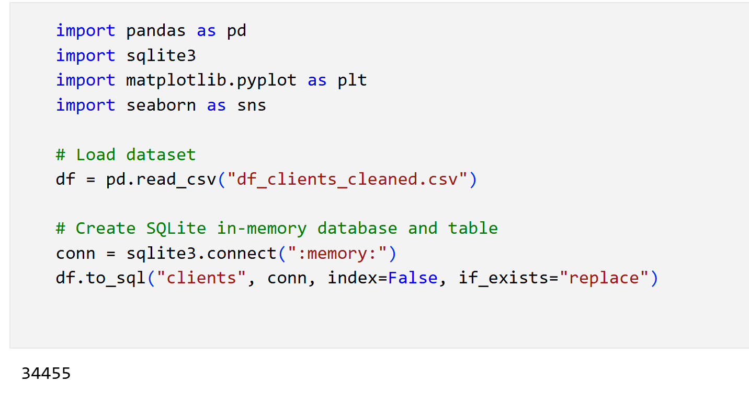
Starting with imports data analysis (pandas), database (sqlite3), and visualization libraries (matplotlib, seaborn). Loads a cleaned client dataset from df_clients_cleaned.csv into a DataFrame. Creates an in-memory SQLite database. Saves the DataFrame as a database table named clients in this temporary database.
Figure 65 Import, dataset load and create SQLite table Clients

Question 1: Distribution of Clients by Credit Risk Class
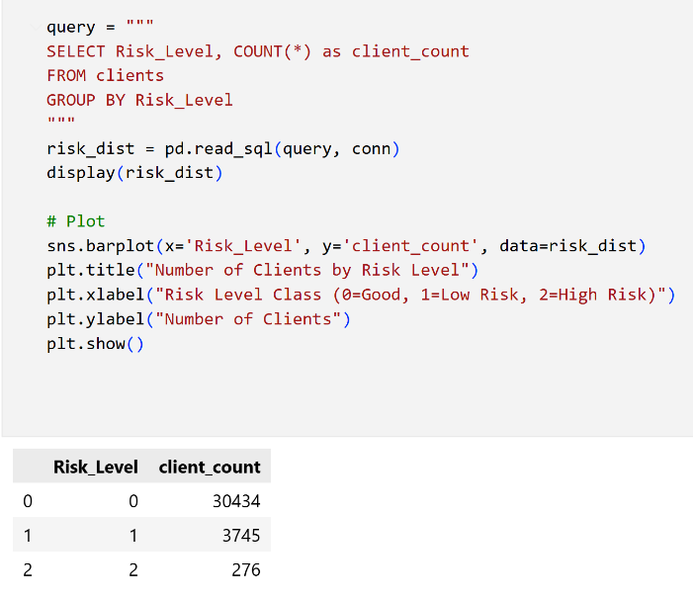 | 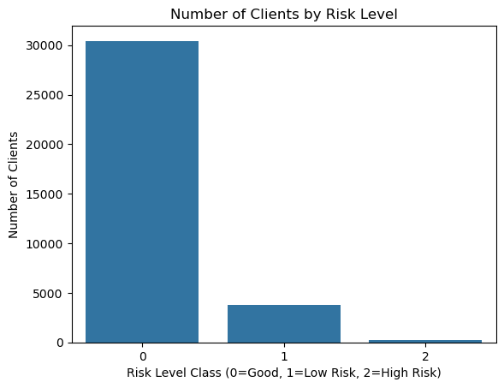
Figure 66 Query, Output and Barplot for Distribution of Clients by Credit Risk Class

The dataset is highly imbalanced with respect to the credit risk classification. The majority of clients (30,434) were labeled as Risk_Level 0 (Good Clients), indicating a low risk of default. A smaller segment, 3,745 clients, were classified as Risk_Level 1 (Low Risk), while only 276 clients were categorized as Risk_Level 2 (High Risk). This class imbalance is typical in credit risk datasets and highlights the importance of using appropriate modeling and evaluation techniques to ensure fair and robust predictions, especially for the rare high-risk group.

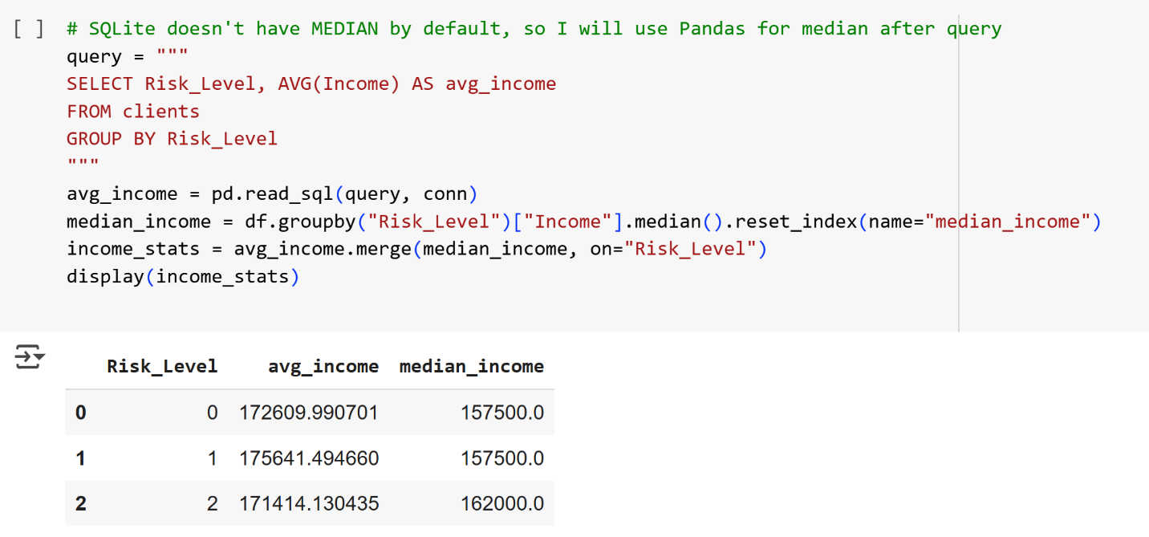
Question 2: Average & Median Income per Risk Class
Figure 67 Query and Output for Average & Median Income per Risk Class

The average and median income levels are remarkably similar across all credit risk classes. Good Clients (0) and Low Risk (1) groups both have a median income of 157,500, while the High Risk group (2) shows a slightly higher median income of 162,000. The average income values are also closely clustered, ranging from approximately 171,400 to 175,600. These results indicate that income alone does not strongly differentiate risk categories in this dataset, and other factors are likely more significant in the model's classification of credit risk.

Question 3: Property Ownership vs Credit Risk
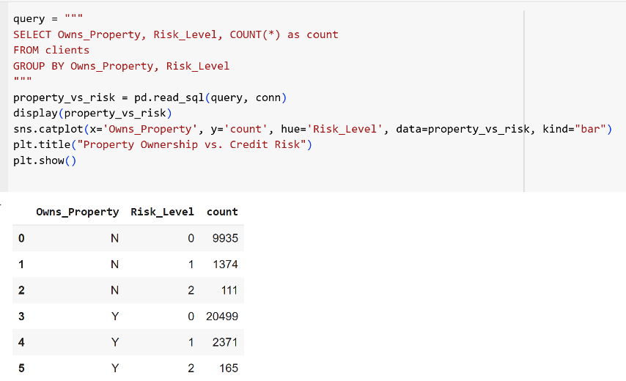 | 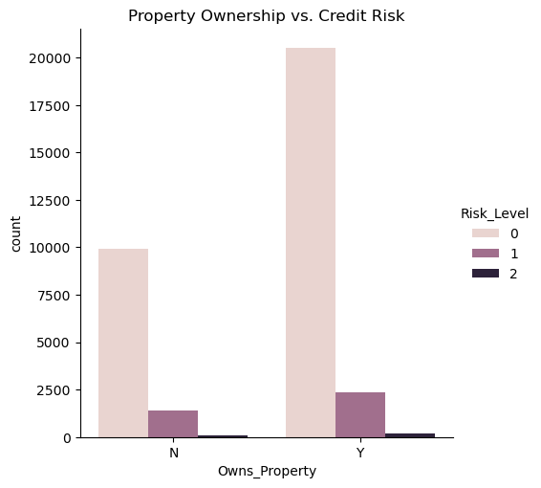
Figure 68 Query, Output and Barplot for Property Ownership vs Credit Risk

This analysis examines the relationship between property ownership and credit risk class. Most clients in all risk categories own property (Owns_Property = Y), with 20,499 Good Clients (Risk_Level 0) owning property compared to 9,935 without property. The pattern is similar in the Low Risk and High Risk groups: the majority in each class are property owners. However, among High Risk clients (Risk_Level 2), the proportion without property is slightly higher (111 vs 165), indicating a marginally increased risk among non-property owners. Overall, property ownership is associated with a lower risk classification, but the distinction is not absolute.

Question 4: Car Ownership Distribution Across Risk
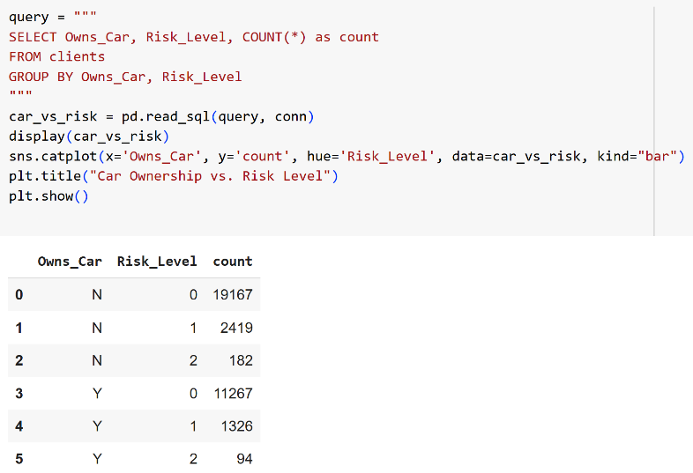 | 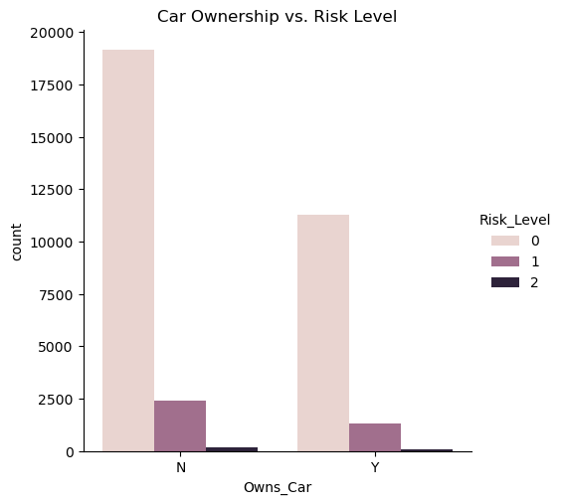
Figure 69 Query, Output and Barplot for Car Ownership Distribution Across Risk

This analysis investigates the relationship between car ownership and credit risk classification. Across all risk levels, a larger number of clients do not own a car (Owns_Car = N). For example, among Good Clients (Risk_Level 0), 19,167 do not own a car, compared to 11,267 who do. This pattern holds for both Low Risk and High Risk groups. In the High Risk category (Risk_Level 2), there are almost twice as many clients without a car (182) compared to those with a car (94). These results suggest that not owning a car is slightly more prevalent among higher-risk clients, which could indicate an association between lack of car ownership and elevated credit risk. However, car ownership alone is not a definitive predictor, as both owners and non-owners are represented across all risk levels.

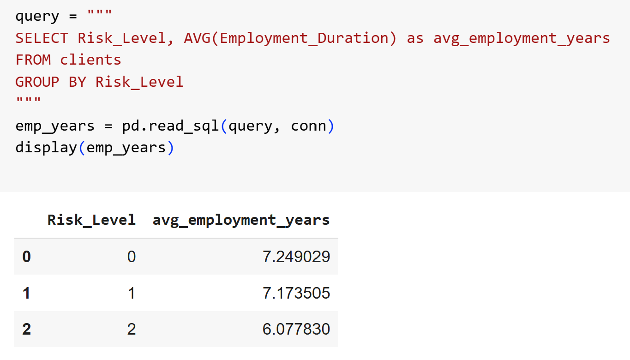
Question 5: Average Employment Duration by Risk Class
Figure 70 Query and Ouput of Average Employment Duration by Risk Class

This analysis examines the average employment duration (in years) for clients in each credit risk category. Good Clients (Risk_Level 0) have, on average, the longest employment history at 7.25 years. Low Risk clients (Risk_Level 1) show a similar average employment duration of 7.17 years. High Risk clients (Risk_Level 2) have the shortest average employment history, with only 6.08 years. This suggests a potential link between employment stability and lower credit risk, as individuals with longer work tenures tend to be classified in safer risk groups. Nevertheless, while employment duration appears to be a contributing factor, it is not the sole determinant of risk, since overlaps exist between groups.

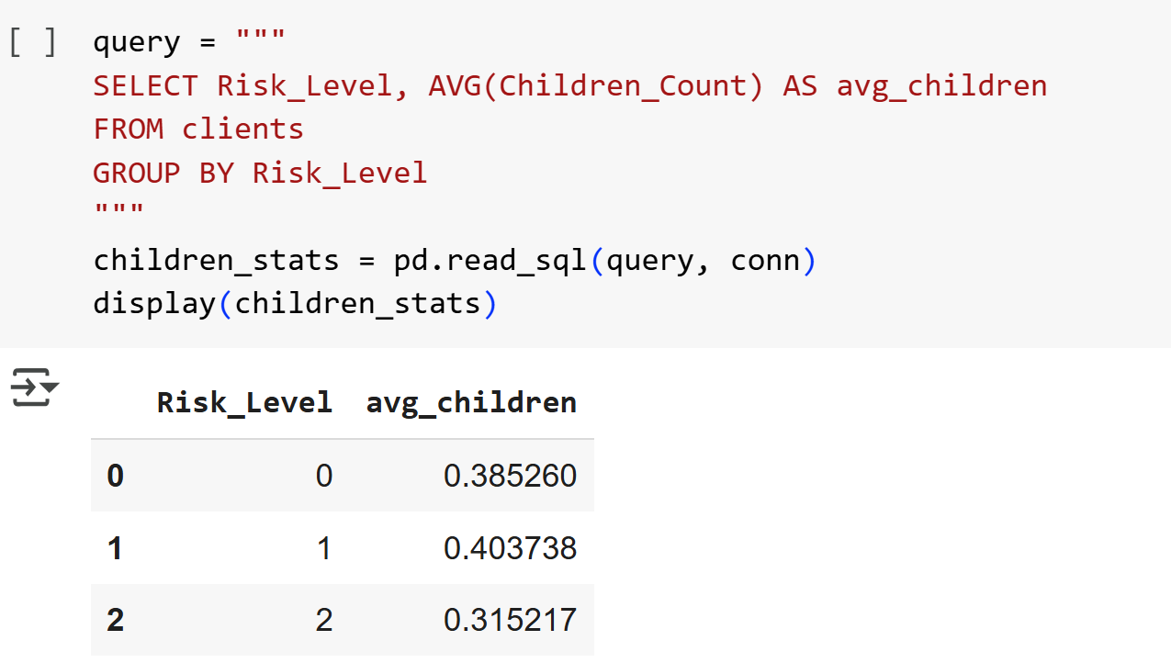
Question 6: Average Number of Children by Risk
Figure 71 Query and output of Average Number of Children by Risk

This analysis investigates the average number of children for clients in each credit risk class. Good Clients (0) and Low Risk clients (1) have, on average, close to 0.4 children per client, while High Risk clients (2) have a slightly lower average at 0.32. The differences across risk classes are minimal, suggesting that the number of children does not substantially differentiate between credit risk categories in this dataset. Therefore, family size, at least as measured by the number of children, is unlikely to be a strong standalone predictor of credit risk.

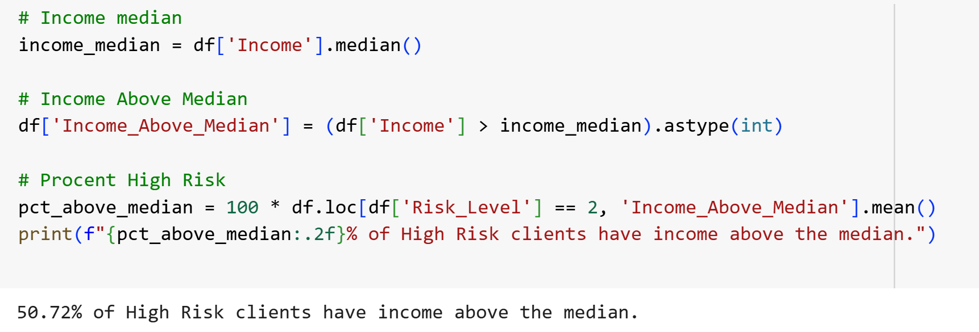
Question 7: Percentage of High-Risk Clients Above Median Income

Figure 72 Code and output of Percentage of High-Risk Clients Above Median Income

This analysis examines the proportion of clients classified as High Risk (2) who have an income above the median for the dataset. The result indicates that 50.72% of individuals in the High Risk group have an income greater than the median value. This finding suggests that a substantial portion of clients identified as high risk are not necessarily low-income individuals. In other words, high credit risk is not exclusively associated with low income in this sample. Therefore, while income is an important factor in credit risk modeling, it does not act as a strict separator for the High Risk group, and other behavioral or demographic features may be more discriminative.

Question 8: Income Type Distribution Across Risk Levels
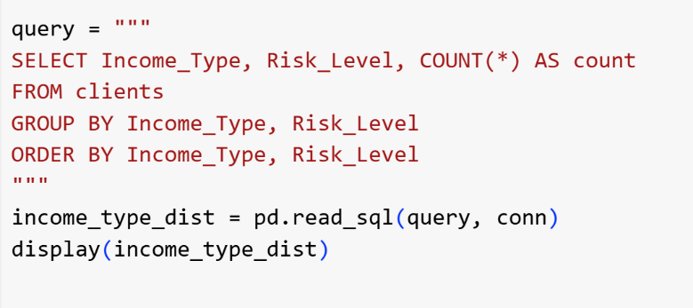 | 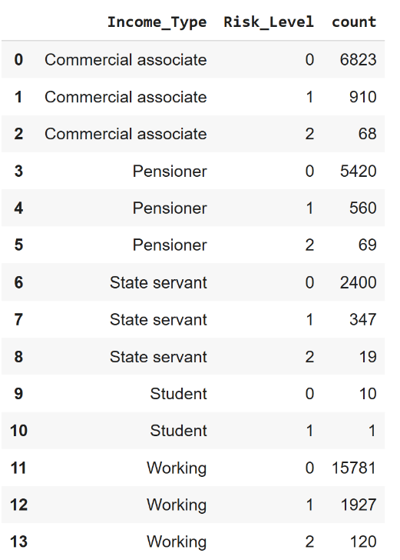
Figure 73 Query and output Income Type Distribution Across Risk Levels

This analysis summarizes the distribution of clients income types across different credit risk categories. The majority of clients classified as Low or High Risk (Risk_Level 1 and 2) are employed ('Working') or are 'Commercial associates', with 'Pensioners' and 'State servants' also represented in both categories. Interestingly, the number of 'Students' in any risk class is very low, and almost absent in the High Risk group. This suggests that income type alone does not exclusively determine risk, but certain types such as 'Working' and 'Commercial associate' are more common among all risk groups, simply due to their higher base prevalence in the population. However, the relatively higher proportions of high-risk cases among 'Pensioners' and 'Commercial associates' compared to their overall group sizes could be indicative of specific financial vulnerabilities or risk profiles.

Question 9: Feature Means for High-Risk Clients
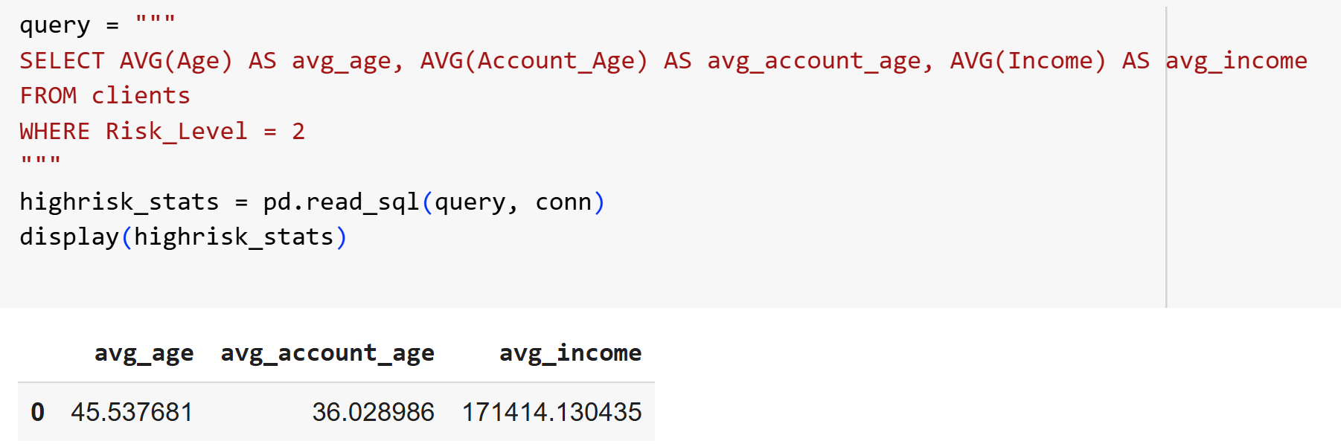
Figure 74 Query and output Feature Means for High-Risk Clients

This query reports the mean values for key features among clients classified as High Risk (Risk_Level = 2). The average age of high-risk clients is approximately 45.5 years, their average account age is about 36 months (3 years), and their average monthly income is 171,414.
These statistics suggest that high-risk clients in this dataset tend to be middle-aged individuals with moderately long credit histories. Despite their higher risk designation, their mean income is similar to the overall population median, indicating that high risk in this context is not strictly associated with lower income. Instead, risk is likely driven by a combination of behavioral factors, account history, and perhaps other demographic characteristics. These aggregated means provide a profile of the typical high-risk client and can inform targeted risk mitigation strategies.

Question 10: Distribution by Family Size and Risk

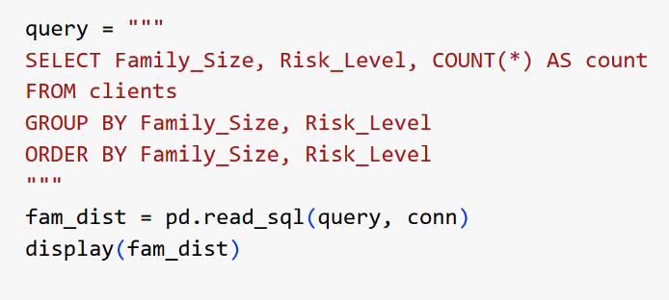 | 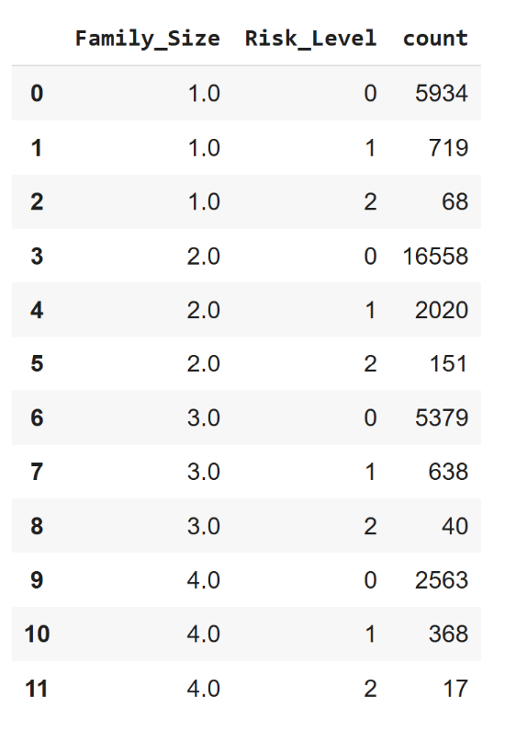
Figure 75 Query and output Distribution by Family Size and Risk

This query analyzes the distribution of clients across different family sizes and risk levels. The majority of clients, regardless of risk, are found in families of size 2.0, followed by family sizes 1.0, 3.0, and 4.0. Within each family size, the vast majority of clients are classified as 'Good Client' (0), with the proportion of 'Low Risk' and 'High Risk' clients decreasing as family size increases.
For example, among families of size 2.0, there are 16,558 good clients compared to only 151 high-risk clients. The trend is similar for other family sizes. This distribution indicates that family size alone is not a strong indicator of credit risk, as the risk class proportions remain fairly consistent across family sizes. However, smaller family sizes (such as 1.0) show a slightly higher proportion of high-risk clients than larger families. This could suggest that single-person households face slightly higher credit risk, possibly due to lower shared financial responsibility or less financial cushioning.
In conclusion the integration of SQL-driven analysis within the credit risk project has provided several tangible benefits. First, it enabled clear, interpretable answers to business-relevant questions such as the distribution of risk classes, average client income, and key demographic relationships that can be communicated directly to decision-makers. Second, SQL queries allowed for efficient aggregation and slicing of large datasets, revealing patterns and trends that might remain hidden in purely algorithmic approaches.
However, it is important to recognize the limitations of SQL as an analytical tool in complex predictive modeling. While SQL excels at aggregation, filtering, and grouping, it is less suitable for advanced statistical analysis, feature engineering, or machine learning, where procedural programming (e.g., in Python or R) offers greater flexibility. Additionally, SQL code can become cumbersome for multi-step, multi-table transformations, and may not easily integrate with version control or modular pipelines.
In summary, supplementing the credit risk workflow with SQL-based questions has enriched the exploratory analysis and improved the transparency and accessibility of results. Nevertheless, for end-to-end modeling and reproducibility, SQL is best viewed as a complementary tool—most effective when integrated with, but not replacing, modern data science programming practices.

9.2 Case Study: Client 3333 – Streamlit Dashboard Explanation

Background & Client Information
- Client Index: 3333
- True Risk Level (Ground Truth): 0 (Good Client)
- Model Prediction: 1 (Low Risk)

Table 19 Client idx 3333 Row Features
Client index | 3333
Gender | 0 (Female)
Age | 62.9
Risk_Level | 0
Owns_Car | 0 (not own a car)
Owns_Property | 1 (owns property)
Income | 202500
Children_Count | 0
Edu_Privileged | 0
Age_Privileged | 1

Protected Attributes are central to group fairness analysis, and AIF360 uses them to measure if machine learning model introduce unfairness or disparate treatment against certain demographic groups. Their explicit display in the dashboard enables both transparency and regulatory compliance.

Table 20 Protected Attributes for client idx 3333
Gender | Indicates the biological sex of the client (in this case, Female)
Age_Privileged | A binary indicator denoting whether the client’s age is above the median value in the dataset (here 1, Age ≥ 42.6)
Edu_Privileged | Indicates whether the client has higher or academic education (here 0, ‘Other’ means the client does not)

Although the ground truth label for this client is "Good Client" (Risk_Level = 0), the model misclassification assigned the prediction "Low Risk" (Risk_Level = 1). This discrepancy is examined using both the SHAP force plot and the feature importances.
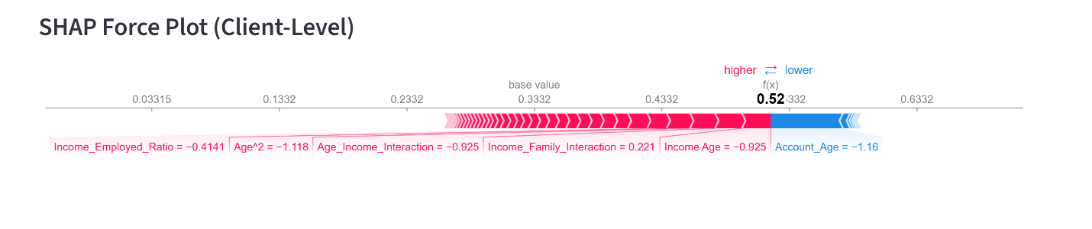
Figure 76 Client idx 3333 SHAP Force Plot

The SHAP force plot visualizes how each feature pushes the prediction toward either a higher or lower risk class:
- Red bars (to the right): Features that increase the predicted risk (toward class 1).
- Blue bars (to the left): Features that push the prediction toward lower risk (class 0).
Table 21 Top Features for this Prediction for client idx 3333
Account_Age | 0.056687322322124804
Income Age | 0.022536
Income_Family_Interaction | 0.021069812849490454
Age_Income_Interaction | 0.019575
Age^2 | 0.018298
Income_Employed_Ratio | 0.015365846477008204
Income_Family_Ratio | 0.015175516108530403
Age_Bin | 0.010824395642528352
Age Employment_Duration_FE | 0.010582497704630439
Employment_Duration | 0.00951

The most influential features (from the provided Table 21 ) were:
Table 22 Client 3333 SHAPE Force plot details
Account_Age | -1.16 | Strong blue, pushing toward Good Client
Income_Age | -0.925 | Red, pushing toward higher risk
Income_Employed_Ratio | -0.414 | Red, higher risk
Age^2 | -1.118 | Red
Age_Income_Interaction | -0.925 | Red
Income_Family_Interaction | 0.221 | Red
Income Age | -0.925 | Red
Income_Employed_Ratio | -0.414 | Red
Income_Family_Interaction | 0.221 | Red

The most important positive contribution came from Account_Age, but it was outweighed by several negative contributions from combined features involving income and age.
The model’s decision was mainly driven by complex interactions between age and income variables. Negative SHAP values for features such as Income_Age, Age^2, and Age_Income_Interaction indicate that, although the client is labeled as "Good," their specific profile shares similarities with "Low Risk" clients, according to how the model learned these relationships.
Despite a strong positive contribution from Account_Age (suggesting a longer credit history, which usually lowers risk), the cumulative effect of the negative contributions pushed the final score just above the threshold for class 1. Notably, this client is female, in the older age group (Age ≥ 42.6), and does not have higher/academic education. These protected characteristics did not appear to directly influence the decision in a biased manner, as shown by the fairness metrics.

This case highlights a limitation of even well-tuned machine learning model: local prediction errors can occur, especially for clients with borderline or unusual profiles. By using SHAP explanations in the deployed dashboard, both technical and non-technical users can clearly see why the model made a certain prediction, supporting trust, transparency, and regulatory compliance. In a real deployment, such borderline cases could be flagged for human review, reducing the risk of unfair rejections or approvals.
This case study demonstrates how the integration of SHAP explanations in a Streamlit dashboard can reveal the key factors behind individual predictions, enabling transparent error analysis and supporting informed, responsible decision-making in credit risk applications.
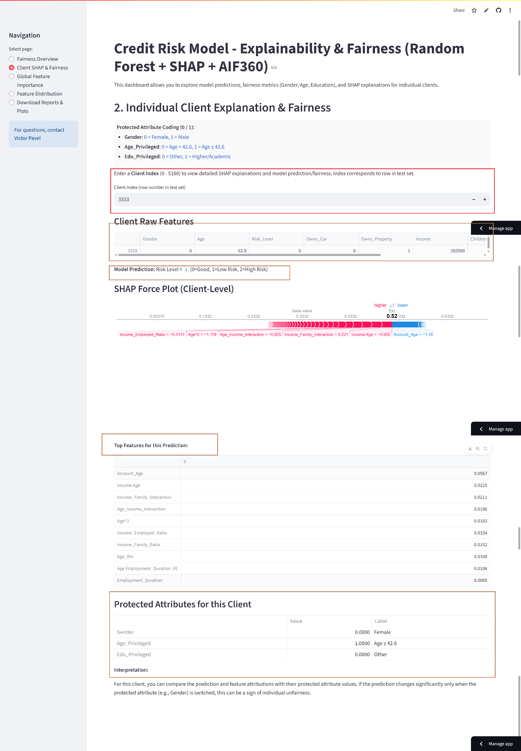
Figure 77 Streamlit Real-time Dashboard SHAP and fairness prediction for client 3333
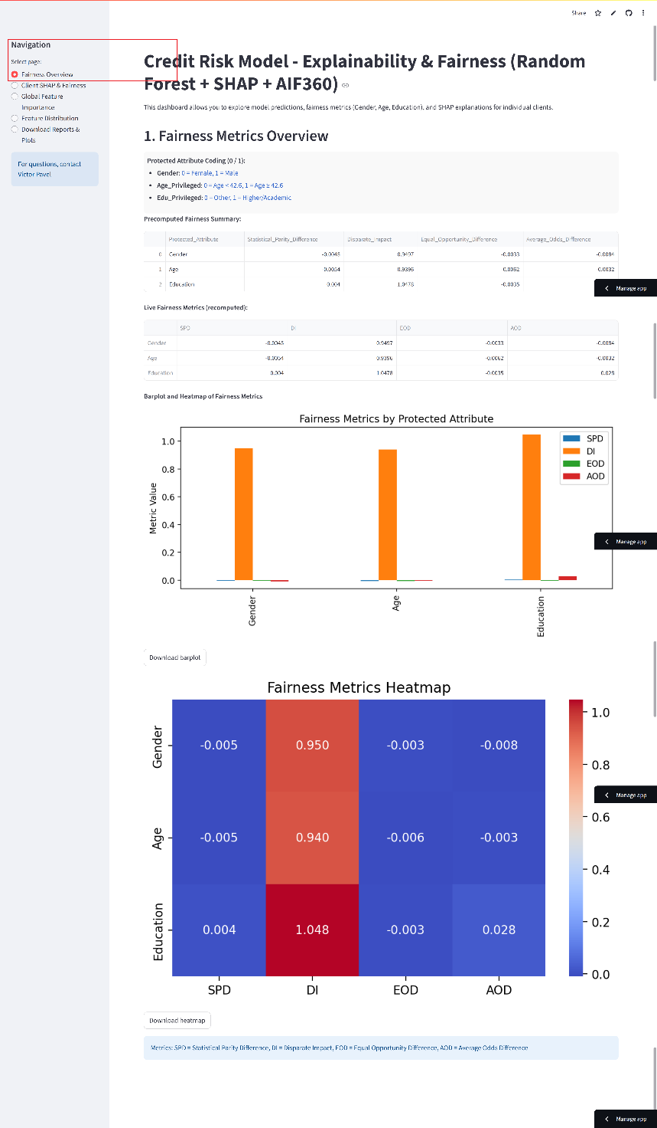
The Fairness Overview section in the Streamlit dashboard provides a centralized summary of all key group fairness metrics such as Statistical Parity Difference, Disparate Impact, Equal Opportunity Difference, and Average Odds Difference computed for each protected attribute (Gender, Age, Education) on the test set from AIF360. This feature enables both technical and non-technical users to quickly assess and monitor whether the credit risk model predictions are fair and unbiased across sensitive demographic groups, supporting transparent and responsible AI deployment
Figure 78 Fairness Overview page
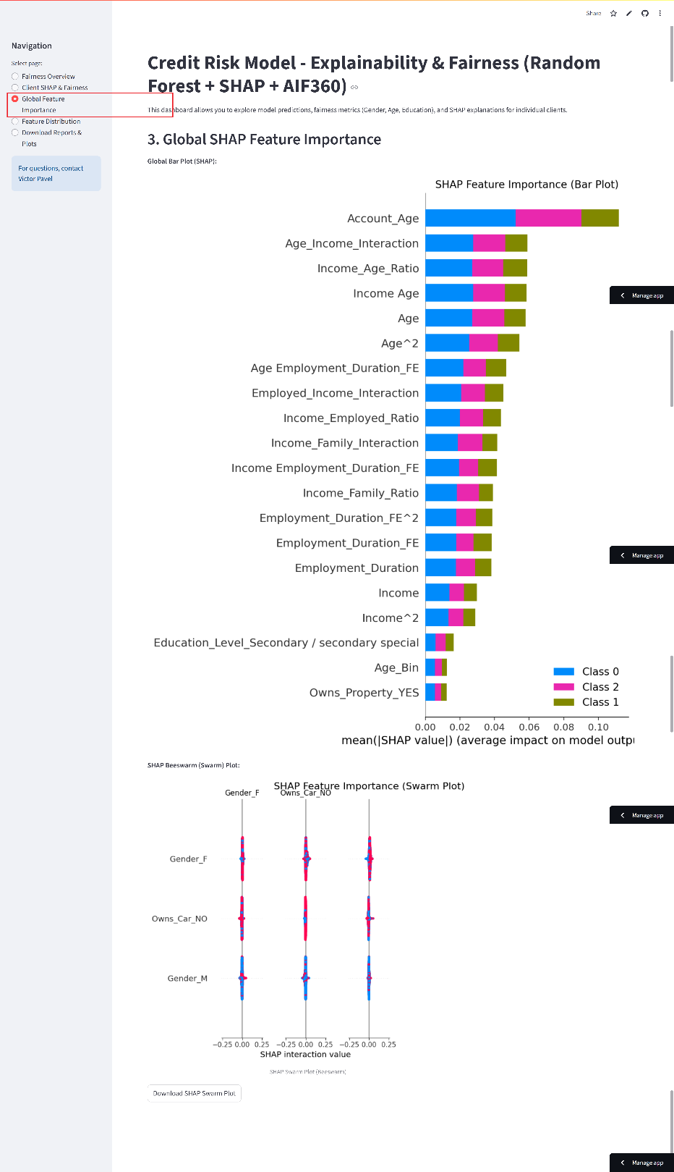
The Global Feature Importance page displays the overall impact of each input variable on the model predictions, using SHAP values aggregated across the test set. By visualizing which features most strongly influence credit risk decisions, this section supports transparency, interpretability, and regulatory compliance, allowing users to understand the primary drivers behind the model outputs.
Figure 79 Global Feature Importance page
The Feature Distribution page allows users to explore how individual features are distributed across predicted Risk Level on the test set. By visualizing the relationship between specific input variables and model predictions, this section helps to identify patterns, detect outliers, and assess whether the model behavior aligns with domain knowledge and expectations.
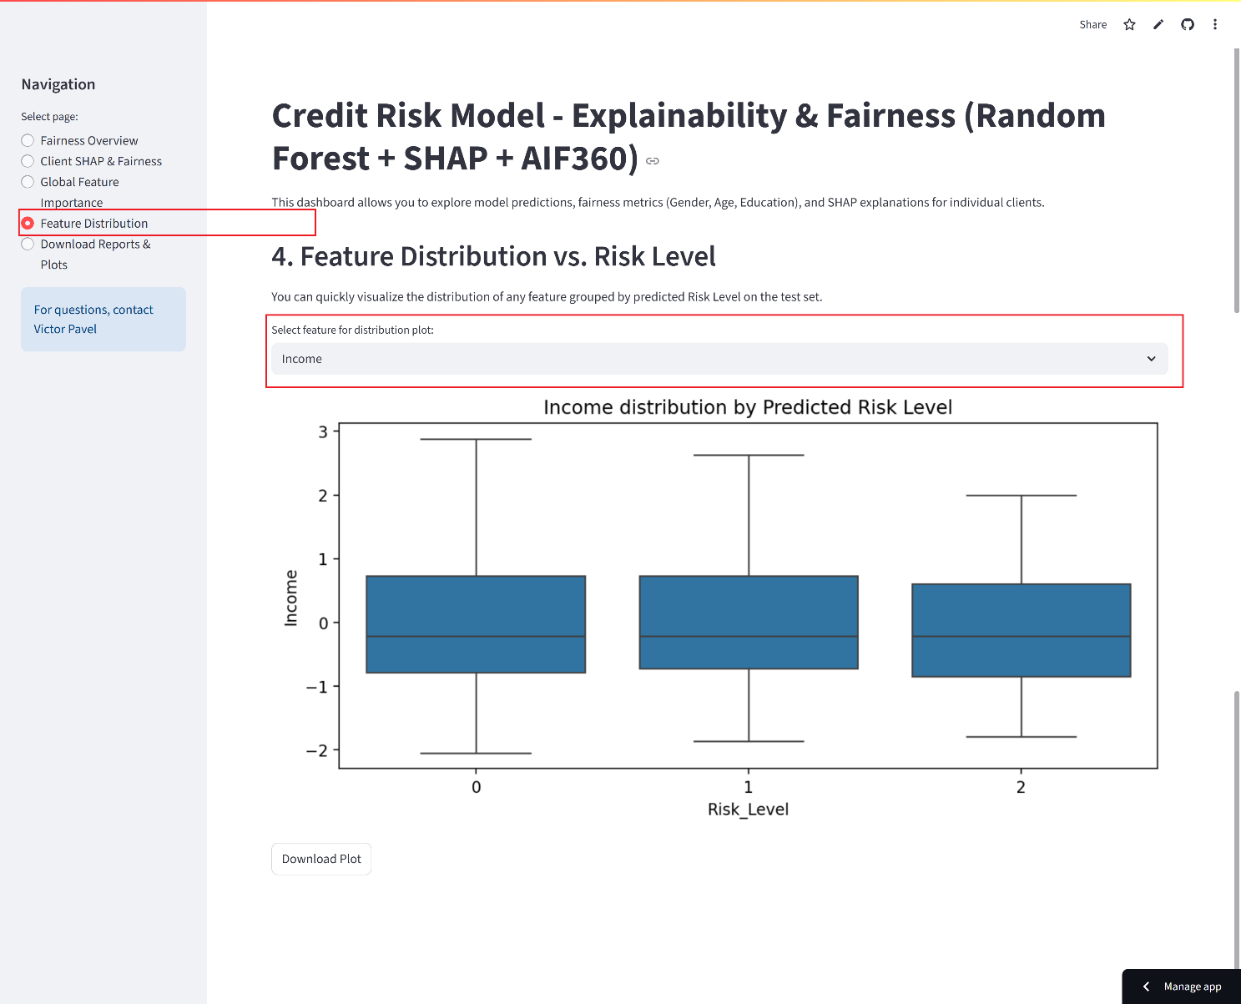
Figure 80 Feature Distribution page

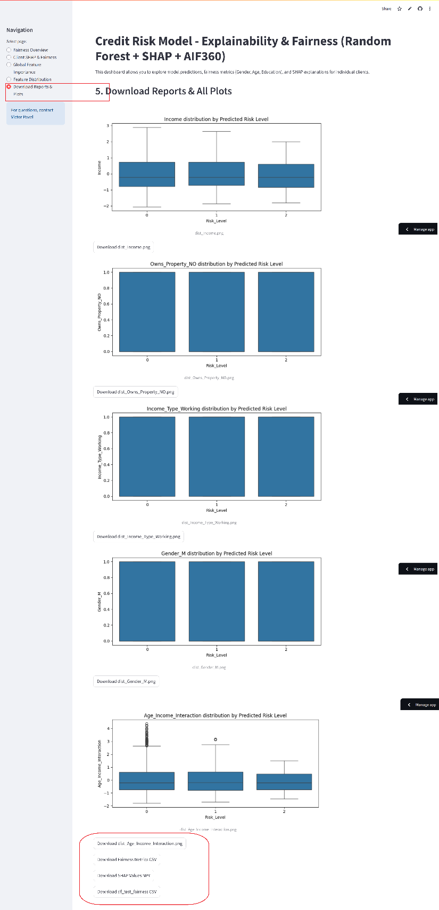
The Download Reports & Plots section provides direct access to all key reports, visualizations, and processed datasets, enabling users to retrieve and archive model results for future reference or external review.
Figure 81 Download Reports & Plots page
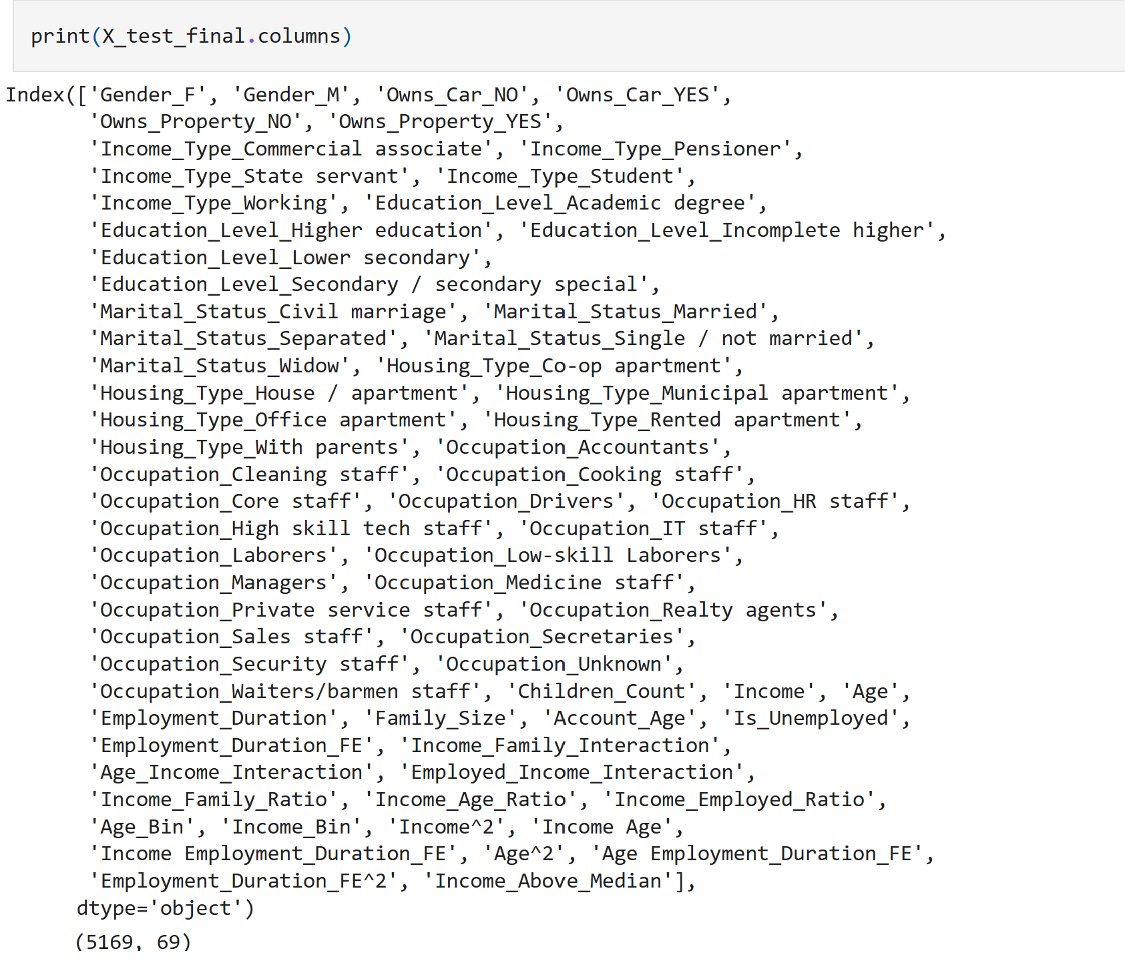
Figure 82 All features in test_final

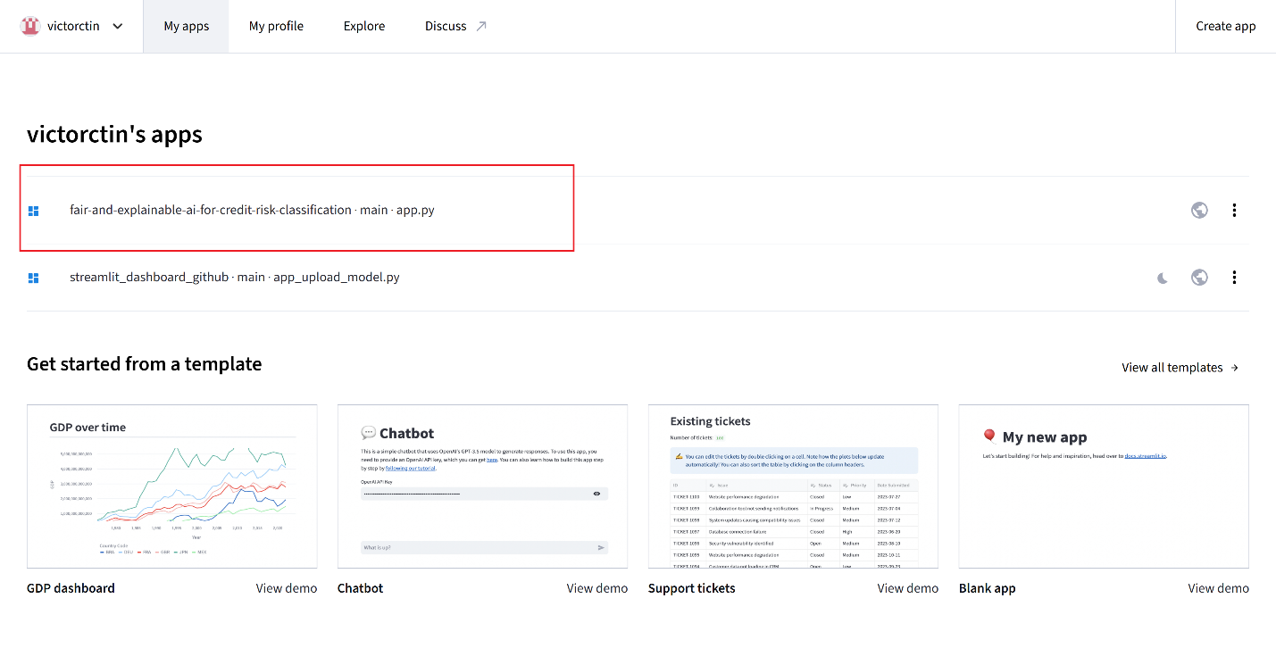
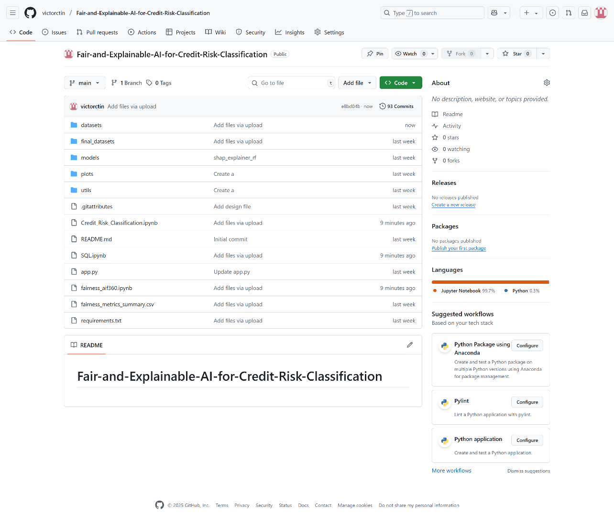
Figure 83 Streamlit share apps
Figure 84 GitHub Repository all files

